CHAPTER I
INTRODUCTION
1.1 PROJECT CONTEXT
The global hospitality and tourism business is rapidly evolving, requiring educational institutions to adapt and provide students with relevant, real-world competencies. In the digital age, students in hospitality and tourism management must have practical knowledge of booking and reservation systems to remain competitive in the industry [1]

Caraga State University Cabadbaran Campus (CSUCC)'s College of Tourism and Hospitality Management (CTHM) recognizes the need of incorporating such technology into its curriculum to better prepare students for the workforce. Simulation platforms, particularly those that replicate airline booking systems, provide a controlled and realistic environment in which trainees can practice and acquire critical skills. This transition towards simulation-based learning is consistent with global educational trends that emphasize interactive and student-centered approaches [2].
Many academic programs continue to rely primarily on conventional, theoretical teaching approaches. There exists a notable gap in the availability and execution of interactive platforms designed exclusively for tourism students, especially in terms of flight booking systems. Most available systems are either commercially constrained or lack educational integration capabilities. As a result, students are deprived of opportunities to apply their academic knowledge in practical, scenario-based settings. Addressing this gap is critical to improving the quality and relevance of tourism education[3].
Students enrolling in CSUCC's tourism and hospitality programs today struggle to acquire practical knowledge about airline booking procedures. Their exposure to realistic situations they are likely to come with in the business is limited by the absence of a good simulation tool. This gap in practical education undermines the university's goal of producing competent. Without immersive tools, students could find it difficult to fully grasp complicated booking systems and client interaction techniques vital for success in their future career.
To address this issue, the proposed "Flight Booking Simulation Platform" offers a practical and educational approach. This platform is intended to replicate real-world airline booking circumstances, allowing students to interact with the system as they would in a professional context. By creating a secure, controlled, and academic atmosphere, the tool improves the learning experience and bridges the gap between theoretical concepts and real-world applications. Implementing this simulation technology not only promotes skill development, but also reflects the university's commitment to academic innovation and excellence in tourist education.

1.2 Purpose and Description:
The purpose of this capstone project is to create a Smart Flight Booking Simulation Platform that can be used as a training tool for CTHM students at CSUCC. The platform will replicate key components of real-world travel booking systems, including flight selection, student information input, seat reservation, payment simulation, booking confirmation and airline pricing
This simulation platform will not be connected to any live airline data or real-time booking systems, but will instead simulate the functionality and interface of true commercial flight booking platforms. The system is meant exclusively for educational purposes, with the goal of improving student capabilities in customer service, reservation handling, digital literacy, critical thinking and decision making skills in dynamic pricing scenarios. [4].

1.3 Objectives of the Study
The objective of this study is to create a smart flight booking simulation platform to help in the training and development of CTHM students at CSUCC.
Specifically, this study aims to:

- Design and develop an Instructor Portal that enables instructors to create and manage sections, enroll students, and configure flight booking simulation activities as structured learning modules.
- Develop an Admin Dashboard that enables administrators to manage the platform's core data including accounts, flights, routes, schedules, seat configurations, taxes, pricing, and add-on services.
- Test the platform's usability and efficiency as a learning tool in actual educational settings.

- Track and monitor the actions of students in the system.

5. Implement a grading and performance reporting system on the instructor side
that allows instructors to evaluate student submissions, view activity
leaderboards, and generate printable grade reports.

1.4 Scope and Limitation of the Study
Scope:
This study covers the Admin and Instructor sides of a simulated airline booking platform developed for use by CSUCC CTHM instructors and administrators. The Admin side includes modules for login authentication, a system dashboard, flight management, route management, schedule management, seat configuration, passenger information, booking payments, pricing configuration, tax management, add-on services management, insurance management, student directory with LMS overview, instructor account management, live flight monitoring, flight dashboard, and passenger manifest management. The Instructor side allows instructors to monitor their classes through a dedicated dashboard, create and manage sections, enroll students, configure course settings, create simulation-based activities, view the enrolled student list, review student submissions and grades, view activity leaderboards, and generate and print grade reports. The platform serves as a scenario-based learning environment that enables instructors to facilitate and assess students' understanding of real-world airline booking operations.

Limitations:
The platform is designed exclusively for educational simulation purposes, covering both the Admin side and Instructor and will not be connected to any live databases or airline systems. For instructors, the learning environment is static when activated; they cannot introduce sudden changes, like flight delays, to test a student's adaptability, cannot shadow a student's screen in real-time through the platform, nor can they remotely take over a student's terminal to guide them through a complex DCS check-in protocol.On the administrative and technical side, the platform operates in an isolated ecosystem. It does not connect to real-world aviation data or weather updates, and it cannot interact with physical airport hardware like bag tag printers or gate scanners.The administration cannot configure complex international variables such as real-time currency exchange rates, multi-country tax schemas, or cross-border Visa and passport validation rules and cannot automatically execute mass re-accommodation (auto-rebooking passengers, issuing hotel vouchers, or shifting crews) if an admin cancels a flight.

1.5 Significance of the Study
This project holds significance for several stakeholders:
Students: It provides an experiential learning to improve comprehension of flight booking processes by integrating theory and practice.
Instructors: It provides a unique approach to delivering course content, monitoring student performance, and assessing preparation for specific activities and generating reports.
Admins: It provides Flight Schedules, User Accounts Management, Manage Overall Data, and operational data oversight.
Institution (CSUCC): Integrating digital tools that fit with industry norms enhances institutional reputation and academic success.
Future Researchers: The platform can serve as a foundation for future system enhancements, such as simulations for hotel or tour package bookings.
CHAPTER II
REVIEW OF RELATED LITERATURE
This chapter presents existing studies and technologies related to airline booking systems, simulation-based learning, and digital training tools in tourism and hospitality education. These resources support the development of a Flight Booking Simulation Platform for CSUCC CTHM students.
2.1 “The Evolution of Internet Pedagogy in Tourism and Hospitality Education” – Journal of Hospitality, Leisure, Sport & Tourism Education
Sigala (2002) [5] views that e-learning can provide an advanced learning to the student. Through the simulation, it helps the students to interact in a data-driven environment by simulating a real-world booking process; students’ performance, digital competency, and technological engagement can all be improved by this simulation.

2.2 Simulation-Based Learning in Higher Education: A Meta-Analysis
Chernikova, Heitzmann, and Stadler (2020) [6] note that simulation-based learning has an effective learning strategy to allow students to have more experience in real-life situations without the risks of actual operations, and it emphasizes the simulation to support decision-making and teamwork. Simulations are particularly helpful for the students to guide them and support them through simulation.

2.3 This is the Pre-Published Version of the article published in the journal: This is the Pre-Published Version of the article published in the journal:
Buhalis and Law (2008) [7] explain the critical role of IT in tourism and the need for education systems to catch up with evolving digital platforms, reinforcing the project’s relevance. [6] further highlight how digital transformation is reshaping both industry practices and academic training, creating new opportunities for innovation. By aligning with these insights, this project contributes to bridging the gap between technological advancement and educational application.

2.4 Learn more, better and faster: computer-based simulation gaming of production and operations
Lainema and Hilmola (2005) [8] prove that simulation-based learning improves retention, practical decision-making, and technical competence. Technology is more effectively used as a tool for learning. The findings validate the proposed approach to skills training.

2.5 “Information Technology and Consumer Behavior in Travel and Tourism” – Journal of Travel Research
Ochoa Siguencia, Marzano, and Herman (2018) [9] identify the growing importance of digital platforms in tourism. This project, a platform for simulating flight bookings, helps students master such systems before entering the industry. It can advance their knowledge and prepare them for the workplace.

2.6 The Role of Information and Communication Technology (ICT ) in Tourism Education : A Case Study of Higher Education Students The Role of Information and Communication Technology ( ICT ) in Tourism Education : A Case Study of Higher Education Students
Beheshti, Rahimizhian, and Ilkan (2020) [10] emphasize that the integration of information and communication technologies (ICT), including simulations, into the tourism curriculum strengthens student outcomes and institutional competitiveness. Further note that interactive digital tools foster stronger engagement and deeper understanding in hospitality training, especially when mimicking real-world interfaces.

2.7 Examining Instructional Technologies in Hospitality and Tourism Education: A Systematic Review of Literature
Huang, de la Mora Velasco, and Haney (2024) [11] identified simulation-based learning as an effective pedagogical approach in hospitality education, enhancing students’ decision-making and problem-solving skills by providing realistic, risk-free environments.

2.8 Perceived usefulness of simulation learning in hospitality education
Price-Howard and Lewis (2023) [12] found that students perceive simulation activities as beneficial for understanding complex concepts in tourism management, indicating a positive impact on their learning experiences and skill development. Simulations serve as both analytic tools and instructional systems, facilitating the development of critical thinking and decision-making abilities among students.

2.9 Enhancing hospitality student learning through the use of a business simulation
Pratt and Hahn (2016) [13] demonstrate through case studies that the effective use of simulations in hospitality management education can significantly improve students’ practical skills and readiness for industry challenges.

2.10 Short-Term Load Forecasting Using EMD-LSTM neural networks with a XGBoost algorithm for feature importance evaluation
Zheng, Yuan, and Chen (2017) emphasize that short-term load forecasting with advanced models like EMD-LSTM and XGBoost highlights the value of data-driven approaches in predicting complex and dynamic systems. The accuracy and reliability of electricity demand forecasts by using artificial intelligence and machine learning. Technology and simulation may be used to solve real-world situations where various aspects influence decision making and consequences. [14]

2.11 Predicting property prices with machine learning algorithms
Ho, Tang, and Wong (2021) show that machine learning in property price prediction demonstrates how data can be used to forecast values by analyzing multiple factors such as location, size and market demand. The Smart Flight Booking Simulation can apply data-driven approaches to simulate real-world airline pricing, seat availability. This allows students to experience how predictive algorithms and data analysis affect decision making in travel and tourism.[15]
further argue that by integrating data-driven simulations, the platform helps learners develop the same analytical and problem-solving skills applied in fields. Students are not only exposed to the booking process but also to how data, trends, and predictive models shape pricing strategies and customer experience. This connection emphasizes the role of technology and analytics in education, preparing future professionals to adapt to the growing use of artificial intelligence and machine learning in tourism.

2.12 Airfare prices prediction using machine learning techniques
This study explores how machine learning models can predict airfare prices based on multiple flight features such as departure time, arrival time, number of stops, luggage allowance, and days before departure. These strategies show that airline corporations are using complex strategies and methods to assign airfare prices. The study tested advanced algorithms, including Random Forest, Bagging Regression Trees, and Neural Networks.

Tziridis, Kalampokas, Papakostas, and Diamantaras (2017) [16] demonstrate how machine learning can capture complex pricing strategies of airlines and provide insights into dynamic fare structures. Their emphasis on feature selection and experimental validation establishes a strong foundation for integrating artificial intelligence into airline management systems.

2.13 Airline Booking System
Shaikh and Borate (2023) presented a web-based airline reservation system; however, the study lacks concrete implementation and evaluation of AI or machine-learning features, fails to simulate real-world booking scenarios, and offers no interactive testing environment. [17]

therefore argue there is a clear need for a Smart Flight Booking Simulation Platform that not only integrates AI-driven booking suggestions and dynamic pricing analytics, but also provides a simulated booking environment for scalability testing, stress analysis, and user interaction modelling, thereby offering deeper insights into operational resilience, user behavior, and system performance.

2.14 Developing Flight Booking Simulation Platform Backend Using Django REST Framework
Carmo et al. (2024) highlight Django REST Framework (DRF) as a vital cornerstone for modern web backends, praised for its low resource consumption, efficient performance, and pragmatic design. This open-source Python framework excels in API development, delivering dynamic, secure, and scalable applications—ideal for educational simulation platforms like this project. Recent benchmarks show DRF matching Node.js in efficiency while maintaining rapid response times.
.

2.15. Seat Reservation Allowing Seat Changes
Boyar, Krarup, and Nielsen (2001) [19] describe the Seat Availability Resolution Algorithm as a computational approach used in reservation systems to determine whether a passenger request can be accepted based on current seat occupancy and travel segment overlaps. This algorithm treats each booking request as an interval between two stations and assigns a seat such that no two overlapping intervals share the same seat. Studies on seat reservation problems describe this process as similar to interval graph coloring, where each seat represents a color and each trip request represents a node that must not conflict with others.

2.16. Embracing Agile
Rigby, Sutherland, and Takeuchi (2016) [20] describe Agile as a modern approach to managing projects that helps teams work faster and more effectively. It was first widely used in software development and has helped improve productivity, product quality, and teamwork. Unlike traditional methods that follow strict plans, agile allows teams to adapt to changes and focus on customer needs. By working in small teams and completing tasks in short cycles, organizations can develop better products and respond quickly to new challenges in a fast-changing environment.

2.17. A Performance Benchmark for the PostgreSQL and MySQL Databases
Salunke and Ouda (2024) indicate that PostgreSQL demonstrates significantly better performance compared to MySQL, particularly in executing select operations on large datasets. In primary tests, PostgreSQL’s execution time for 1 million records ranged from 0.6 ms to 0.8 ms, while MySQL’s ranged from 9 ms to 12 ms, indicating that PostgreSQL is about 13 times faster. For select queries with a where clause, PostgreSQL required 0.09 ms to 0.13 ms compared to1MySQL’s 0.9 ms to 1 ms, making it roughly 9 times more efficient. [21]

further note that this superior performance suggests PostgreSQL is highly suitable for continuous authentication systems, where rapid retrieval of user data is crucial for real-time verification and system responsiveness. Studies showing better write operation performance than MySQL demonstrate PostgreSQL’s strong support for hierarchical data models, such as the adjacency list model, which enables effective management insertion of complex tree-like data structures by handling recursive queries and optimizing write-heavy operations.

2.18 Performance Comparison of React, Angular, and Vue.js Frameworks
A 2023 study in the World Journal of Advanced Engineering Technology and Sciences evaluates React, Angular, and Vue.js for performance and scalability in complex web applications. React excels with its virtual DOM for fast rendering, though complex state changes require optimization; Angular offers robust features but higher memory usage; Vue.js balances low memory footprint with quick render times. For educational platforms like this flight booking simulator, React's dynamic UI handling and scalability make it the optimal choice among the three.

Chapter III
Methodology

This chapter explains the plan for the project in this study. It shows how developmental research was effectively used here and how it helps developers understand what the system needs and choose the right methods to build it.

3.1 Requirements Specification
3.1.1 Technical Feasibility
The list below outlines the suggested hardware and software specifications needed to develop the system effectively.

3.1.1. Technical Feasibility

Table 1. Minimum Hardware Requirements
Table 1. Estimated Project Costs

Item Description | Technical Specifications | Quantity | Unit Price (PHP) | Total Cost (PHP)
System Unit | Core i5-12th Gen, 16GB DDR4 RAM, 500GB SSD | 1 unit | 25,000.00 | 25,000.00
Monitor | 21.5" Full HD LED Display | 1 unit | 6,912.00 | 6,912.00
Peripherals | Standard Keyboard and Optical Mouse Bundle | 1 set | 748.00 | 748.00
Network Interface | Built-in Realtek LAN / USB WiFi Adapter | 1 unit | 600.00 | 600.00
TOTAL INITIAL COST |  |  |  | ₱ 33,260

Table 3 The hardware investment for the platform is strategically budgeted to ensure the system unit provides the necessary computational power for the concurrent execution of the Django backend and PostgreSQL database. By allocating funds for a high-performance 12th Gen processor and 16GB of RAM, the platform maintains the responsiveness required for a data-driven simulation environment. The budget further accounts for essential visual and input components, such as the 21.5" LED monitor and a standard peripheral bundle, to ensure a complete and ergonomic workstation setup. Additionally, the inclusion of a versatile network interface supports seamless connectivity via local LAN or WiFi, which is vital for real-time system operations. These specific hardware selections prioritize long-term technical stability while keeping the initial capital outlay economically viable for institutional implementation.

Table 3. Software Requirements

Item | Specifications
Front end | Tailwindcss, Vue.js(Javascript)
Front end Tool | Visual Studio Code
Back end | Django(python)
Database | PostgreSQL

Table 2 lists the software requirements for the proposed “SMART FLIGHT BOOKING SIMULATION PLATFORM FOR CTHM-CSUCC: AN INTERACTIVE AND DATA-DRIVEN TRAINING TOOL FOR HOSPITALITY AND TOURISM EDUCATION. The system’s front end (user interface) is built using Tailwind css for styling , JavaScript for interactivity and Vue for displaying UI/UX. The back end (server-side) runs on Python with the Django framework. Developers used Visual Studio Code to write the code, and PostgreSQL serves as the database to store and manage data.

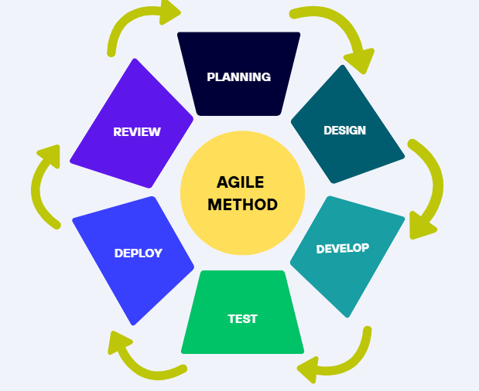
3.2 Data Processing Model

Figure 1. Structure Design

Figure 1 illustrates the structure design based on the Agile Methodology, which guided the development of the proposed “Smart Flight Booking Simulation Platform for CTHM-CSUCC: An Interactive and Data-Driven Training Tool for Hospitality and Tourism Education”. The Agile approach enabled the developers to work in iterative cycles, allowing continuous improvement of the system through regular feedback. The diagram highlights the flow of processes and key components involved in the platform’s development.

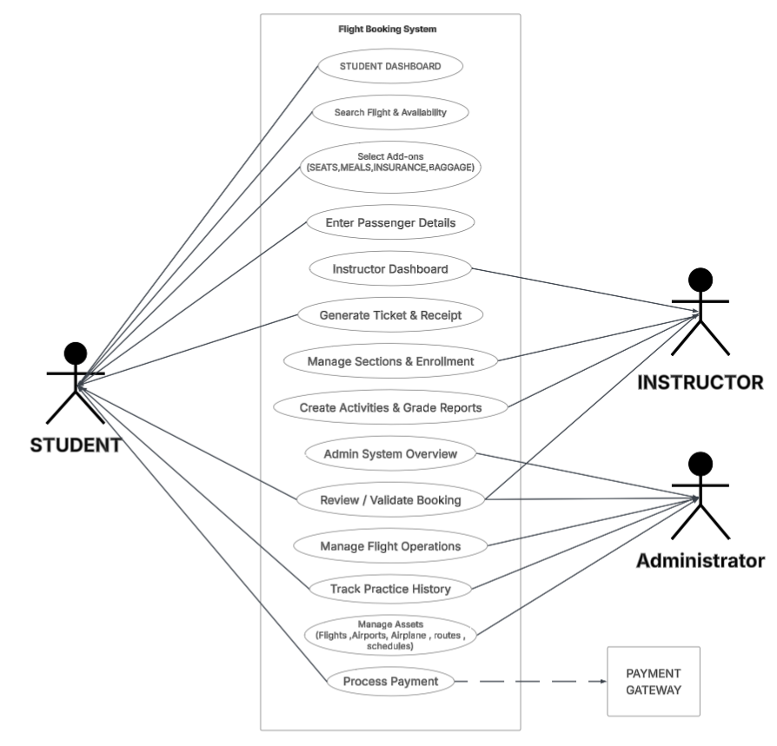

Figure 2. UML Use Case Diagram for the Flight Booking Simulation Platform for CTHM-CSUCC

Figure 2 illustrates the UML use case diagram for the Flight Booking Simulation Platform for CTHM-CSUCC: A Training Tool for Hospitality and Tourism Education. The updated platform includes three primary participants: STUDENT, INSTRUCTOR, and ADMINISTRATOR. The STUDENT can initiate and complete the entire flight booking process, which involves searching for flights based on chosen criteria, selecting flight add-ons (such as seats, meals, Insurance , Baggage), providing passenger and booking information, reviewing the booking summary, making secure simulated payments through an external payment gateway (PayMongo), and ultimately receiving generated tickets and receipts. On the opposite side, the administrative functions are divided between the INSTRUCTOR and ADMINISTRATOR to ensure focused management. The INSTRUCTOR acts as the educational facilitator, tasked with managing class sections, enrolling students, creating booking activities, grading submissions, and validating the students' practice booking history. Meanwhile, the ADMINISTRATOR serves as the system manager, tasked with overseeing the core backend data. This includes determining active flight operations, managing essential assets like airplanes and airports, and monitoring the system-wide dashboard to ensure the reliability, accuracy, and efficiency of the overall simulation platform.

Figure 3. Flowchart of Instructor and Admin
INSTRUCTOR FLOWCHART
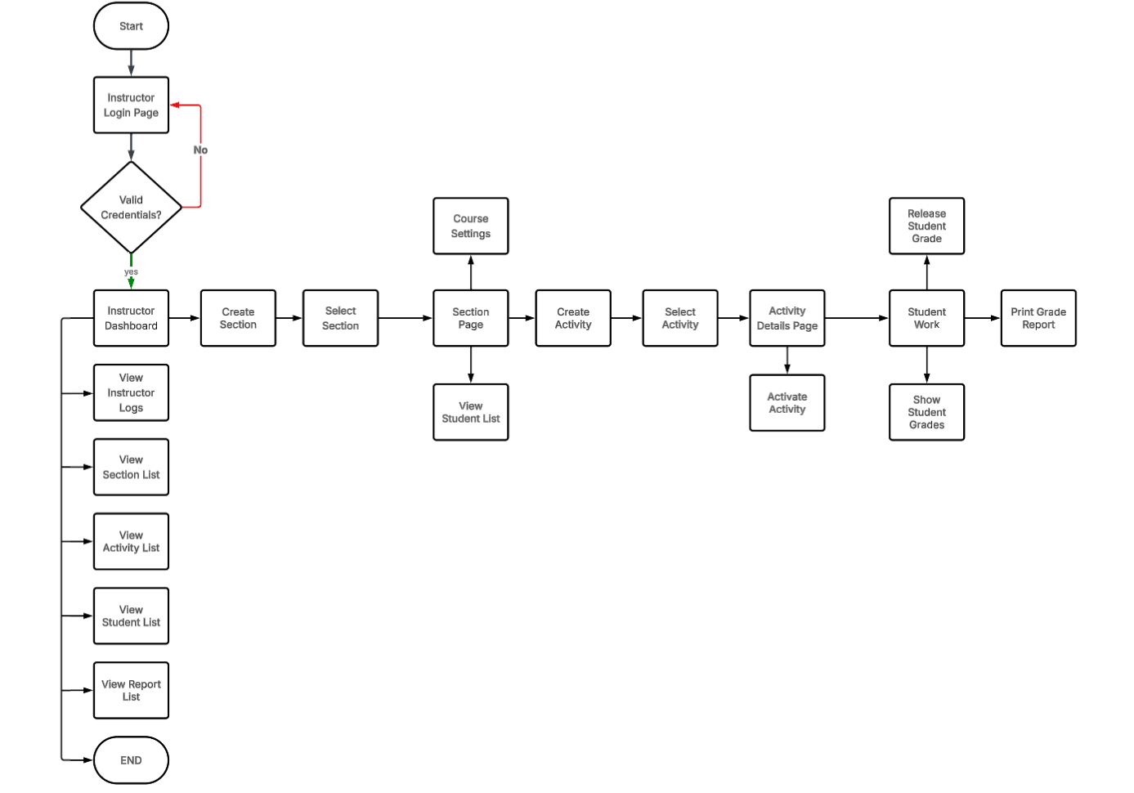

Figure 3 Flow Chart for the Operations of Instructor and Administrator in the Flight

Booking Simulation Platform: The flowchart shows the distinct operational pathways and administrative tasks handled by the Instructor and the Administrator within the platform. The process begins with Login Authentication where the system identifies the user's role and directs them to their respective workflow. The Instructor starts at the Instructor Dashboard, specifically focusing on the Learning Management System (LMS) features. They proceed through steps such as Manage Classes & Sections, Enroll Students to Sections, Create Booking Activities, and Activate Activity for Students. Once students submit their simulated bookings, the instructor proceeds to Review Submitted Activities & Grade Performance, Grade Performance, Monitor Continuing Practice Bookings, and ultimately Generate Class Reports to assess overall student performance. Conversely, the Administrator focuses on the technical maintenance and core operations of the system. Starting from the Admin Overview, they proceed through steps to Manage Base Assets (such as Airports, Airlines, and Taxes), Manage Flight Routes & Schedules, and Configure Dynamic Pricing & Seat Configurations. The workflow concludes with the continuous process to Monitor Overall Platform Reliability, ensuring that the simulation environment remains accurate and fully functional for both instructors and students.

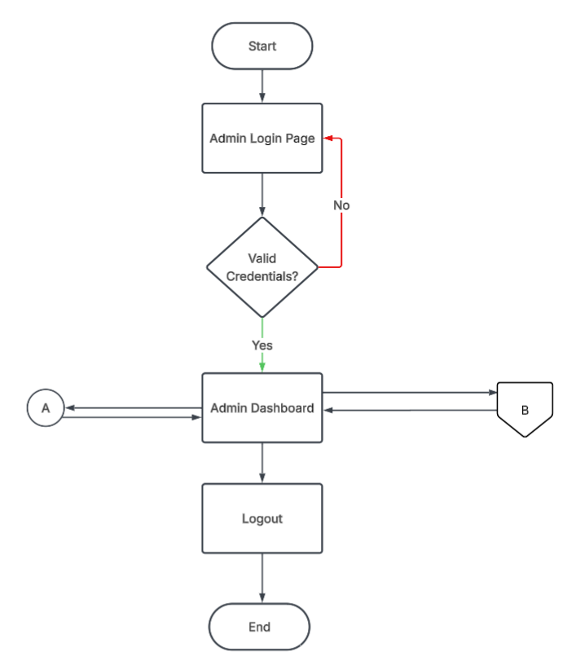
ADMIN FLOWCHART

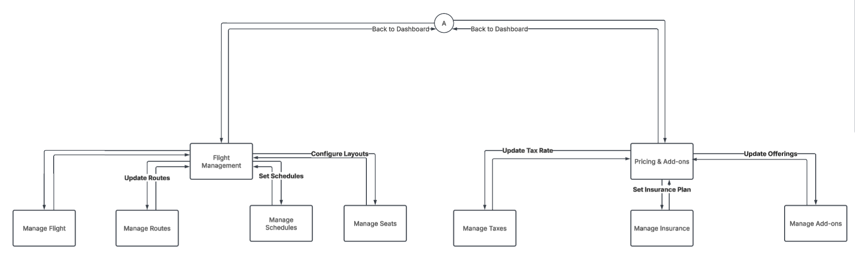

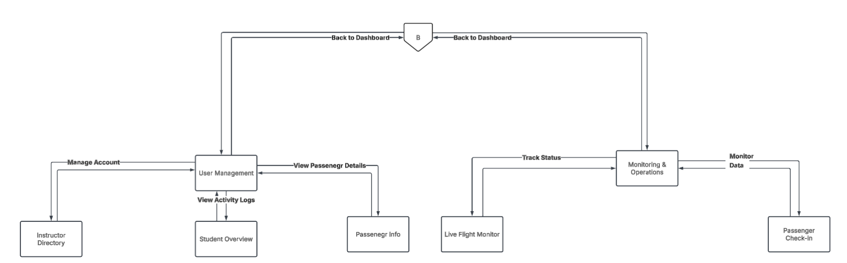

Figure 3. Flowchart of the Administrator Module for the Flight Booking Simulation Platform

Figure 3 illustrates the system flowchart for the Administrator Module. Following successful credential validation at the Login Page, administrators access the Dashboard, which branches into four core operations. In Flight Management, administrators control the simulation's infrastructure by adding or editing flight profiles, routes, active schedules, and seat layouts. The Pricing & Add-ons module handles the financial constraints of the simulation, allowing updates to tax rates, travel insurance plans, and add-on services like baggage or meals. To maintain the educational environment, the User Management flow enables administrators to manage instructor accounts, review student activity-tracking logs, and access consolidated passenger details. Meanwhile, the Monitoring & Operations flow provides administrative oversight without interfering with student tasks; administrators can track real-time flight statuses and view passenger check-in data generated by students during their simulation exercises. All process paths are designed to return to the Admin Dashboard upon completion, and the flow formally concludes when the administrator initiates a secure Logout to end the session.

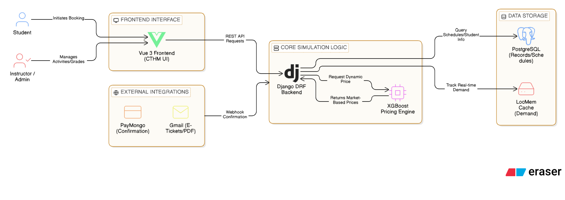

Figure 4. illustrates the SYSTEM ARCHITECTURE of the Flight Booking Simulation Platform for CTHM-CSUCC

A training tool designed to enhance hospitality and tourism education. The STUDENT initiates the VERIFICATION and BOOKING PROCESS via the Vue 3 Frontend, which connects to FLIGHT SCHEDULES and STUDENT RECORDS managed by the Django REST Backend to simulate real-life reservations. A specialized ML PRICING ENGINE using XGBoost provides dynamic fare calculations to mirror real-world market conditions. Once the booking is confirmed through the PAYMONGO GATEWAY, the system generates a PLANE TICKET (PDF) as proof of the reservation. The INSTRUCTOR/ADMINISTRATOR manages the platform through a secure ADMIN LOGIN, handling tasks such as creating GRADED ACTIVITIES, reviewing STUDENT PROGRESS, and updating CORE FLIGHT DATA stored in the POSTGRESQL database. This architecture highlights a user-friendly and practical system, MIRRORING REAL-WORLD AIRLINE SYSTEMS to effectively TRAIN CTHM-CSUCC STUDENTS in managing tourism and hospitality operations.

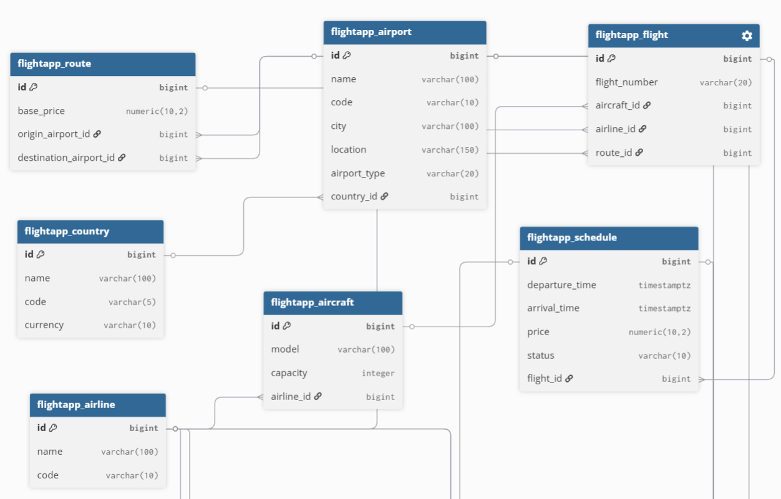

Figure 5 . Core Flight Infrastructure Module

Figure 5 shows the Entity Relationship Diagram (ERD) for the Core Flight Infrastructure Module, which serves as the foundation of the Flight Booking Simulation Platform. This module is structured to manage essential location and carrier data through the COUNTRY, AIRPORT, AIRLINE, and AIRCRAFT tables. The ROUTE table defines the critical connections between airports, while the FLIGHT table identifies specific flight numbers. Finally, the SCHEDULE table manages the operational layer, including departure and arrival timings as well as real-time flight status.

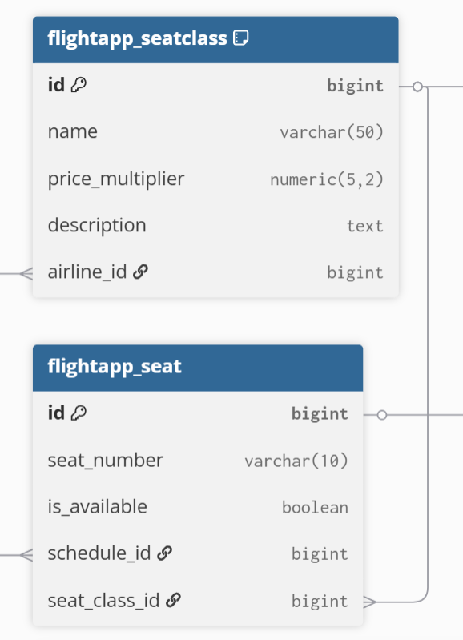

Figure 6. Seat & Pricing Module
Figure 6 illustrates the Seat & Pricing Module, which governs the inventory and valuation logic of the system. The SEATCLASS table defines the various service tiers (such as Economy, Business, or First Class) and their associated price multipliers. These tiers are linked to individual records in the SEAT table, which tracks the real-time availability of specific seat numbers for every scheduled flight, ensuring that pricing scales dynamically based on the selected class.
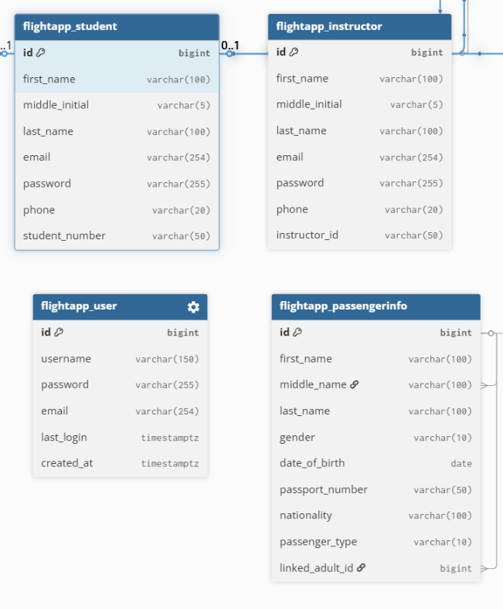

Figure 7. User & Passenger Management Module

Figure 7 details the User & Passenger Management Module, responsible for handling both system access and traveler identity. It distinguishes between academic roles via the STUDENT and INSTRUCTOR tables, while the USER table manages general authentication. For the booking process, the PASSENGERINFO table stores sensitive travel data—including passport numbers and nationalities—and facilitates the linking of primary adult passengers to dependents.
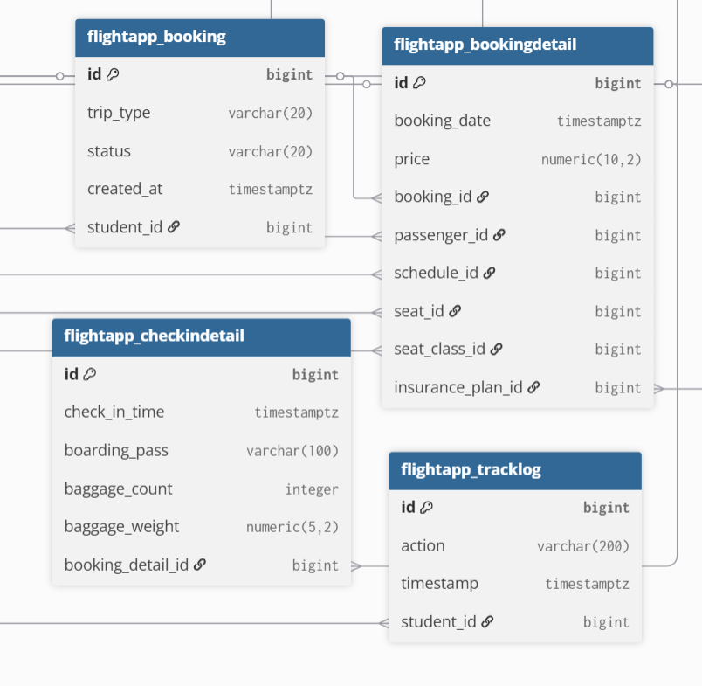

Figure 8 .Booking & Operations Module

Figure 8 represents the Booking & Operations Module, the transactional core of the platform. The BOOKING table acts as the primary record for a reservation, while the BOOKINGDETAIL table provides a granular breakdown, linking passengers to specific seats, schedules, and insurance plans. This module also encompasses post-booking logistics through the CHECKINDETEAL table, which manages baggage and boarding passes, and the TRACKLOG table for auditing user actions.

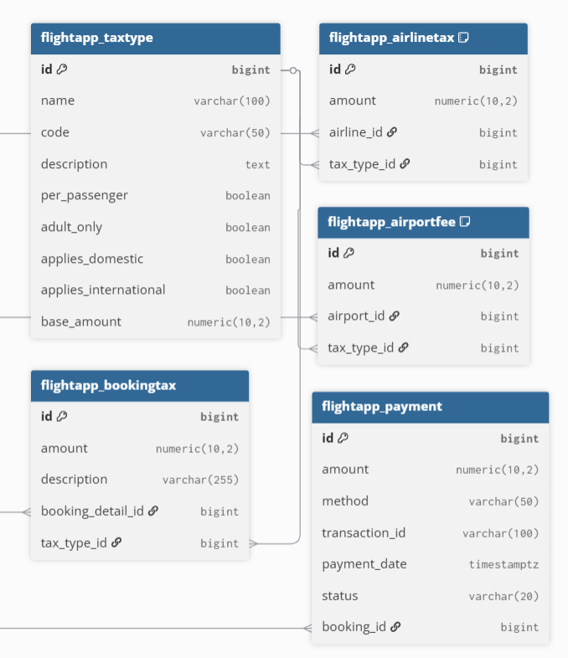

Figure 9.Financial & Taxation Layer Module

Figure 9 shows the Financial & Taxation Layer, which manages the complex fiscal requirements of the aviation industry. The TAXTYPE table defines various tax rules, which are then applied specifically to carriers or locations via the AIRLINETAX and AIRPORTFEE tables. Applied taxes are captured in the BOOKINGTAX table for every transaction, while the PAYMENT table tracks the status, method, and transaction IDs for all financial exchanges.

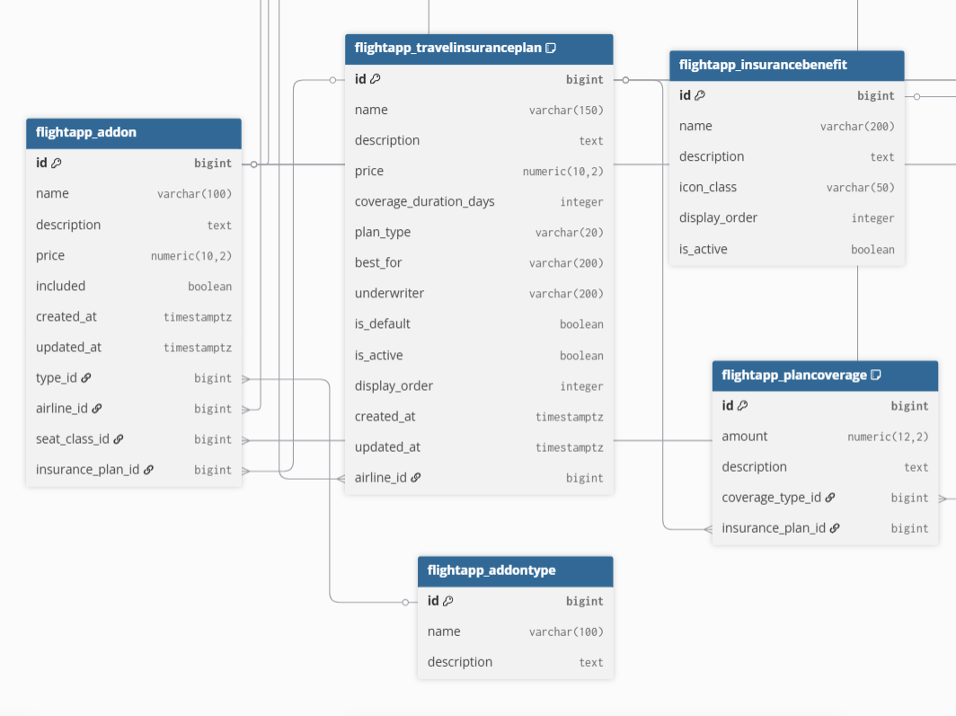

Figure 10. Add-on & Insurance System Module

Figure 10 illustrates the Add-on & Insurance System, designed to manage ancillary services and traveler protection. The ADDON table, categorized by ADDONTYPE, allows for the selection of extra services like meals or baggage. Simultaneously, a comprehensive insurance sub-system—comprised of TRAVELINSURANCEPLAN, INSURANCEBENEFIT, and PLANCOVERAGE—provides students with the ability to simulate the selection of protection plans based on duration and coverage types.

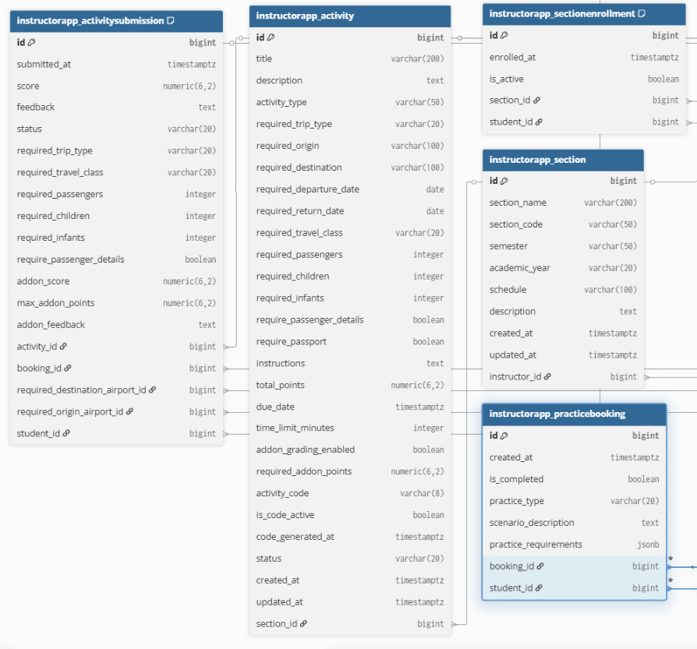

Figure 11. Educational Simulation Layer Module

Figure 11 details the Educational Simulation Layer, which integrates the simulation into an academic curriculum. Instructors manage students through the SECTION and SECTIONENROLLMENT tables, while the ACTIVITY table allows for the creation of specific booking scenarios. The module enables automated grading by comparing data in the ACTIVITYSUBMISSION and STUDENTSELECTEDADDON tables against the instructor's predefined requirements, providing a robust tool for vocational training.

Chapter IV
RESULT AND DISCUSSION
4.1 Introduction
This chapter presents the results of the developed Smart Flight Booking Simulation Platform, including its features, system implementation, testing procedures, and evaluation. It also discusses the system’s performance, usability, and effectiveness based on the results gathered during testing and user evaluation. The findings in this chapter aim to determine whether the system successfully achieved the objectives stated in Chapter 1.

4.2 Requirements Modeling
This section presents the requirements modeling of the developed Smart Flight Booking Simulation Platform. It identifies and organizes both the functional and non-functional requirements that guided the system design and development. These requirements ensure that the system meets the intended objectives and provides an effective simulation environment for users.

Table 4.1: Functional Requirements Implementation Status
ID | Functional Requirement | Description | Status
FR‑01 | Student Booking Process | Complete flight booking workflow including login, search, selection, payment, and confirmation | Implemented
FR‑02 | Student Check-in Process | Perform passenger verification, seat assignment, and boarding pass generation | Implemented
FR‑03 | Student Activity Access | View dashboard, select activities, and follow simulation instructions | Implemented
FR‑04 | Instructor Activity Management | Create, manage, and activate simulation activities | Implemented
FR‑05 | Instructor Student Monitoring | View student progress, submissions, and performance | Implemented
FR‑06 | Instructor Report Generation | Generate and manage student grade reports | Implemented
FR‑07 | Admin Flight Management | Manage flights, routes, schedules, and seat configurations | Implemented
FR‑08 | Admin Pricing & Add-ons | Configure pricing rules, taxes, and additional services | Implemented
FR‑09 | Admin User Management | Manage student and instructor accounts and records | Implemented
FR‑10 | System Security | Implement authentication, authorization, and error handling | Implemented
FR‑11 | End Process | Complete workflow for all system users | Implemented

Table 4.2: Non-Functional Requirements Verified Within Constraints
ID | Requirement | Target | Result | Verification Method
NFR-01 | System load time | <3s | 2–3s (avg) | Measured using browser developer tools
NFR-02 | Booking response time | <5s | 2–4s (avg) | End-to-end testing
NFR-03 | Concurrent users | Defined limit | Passed (multiple users supported) | Load testing using concurrent sessions
NFR-04 | Cross-browser compatibility | Chrome, Firefox, Edge | Passed | Manual testing on supported browsers
NFR-05 | Database query response | <500ms | ~180–210ms (avg) | Query profiling
NFR-06 | Data submission (forms) | <100ms | ~85ms (avg) | Backend request logging
NFR-07 | Flight search processing time | <5s | ~6s (avg) | Simulated flight search testing
NFR-08 | System uptime | ≥99% | 24 hours continuous | Continuous runtime monitoring
NFR-10 | Security: authentication | Required | Implemented | Authentication and hashing validation
NFR-11 | System protection | Required | Implemented | Input validation and access control

4.3 The Developed System
This section presents the developed system for the proposed Smart Flight Booking Simulation Platform designed for educational purposes. On the instructor side, the system provides tools for creating activities, monitoring student performance, and grading submissions. The administrator manages system data such as flights, airports, and pricing configurations.
Show actual system output.
(Put screenshots + short explanation only)
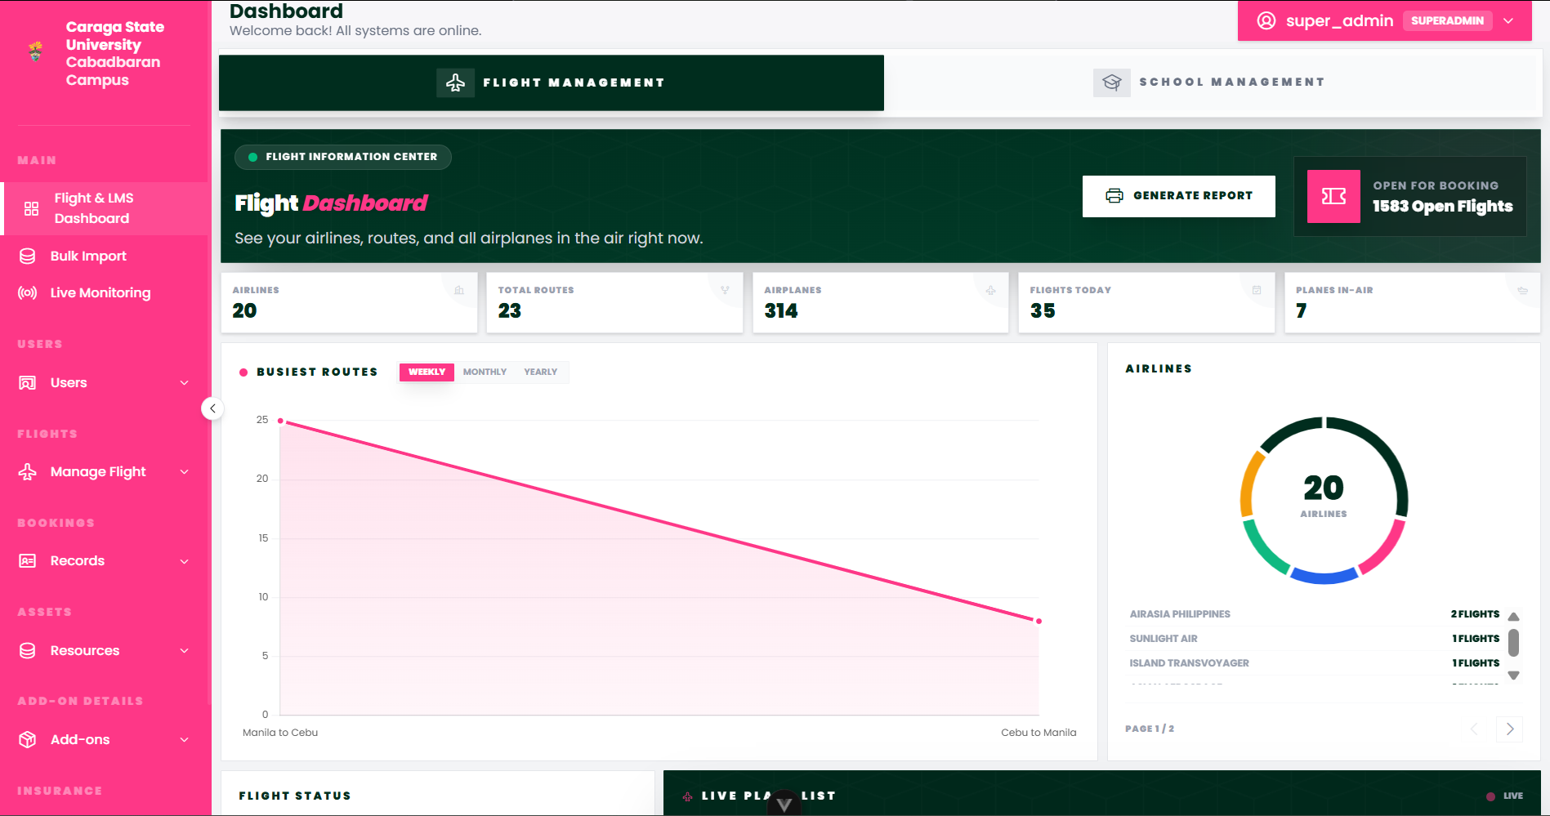
ADMIN SIDE OUTPUT

Figure 1 . Admin Flight Management Dashboard
The Admin Flight Management Dashboard offers a real-time operational overview through summary cards tracking key metrics such as total airlines, routes, airplanes, flights today, and planes in-air. A busiest routes chart and airline breakdown provide quick analytical insight, while the Live Plane List displays active flights with their current status. The left sidebar consolidates all administrative controls, enabling efficient management of the entire flight simulation system from a single interface.
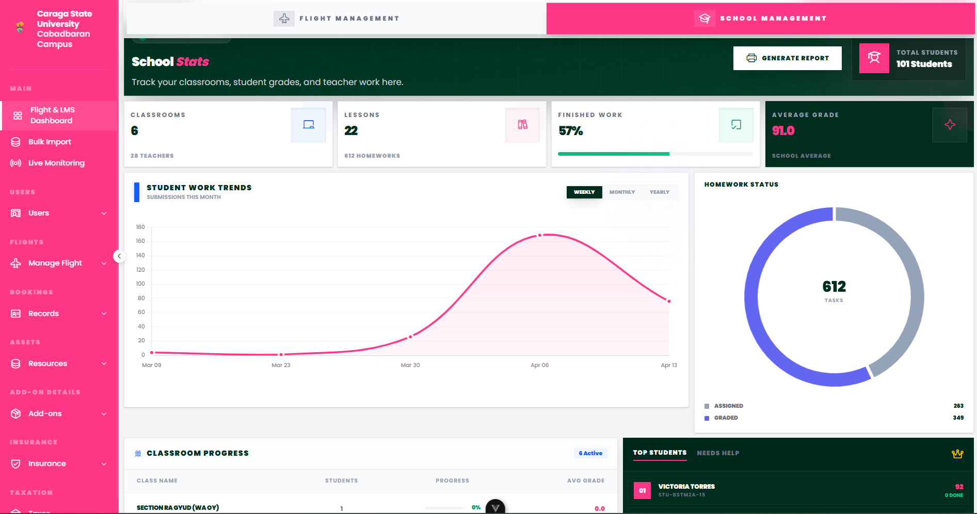
Figure 2. Admin School Management (LMS) Dashboard
The Admin School Management Dashboard provides a comprehensive view of academic performance and institutional health. It tracks key educational metrics including total students, active classrooms, and lessons completed, alongside real-time Student Work Trends and Homework Status analytics. The interface features a classroom progress leaderboard and a student-at-risk monitoring system, allowing administrators to oversee both teaching workloads and student achievements from a centralized portal.
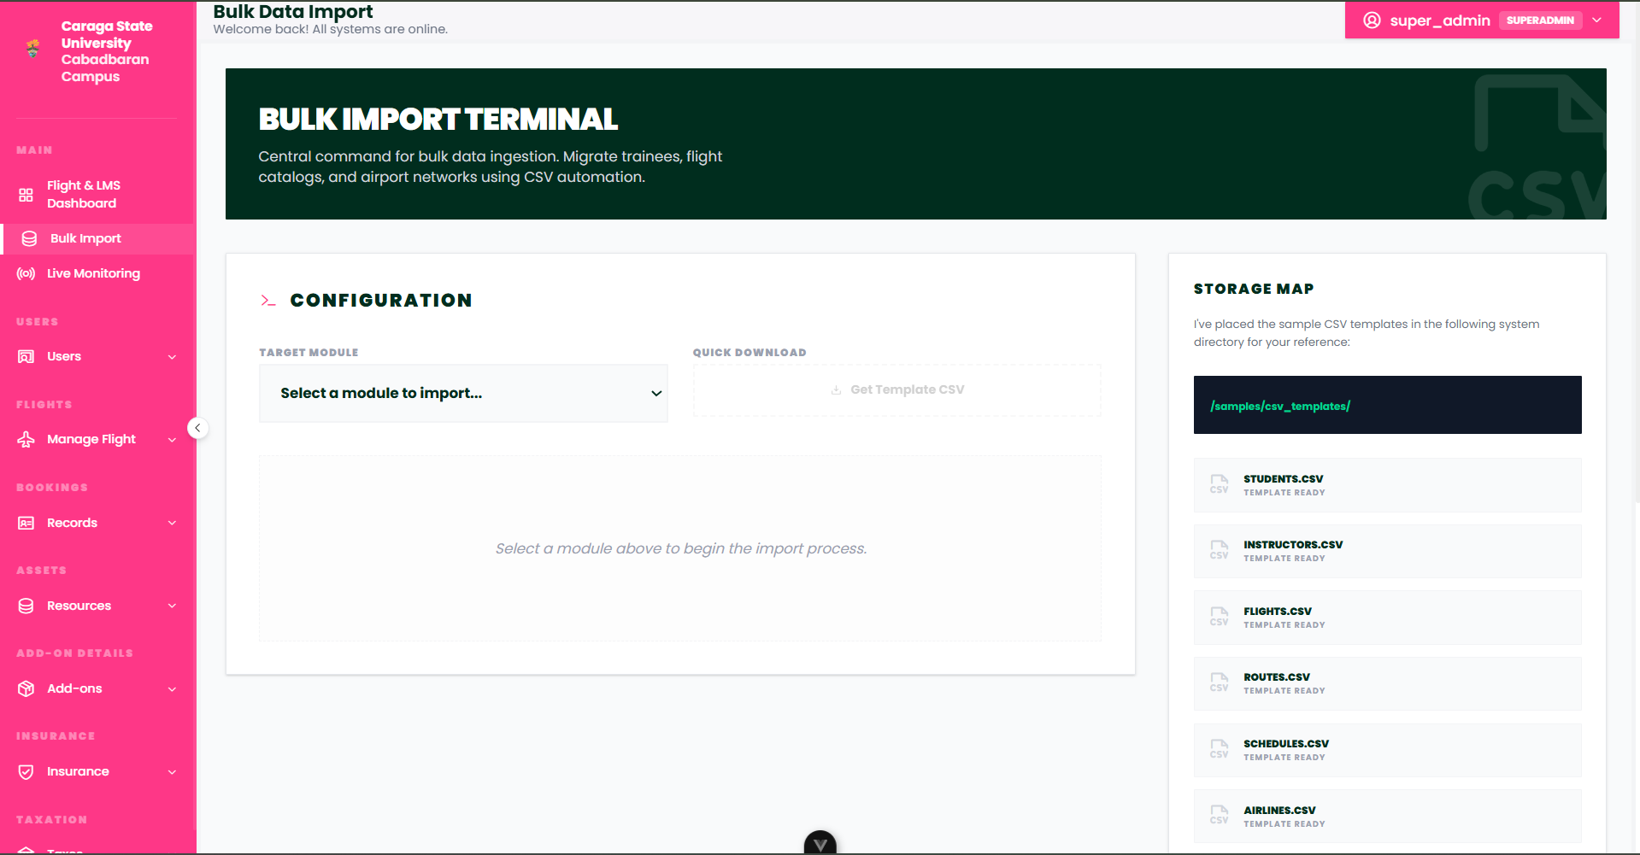
Figure 3. Bulk Data Management System
The Bulk Import Interface streamlines the population of the simulation environment by allowing administrators to upload large datasets via CSV or Excel. This tool automates the creation of flight profiles, passenger manifests, and asset registries, ensuring rapid system deployment and data consistency. It includes built-in validation logic to prevent duplicate entries and maintains the integrity of the flight reservation database during large-scale updates.
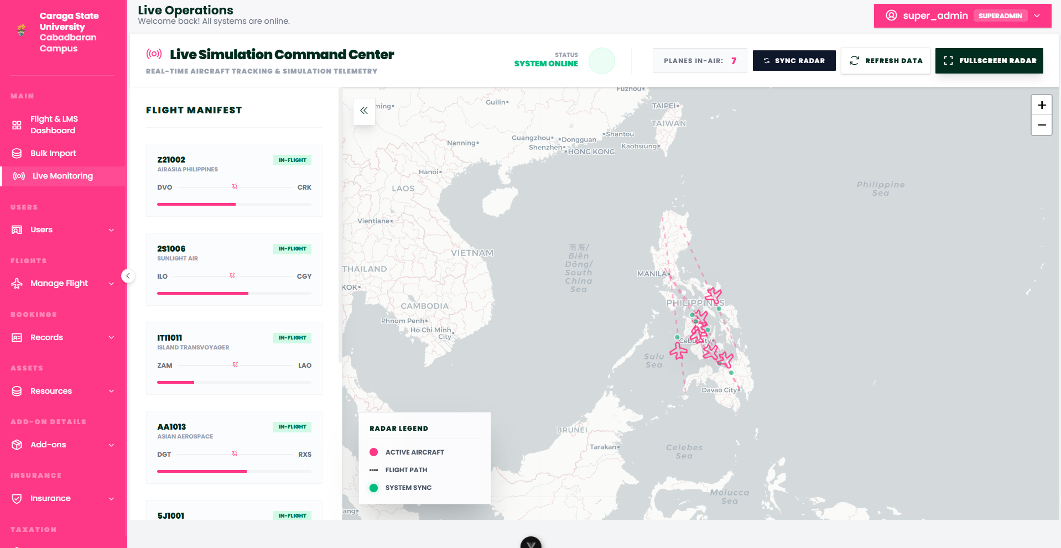
Figure 4. Live Flight Monitoring Interface
The Live Monitoring Interface serves as the system's "mission control," displaying a high-fidelity radar simulation of all active flights. It provides real-time telemetry including flight IDs, carrier information, and current route trajectories. This module allows administrators to audit live simulation activity, ensuring that flight paths and timings align with the global schedule while providing a visual representation of the system’s operational scale.
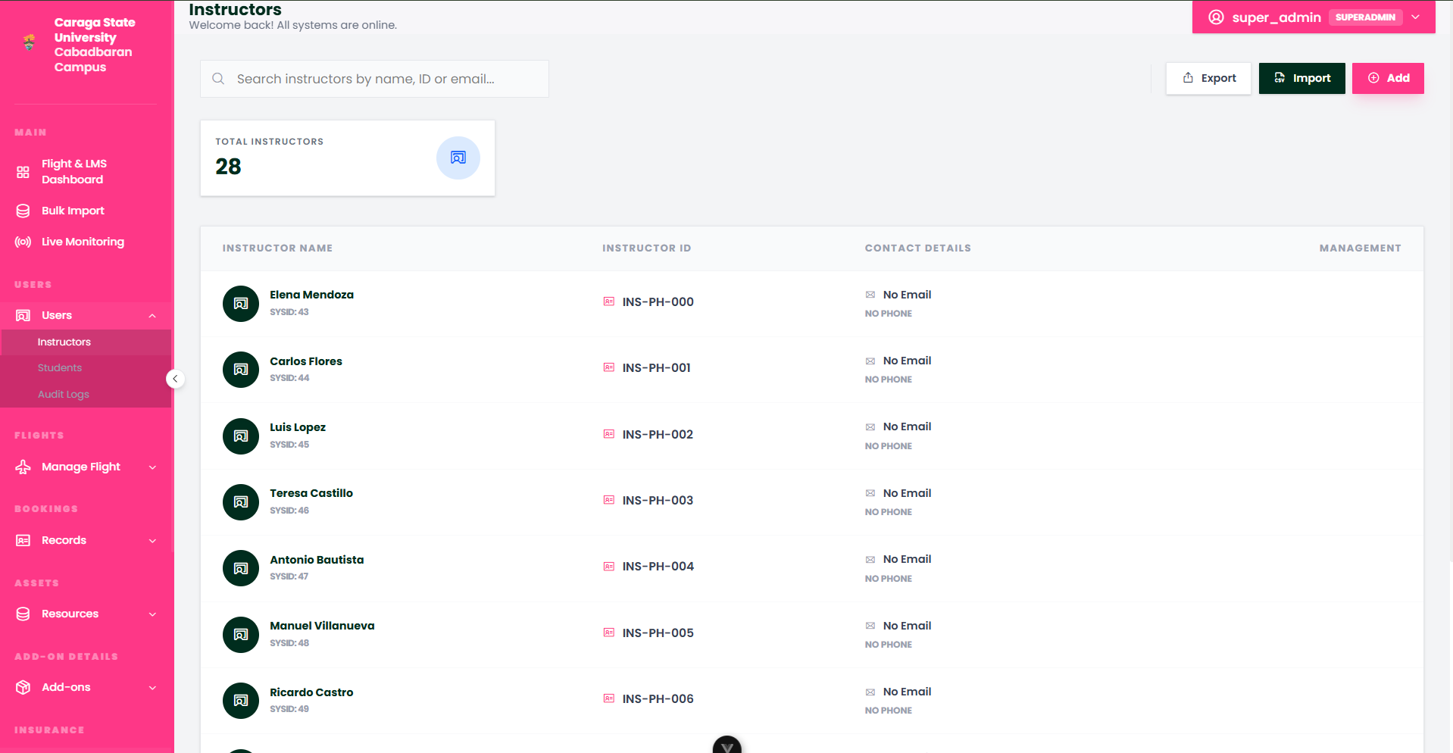
Figure 5. Instructor Management Interface
The Instructor Management module enables administrators to oversee the teaching faculty by managing instructor profiles, assigning teaching credentials, and monitoring instructional workloads. It provides a centralized view of all active educators, their assigned classroom sections, and their grading activity, ensuring that the human resource component of the flight training simulation is efficiently organized and accessible.
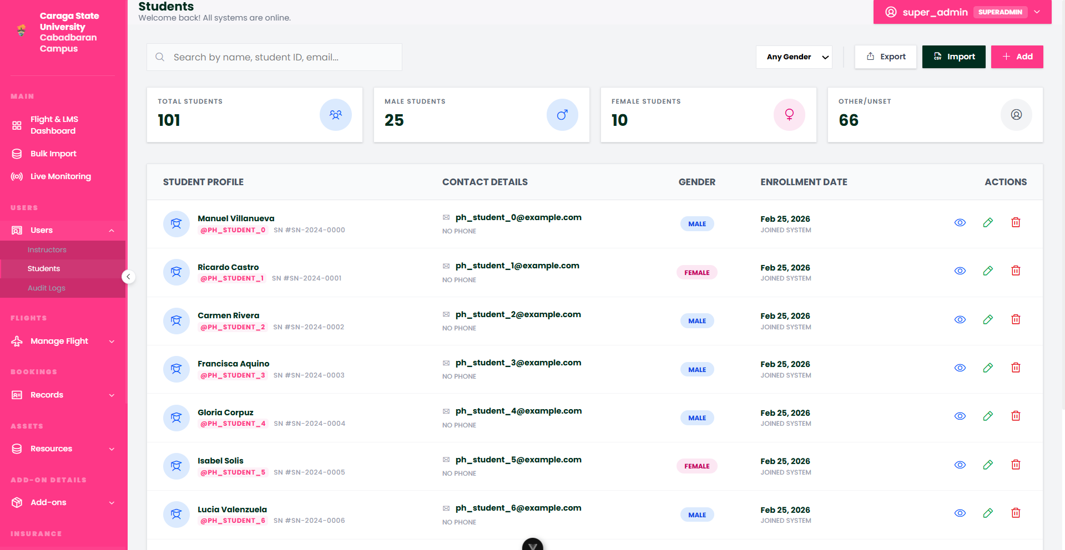
Figure 6. Student Registry and Profile Management
The Student Management module serves as the primary database for all enrolled trainees within the system. It allows for the tracking of student enrollment status, academic history, and individual progress through the flight simulation modules. Administrators can use this interface to manage student credentials and view detailed performance metrics, facilitating a personalized approach to aviation training and student support.

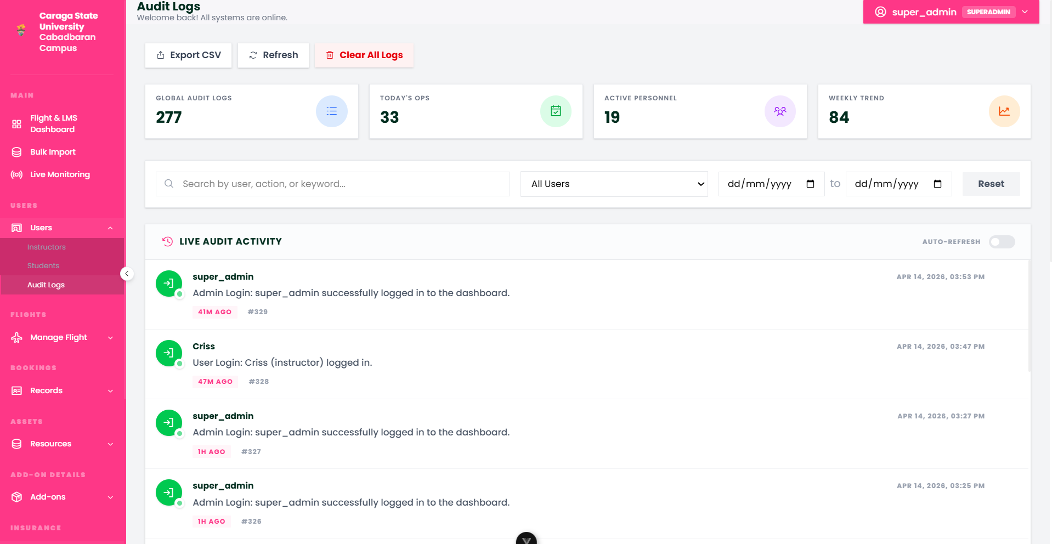
Figure 7. System Audit and Activity Logs
The Audit Logs interface provides a secure, chronological record of all significant actions taken within the platform, from data modifications to system configuration changes. By capturing user-specific activity and timestamps, this module ensures total system transparency and institutional accountability. It serves as a vital tool for auditing administrative workflows and maintaining the integrity of the flight reservation and learning management data.

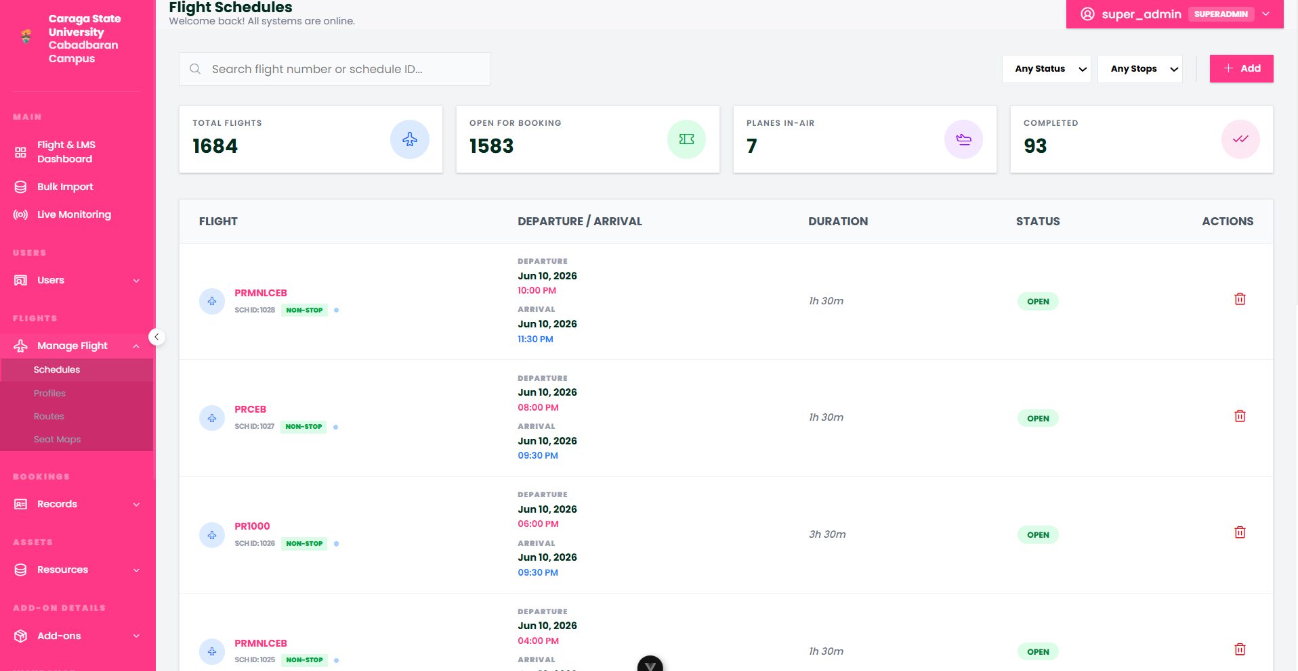
Figure 8. Flight Scheduling and Timing Control
The Schedules module allows administrators to define the temporal framework of the simulation by setting specific flight dates, departure times, and arrival windows. This interface enables the creation of recurring flight patterns and one-off scenarios, ensuring that the simulator's timeline is synchronized across both the booking system and the live monitoring modules for operational consistency.
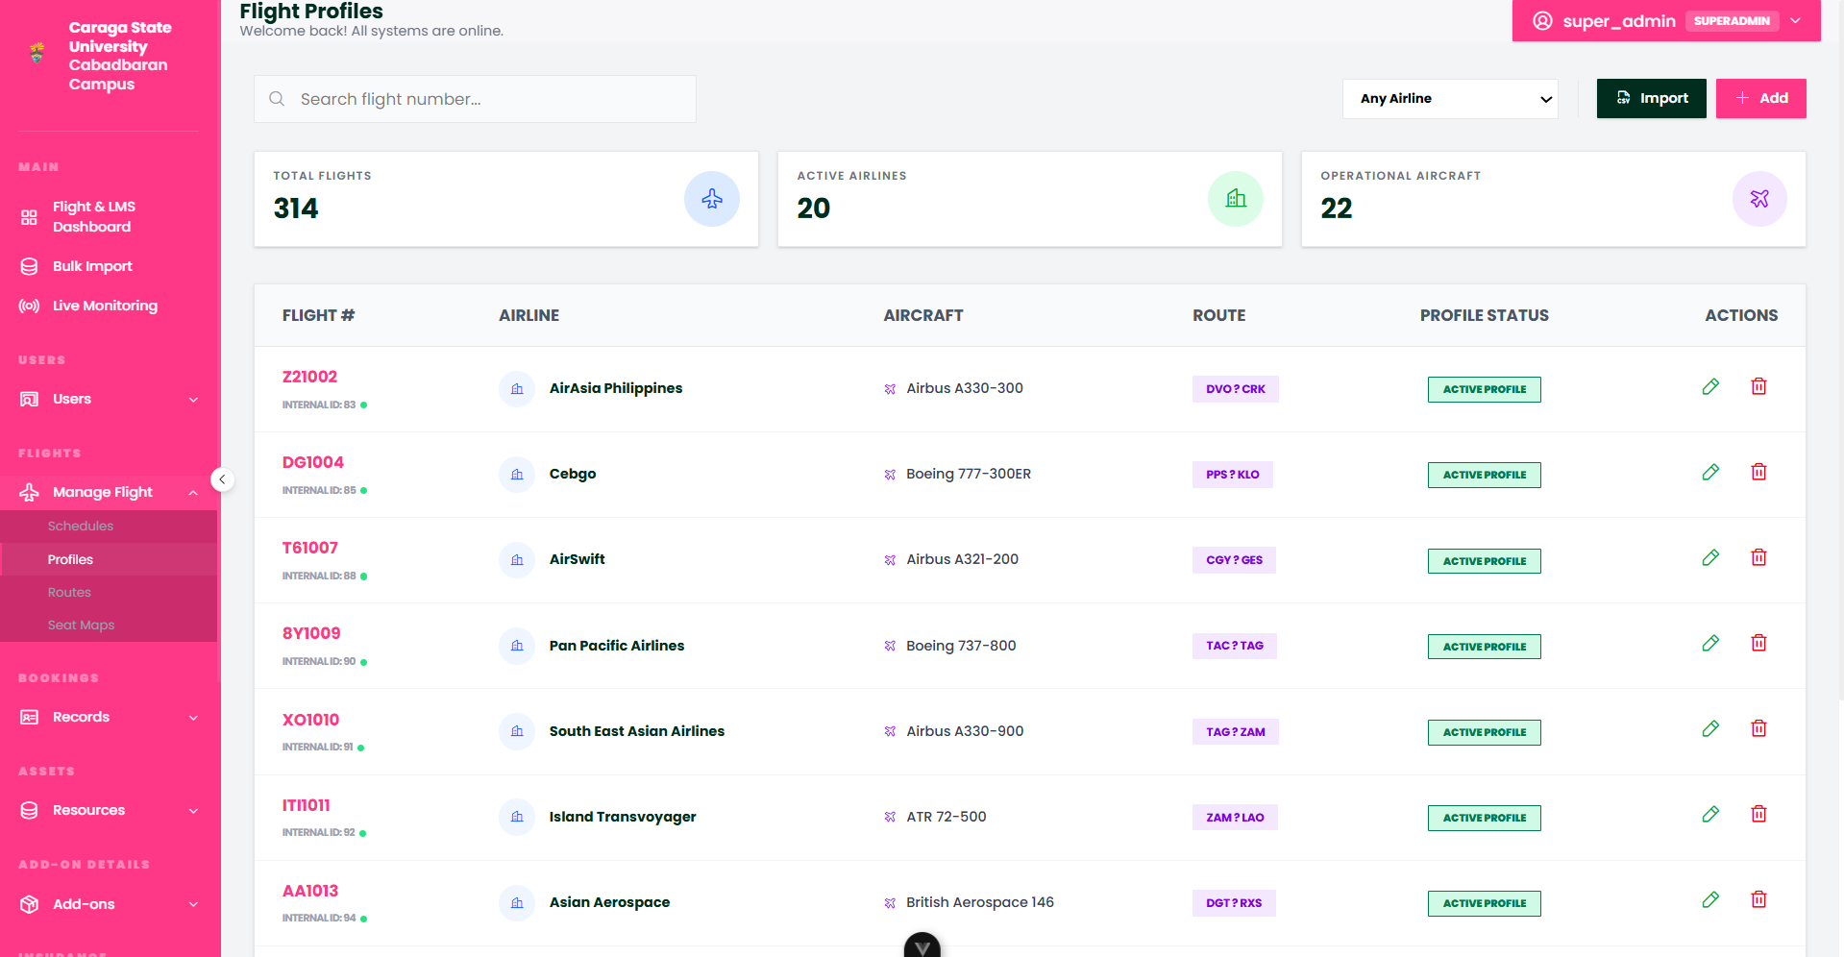
Figure 9. Flight Profile Configurations
The Flight Profiles module manages the technical templates for each flight in the system, linking specific aircraft types to their operational characteristics. By defining standard operating parameters for each flight "profile," administrators can ensure that every mission in the simulation follows established airline protocols, simplifying the creation of new flights by using pre-configured performance and service models.

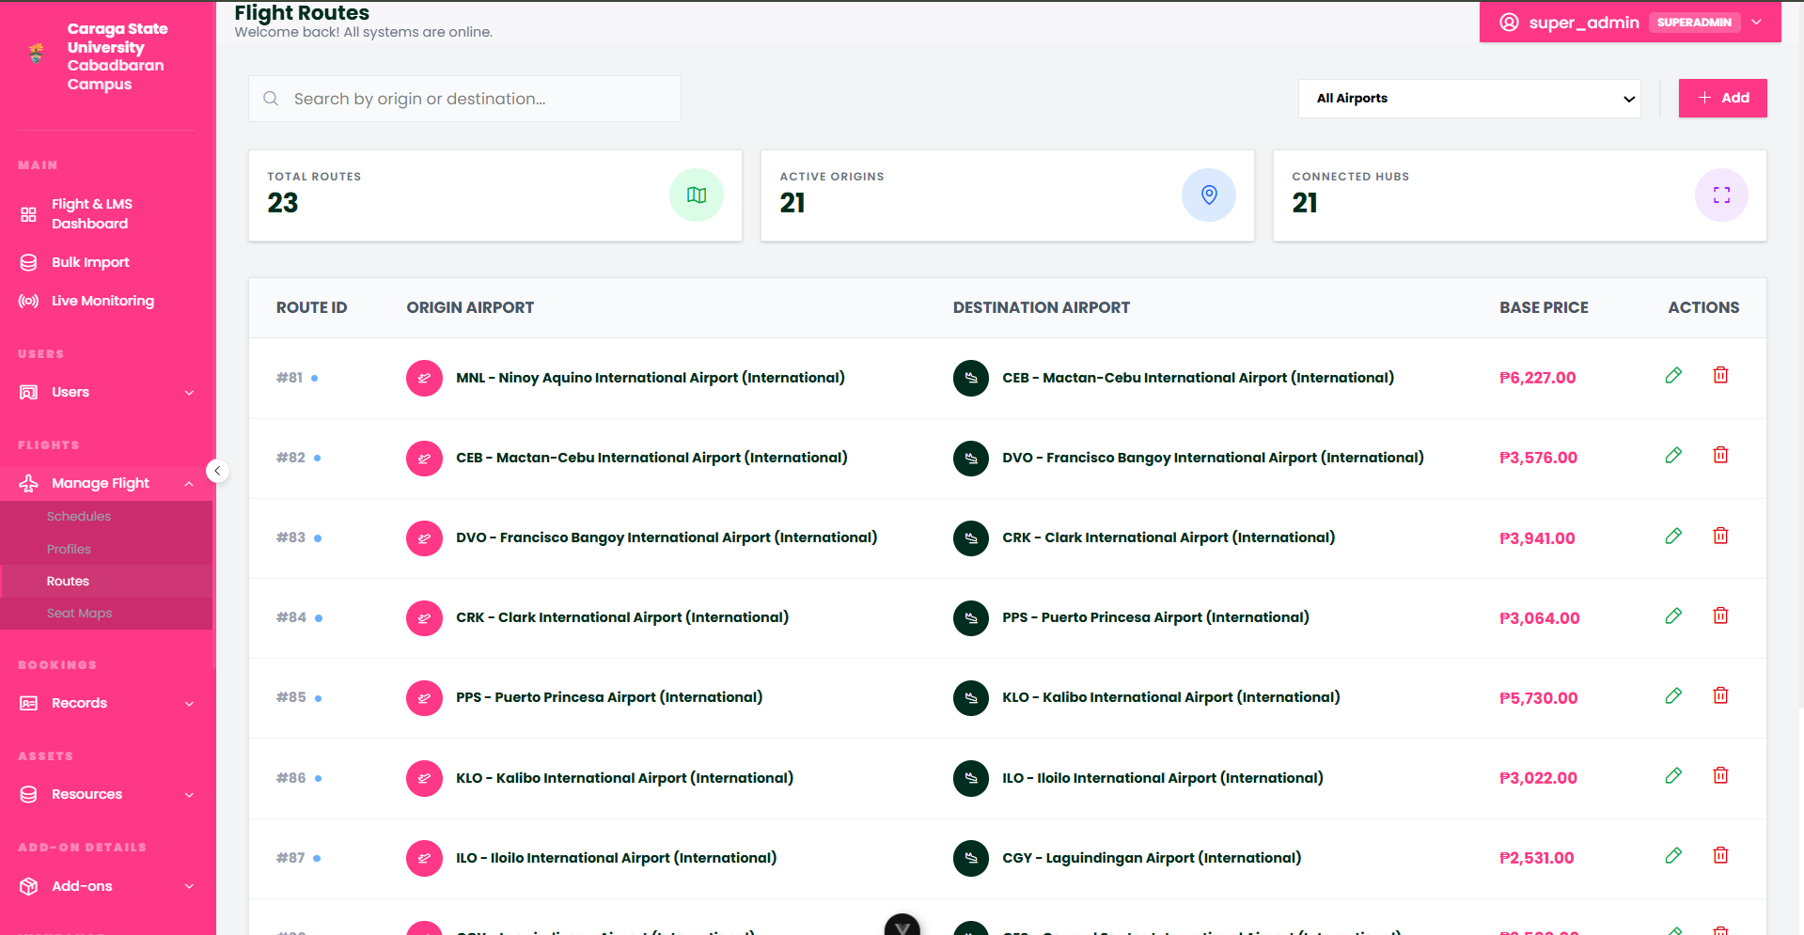
Figure 10. Route Network Management
The Routes module defines the geographical connectivity of the flight system, managing the origin and destination pairs across the airport network. It tracks key data points such as estimated flight durations, distances, and trajectory paths. This module serves as the backbone of the flight grid, allowing administrators to expand or restrict the simulation's operational reach by managing the available corridors of travel.

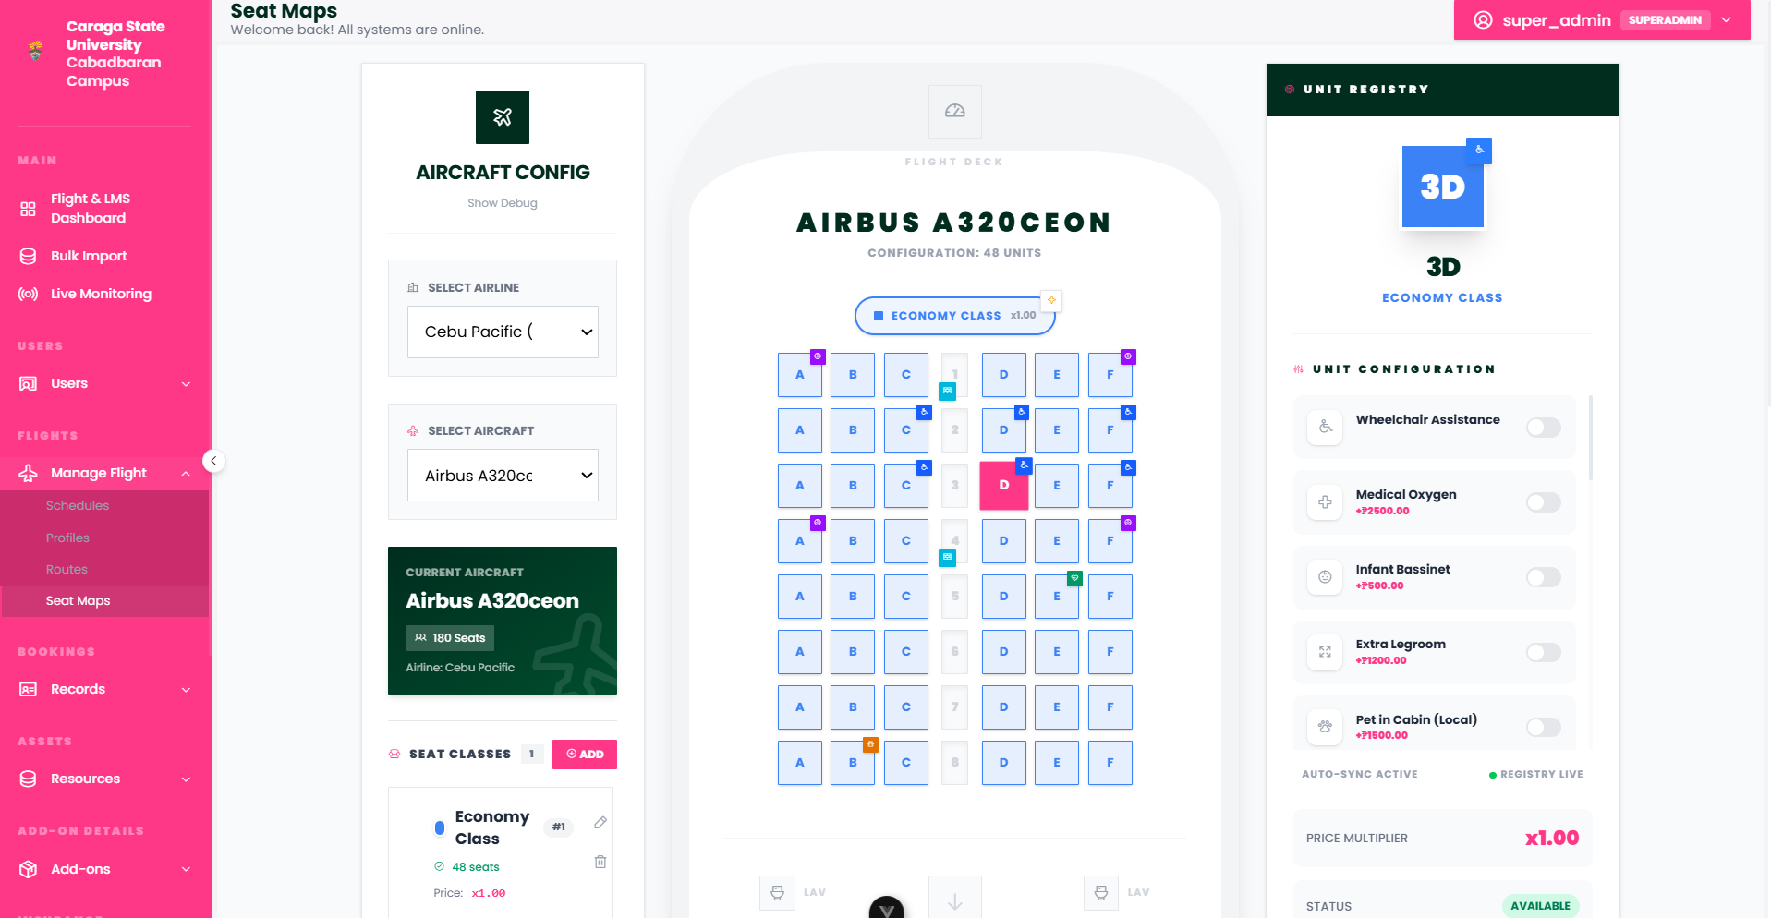
Figure 11. Aircraft Seat Map Configurations
The Seat Maps module provides a high-fidelity visual interface for configuring the internal layout of each aircraft in the fleet. Administrators can define seat classes (such as Economy, Premium, or Business), assign seat numbering, and establish layout orientations. This configuration directly influences the booking engine’s seat selection phase, ensuring that the physical limitations of the simulated aircraft are accurately reflected during the reservation process.
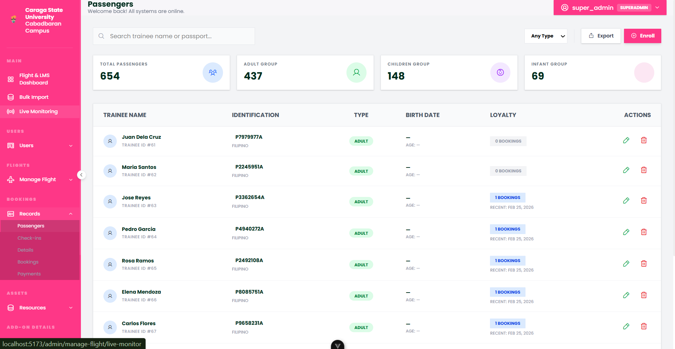
Figure 12. Passenger Manifest and Registry
The Passengers module serves as a comprehensive database of all travelers who have interacted with the simulation. It manages sensitive traveler information, including identity details and contact data, allowing administrators to audit the passenger list for any given flight. This centralized registry ensures that passenger data is consistently available for regulatory compliance and operational manifest generation.
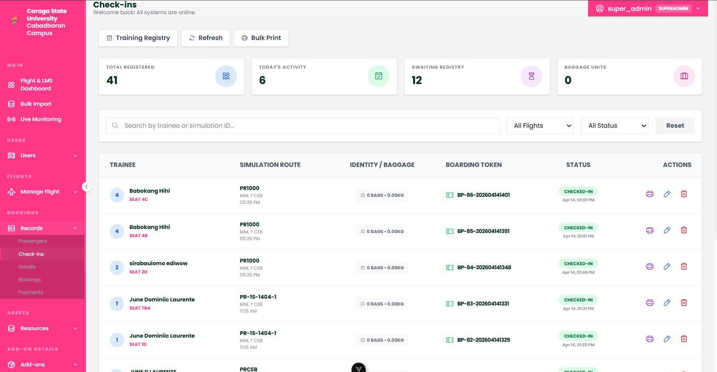
Figure 13. Real-Time Check-in Monitoring
The Check-ins module tracks the operational transition of passengers from confirmed bookings to boarded status. It provides real-time visibility into who has completed the online check-in process, their assigned seats, and their current boarding readiness. This data is critical for simulating gate operations and ensuring that flight manifests are finalized before the simulated departure.
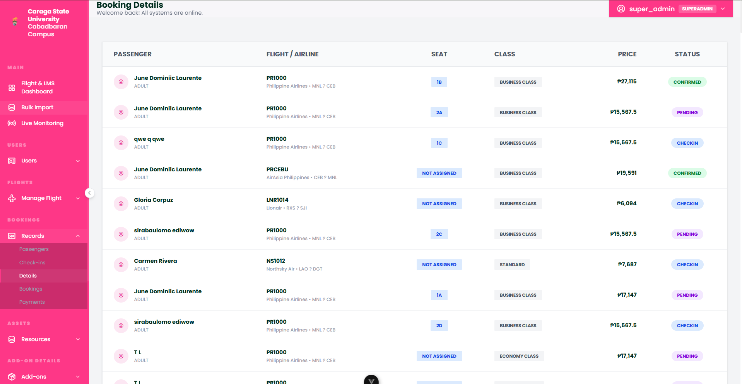
Figure 14. Transactional Booking Records
The Bookings module acts as the primary ledger for all flight reservations made within the system. It offers a searchable list of every transaction, detailing the booking reference numbers, passenger counts, and overall reservation status (such as "Confirmed" or "Cancelled"). This interface allows administrators to manage the lifecycle of a reservation and handle bulk booking audits.
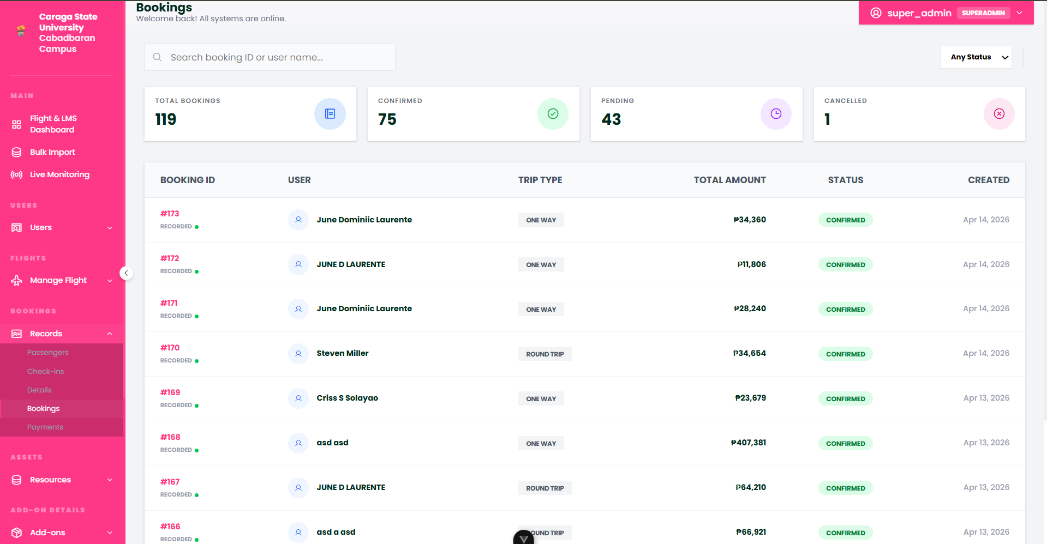
Figure 15. Detailed Booking Analytics and Logistics
The Booking Details module provides a granular breakdown of individual reservations, including selected add-ons, seat preferences, and traveler special requests. This view consolidates all logistical data associated with a single booking reference, enabling administrators to resolve specific traveler inquiries or modify complex reservation parameters that are beyond the standard booking list.
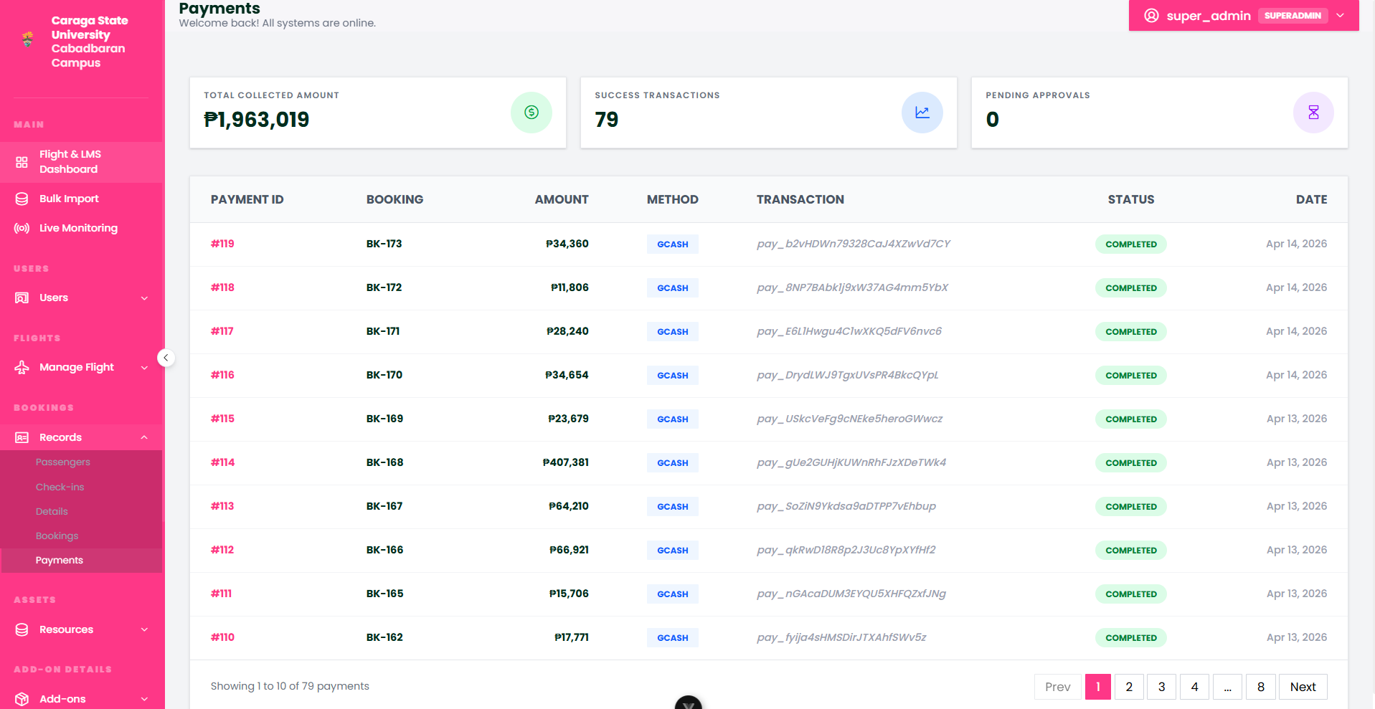
Figure 16. Financial Transaction and Payment Registry
The Payments module is the financial command center of the platform, recording every monetary transaction processed through the booking engine. It tracks payment statuses, transaction IDs, and settlement methods, providing administrators with a clear audit trail for revenue management. This module ensures that all simulated financial interactions are accurately recorded for institutional reporting and fiscal oversight.
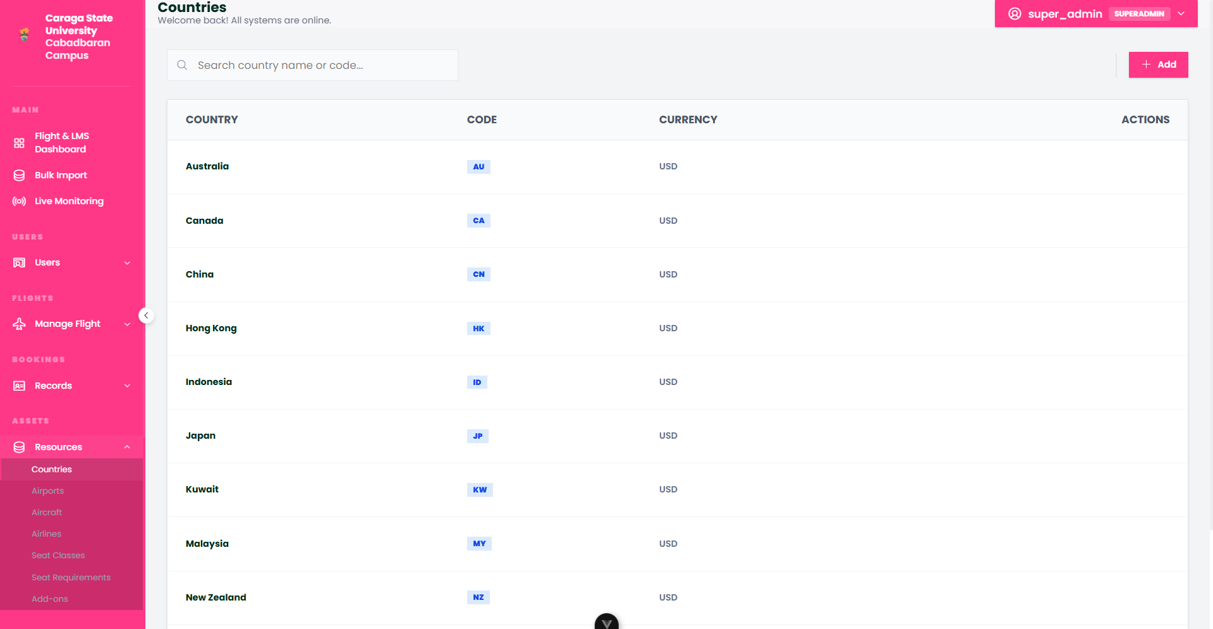
Figure 17. Domestic Region and Country Registry
The Countries module defines the primary geographical territory of the platform, focusing on the domestic regions and provinces available for travel within the simulation. This registry serves as the foundational data layer for local tax scales, provincial settings, and regional airport localization, ensuring that the simulation maintains accurate and consistent standards for domestic aviation geography.
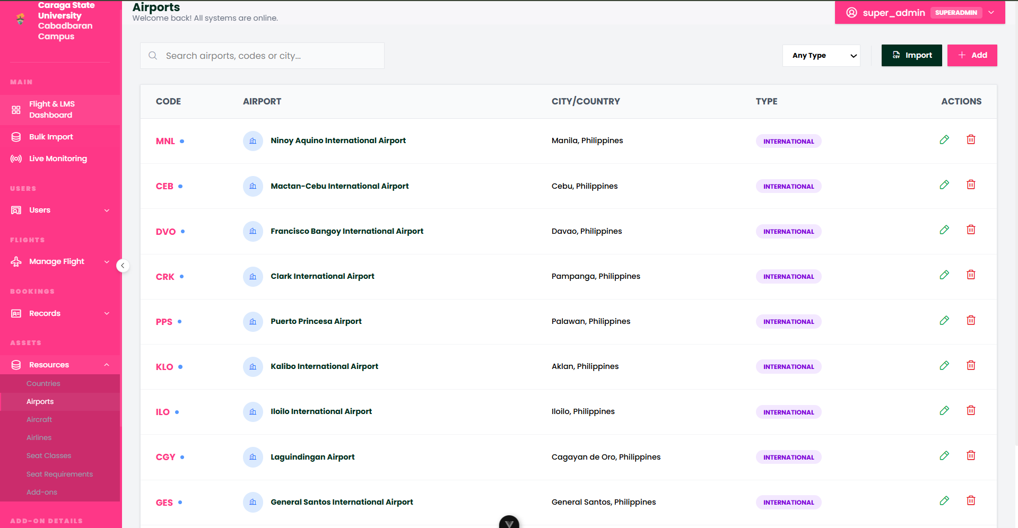Figure 18. Airport Infrastructure Management
The Airports module manages the specific operational nodes within the flight network, storing critical data such as IATA codes, city locations, and geographic coordinates. This interface allows administrators to scale the simulation's reach by adding new destination hubs and configuring the technical details of every terminal in the operational grid.
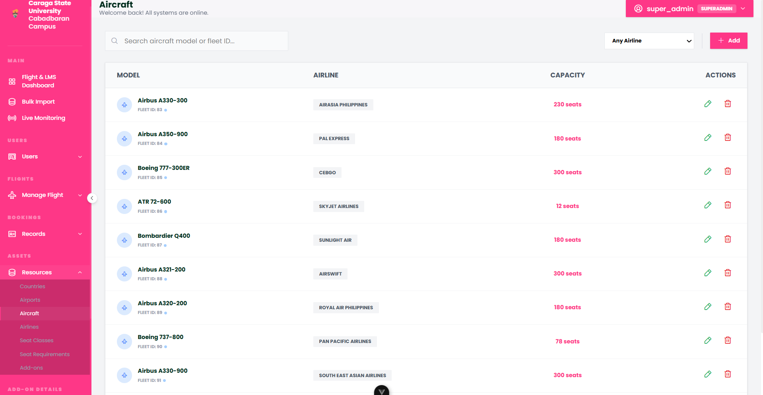
Figure 19. Aircraft Fleet Registry
The Aircraft module acts as the physical asset inventory for the system, cataloging every plane in the simulated fleet. It tracks specific aircraft models, tail numbers, and overall passenger capacities. This module ensures that all flights are assigned to viable physical assets, maintaining the link between the flight schedule and the available technical hardware.
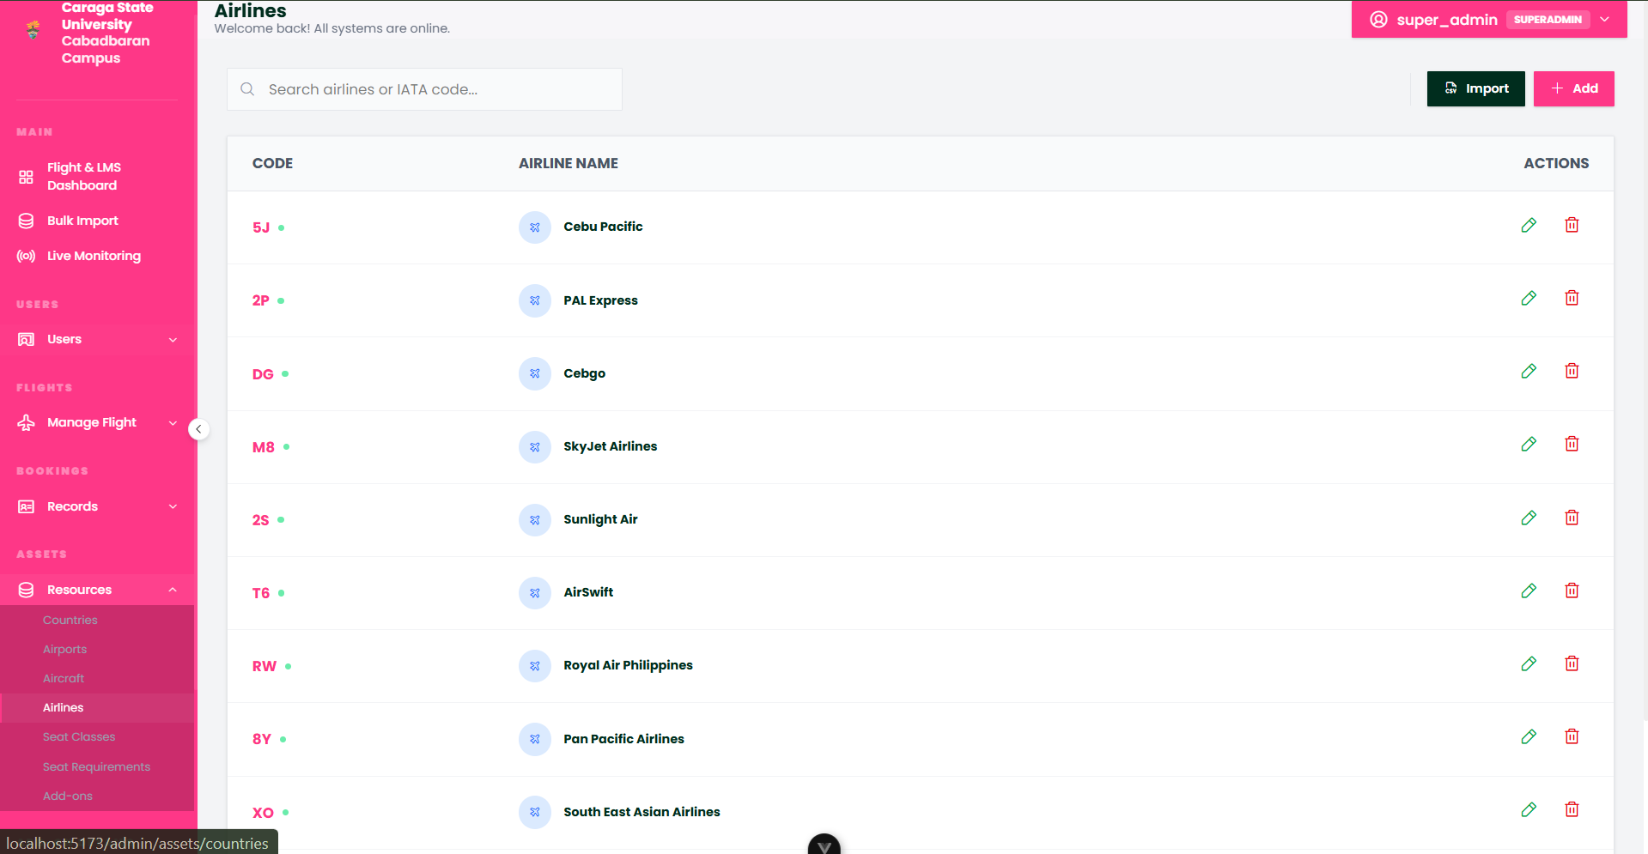
Figure 20. Airline Carrier Profiles
The Airlines module manages the identity and branding of the various carriers operating within the simulation. Administrators can use this interface to define airline names, codes, and logo assets, providing a multi-carrier environment where students can manage competing or codeshare airline scenarios.

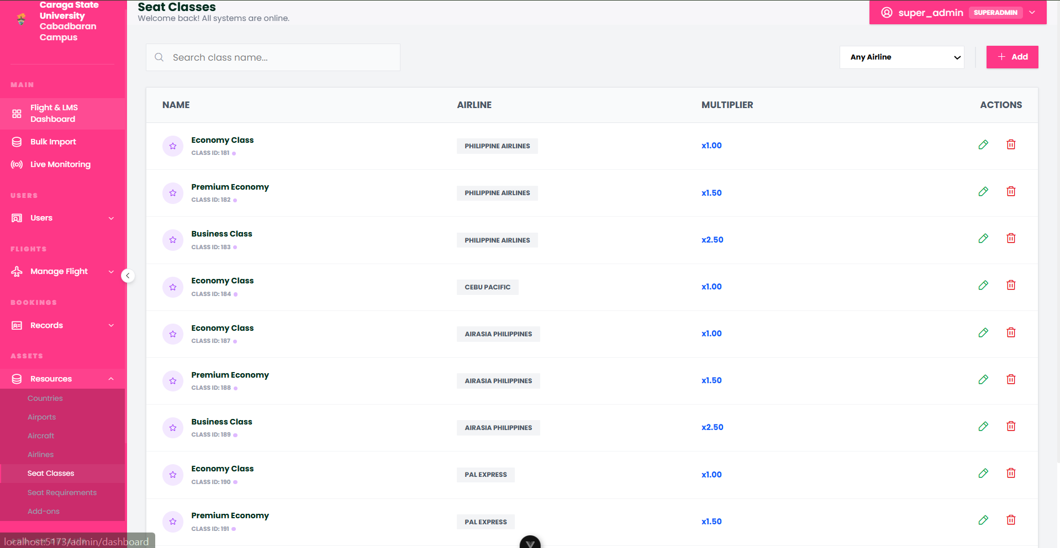
Figure 21. Service Tier and Seat Class Definitions
The Seat Classes module defines the tiers of service available on each flight, such as Economy, Premium, and Business classes. This module allows administrators to set the pricing multipliers and service standards associated with each tier, which directly influences the value proposition offered to simulated passengers during the booking flow.
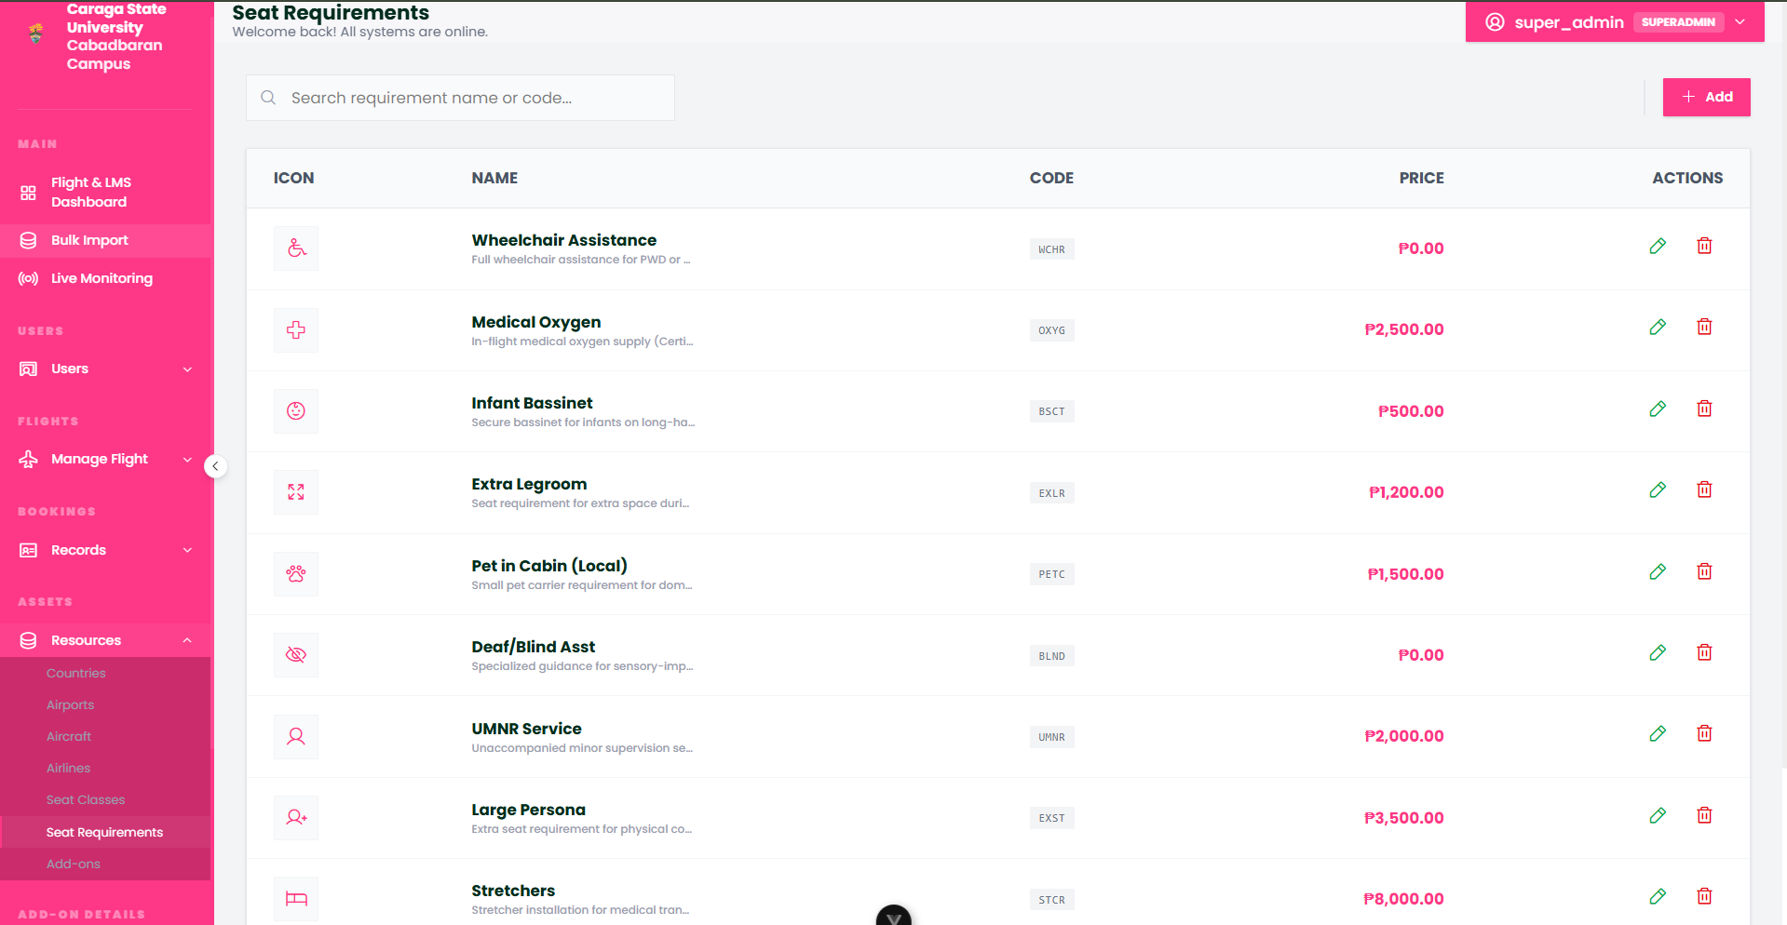
Figure 22. Technical Seat Requirements
The Seat Requirements module manages the specific rules and technical constraints associated with cabin seating, such as exit row restrictions, weight limits, or accessibility requirements. By defining these parameters, administrators can ensure that the simulation enforces realistic safety and operational protocols during the automated or manual seat assignment phase.
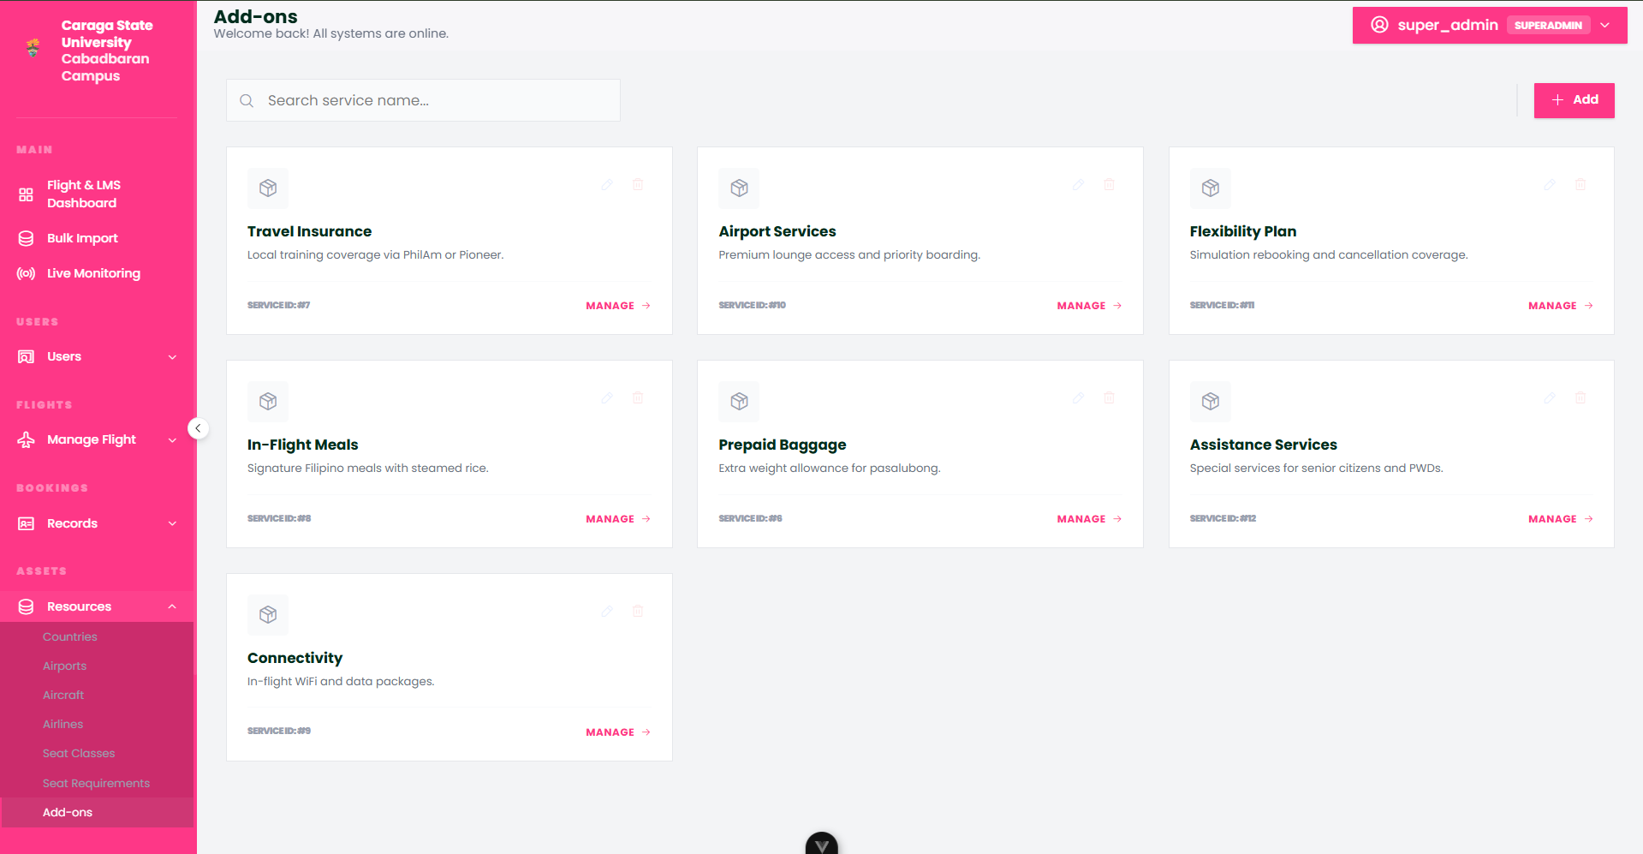
Figure 23. Ancillary Services and Add-ons Registry
The Add-ons module is the central catalog for all ancillary products and services available for purchase, such as priority boarding, in-flight connectivity, or sports equipment handling. This interface allows for the management of the various "extras" that contribute to the simulation's revenue management objectives, allowing for a realistic assessment of non-ticket revenue streams.
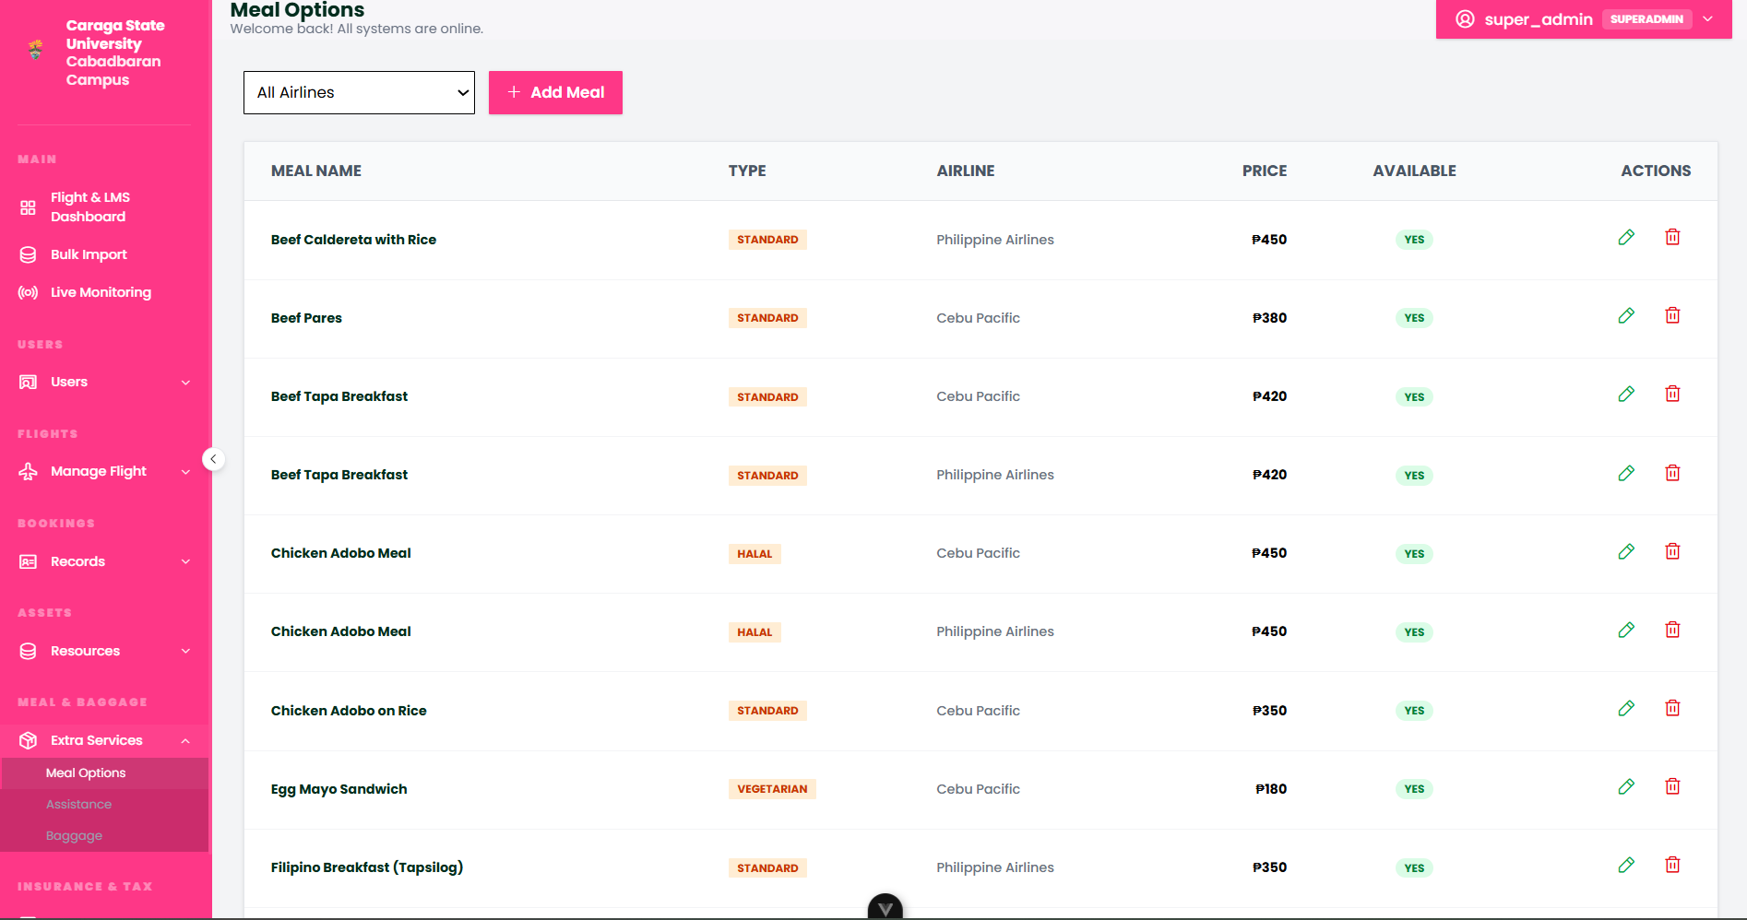
Figure 24. In-flight Catering and Meal Options
The Meal Options module manages the digital menu for in-flight catering services, allowing administrators to define various dietary tiers and specific food offerings. This interface enables the simulation of onboard services by tracking meal preferences linked to passenger records, ensuring that the catering logistics of the flight are accurately reflected in the reservation data.
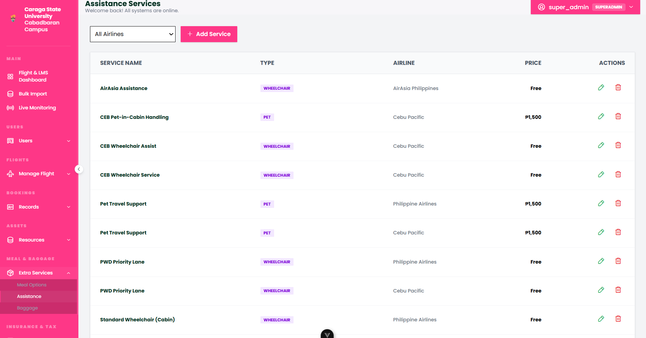
Figure 25. Special Assistance and Accessibility Services
The Assistance module defines the framework for passenger special requests, such as wheelchair accessibility, medical support, or unaccompanied minor services. This interface ensures that the simulation accounts for the diverse needs of travelers, allowing administrators to monitor and manage the deployment of specialized ground and cabin resources for passengers requiring extra care.
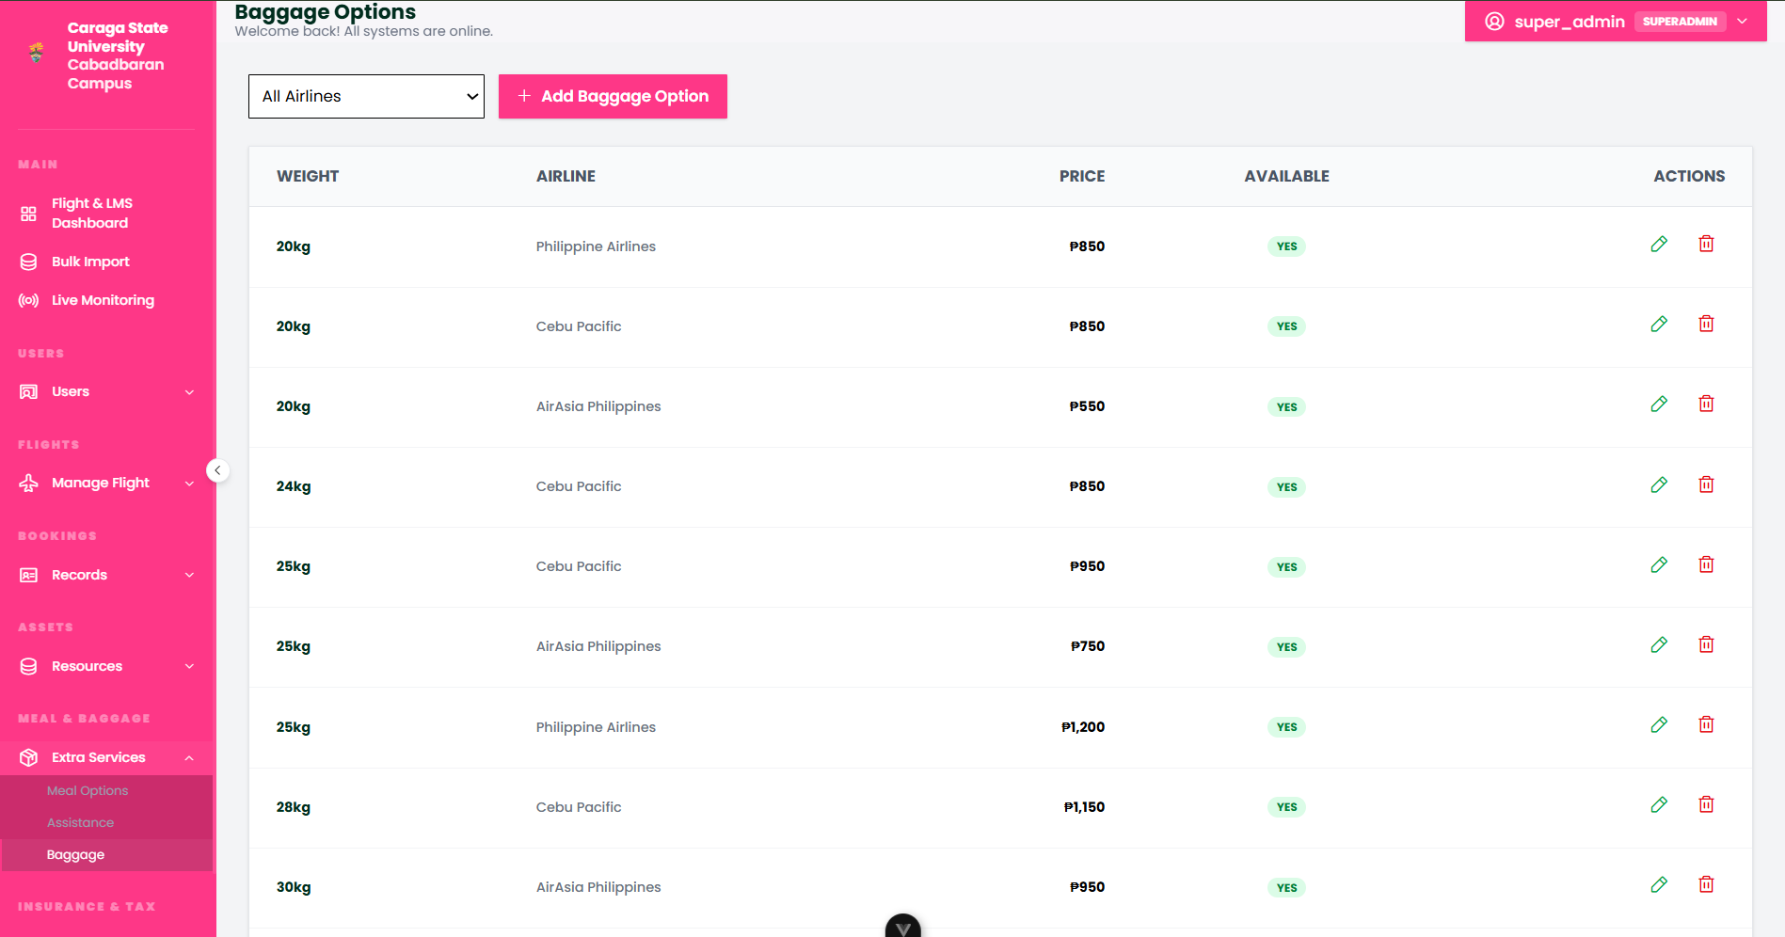
Figure 26. Baggage Allowance and Logistics Management
The Baggage module serves as the primary tool for configuring luggage policies, including weight tiers, piece counts, and excess baggage fees. By establishing these parameters, administrators can simulate the complex revenue and logistical models associated with baggage handling, ensuring that the physical constraints and financial opportunities of cargo management are integrated into the core booking engine.
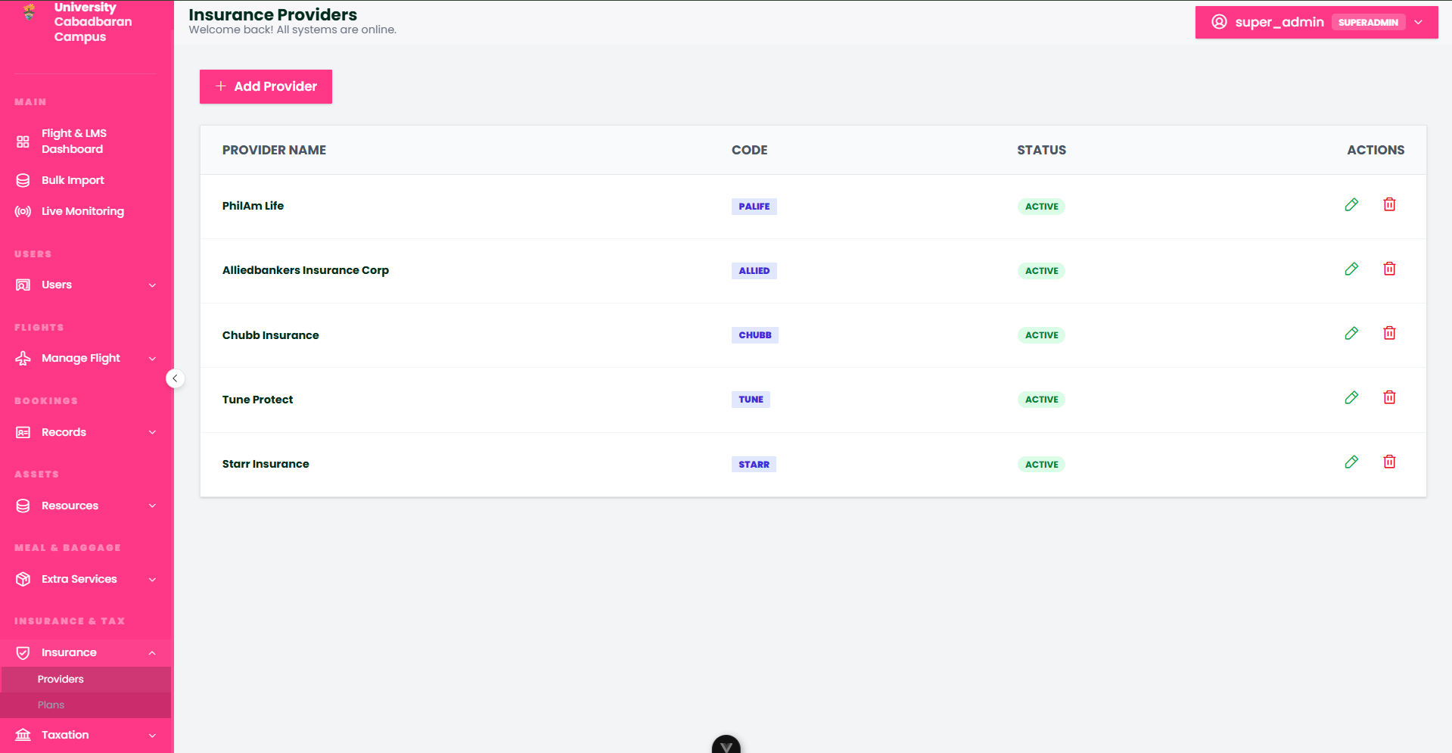
Figure 27. Insurance Providers and Partnerships
The Providers module manages the registry of third-party insurance companies integrated into the platform. This interface allows administrators to track partner information and manage the relationships with various underwriters, ensuring that the ancillary insurance offerings available to passengers are linked to valid and active service providers.
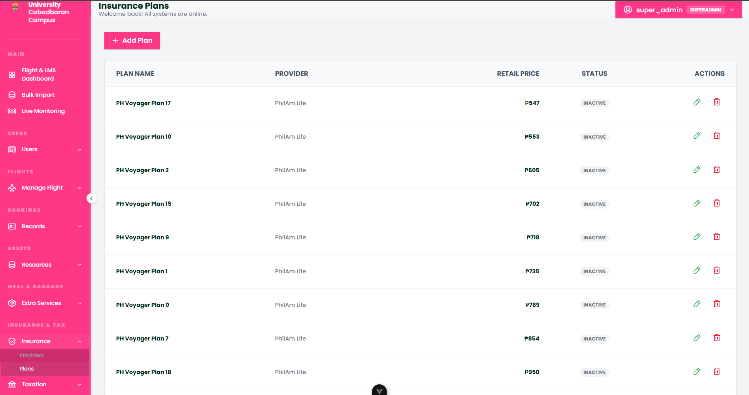
Figure 28. Travel Insurance Plans and Coverage
The Plans module defines the specific insurance products available for purchase during the booking process, including coverage limits, terms of service, and pricing models. Administrators can configure various plan tiers (such as Basic Travel or Comprehensive Protection) to simulate the distribution of insurance products, adding another layer of realistic revenue management and passenger risk mitigation to the simulation.
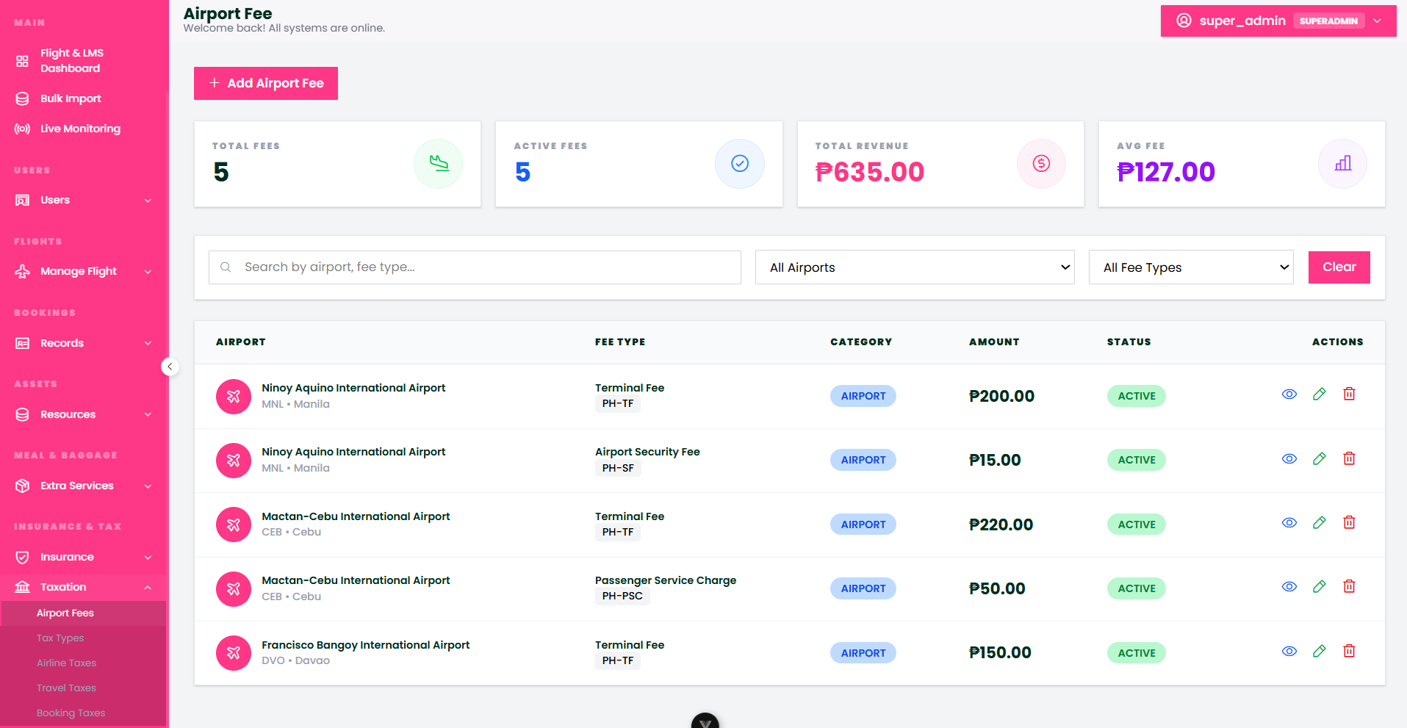
Figure 29. Airport Fees and Facility Levies
The Airport Fees module manages the specific levies associated with each node in the travel network, such as terminal fees and ground handling surcharges. By configuring these location-based costs, administrators ensure that the final ticket price accurately reflects the operational overhead of the specific departure and arrival airports selected in the booking.
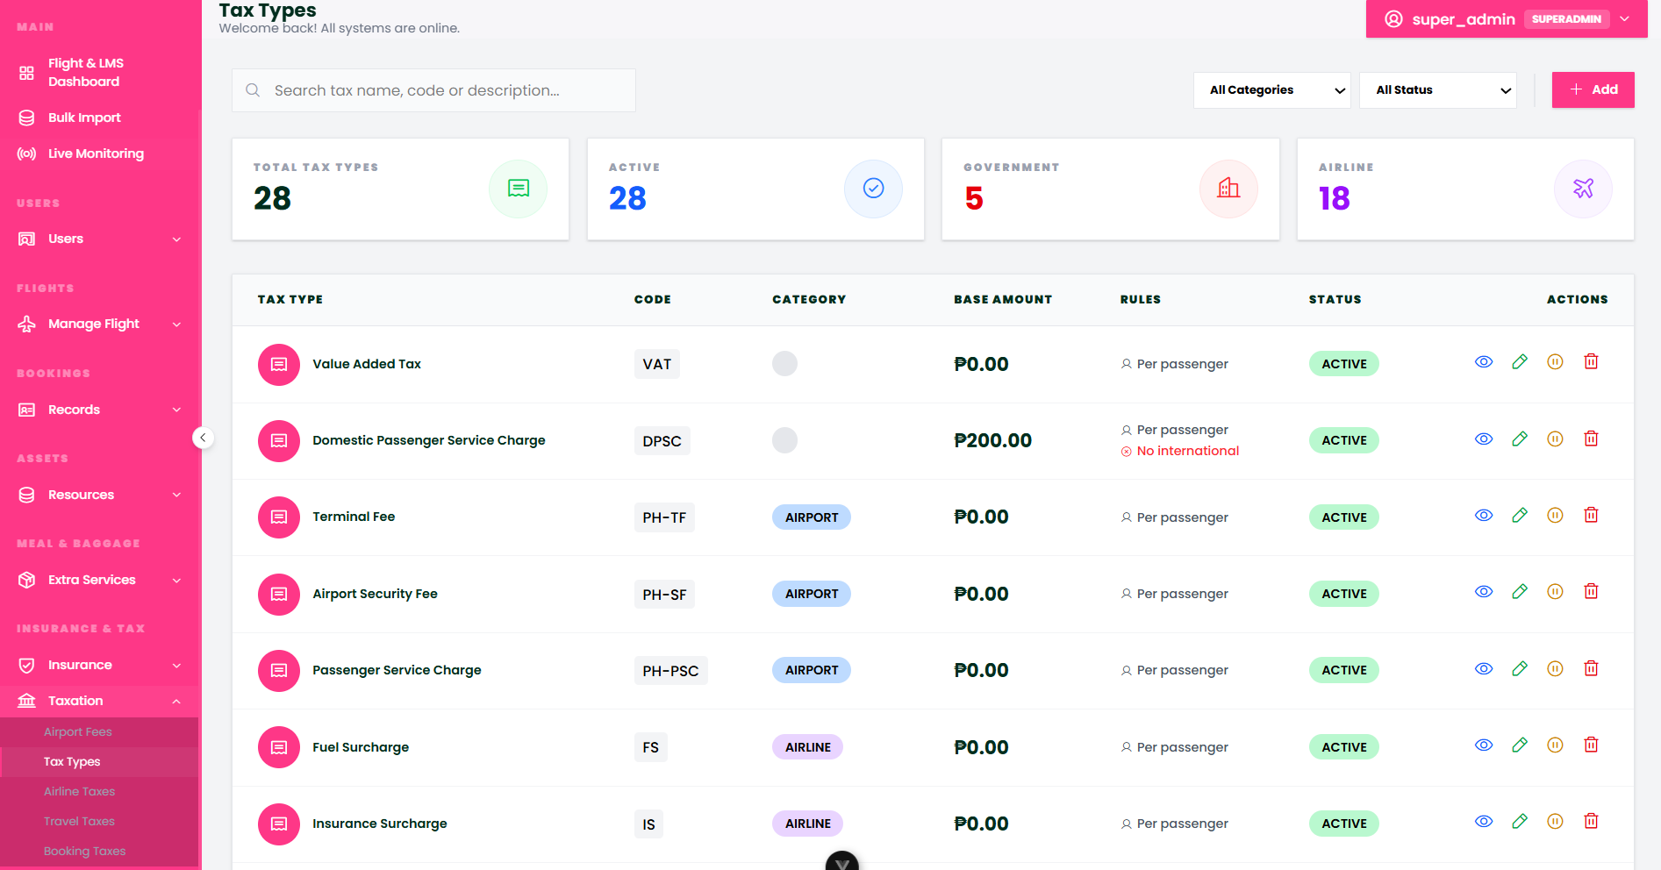
Figure 30. Unified Tax Type Registry
The Tax Types module serves as the central classification system for all fiscal categories within the platform, including VAT, excise taxes, and service levies. This registry allows for the standardized definition of tax behaviors and calculation methods, which are then applied across various levels of the flight transaction to maintain consistent accounting.
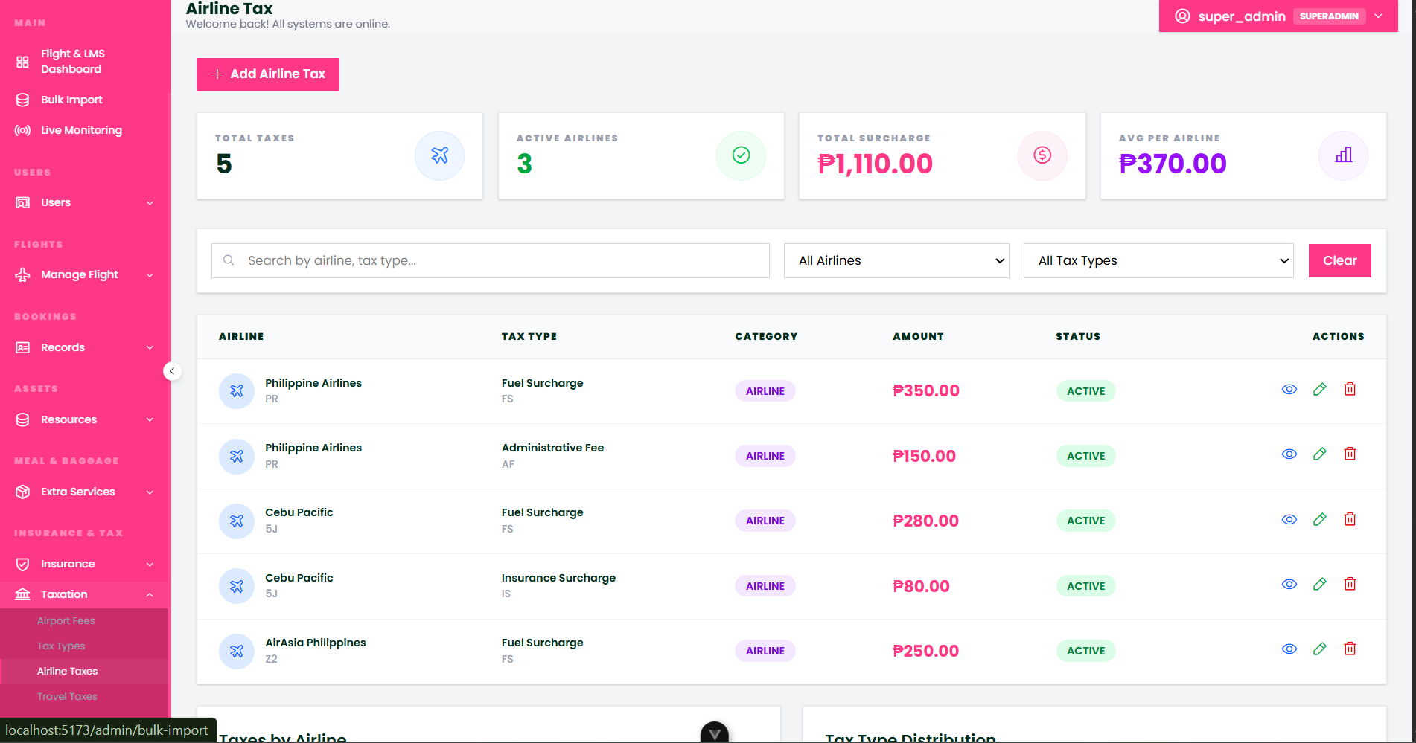
Figure 31. Airline-Specific Surcharges and Taxes
The Airline Taxes module manages the carrier-specific fees and government taxes that are applied at the airline level. This interface allows administrators to simulate different fiscal environments for various airlines, accounting for carrier-exclusive surcharges that influence the competitive pricing of the flight profiles.
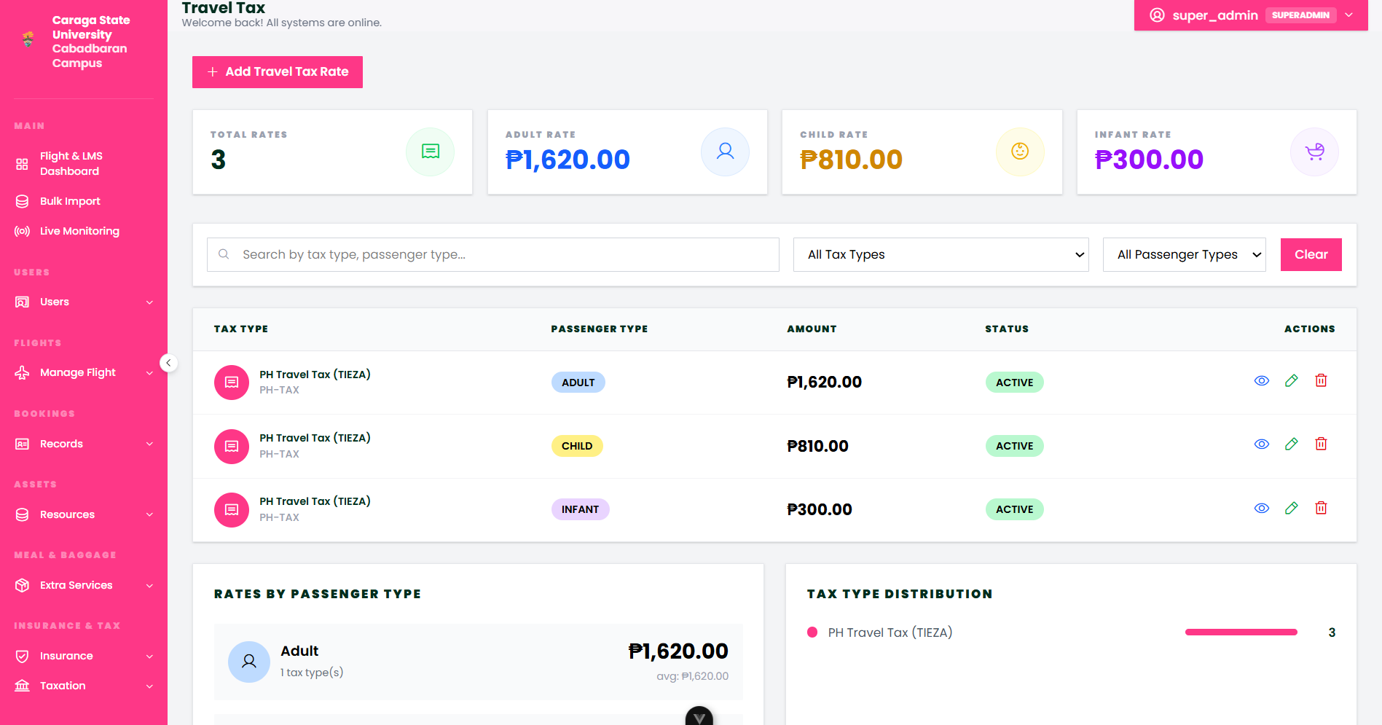
Figure 32. National and International Travel Taxes
The Travel Taxes module handles government-mandated taxes applied to individual travelers, such as international departure taxes or regional passenger levies. This module ensures that the simulation adheres to regulatory fiscal requirements, providing a realistic breakdown of the non-airline costs that contribute to the total travel budget.
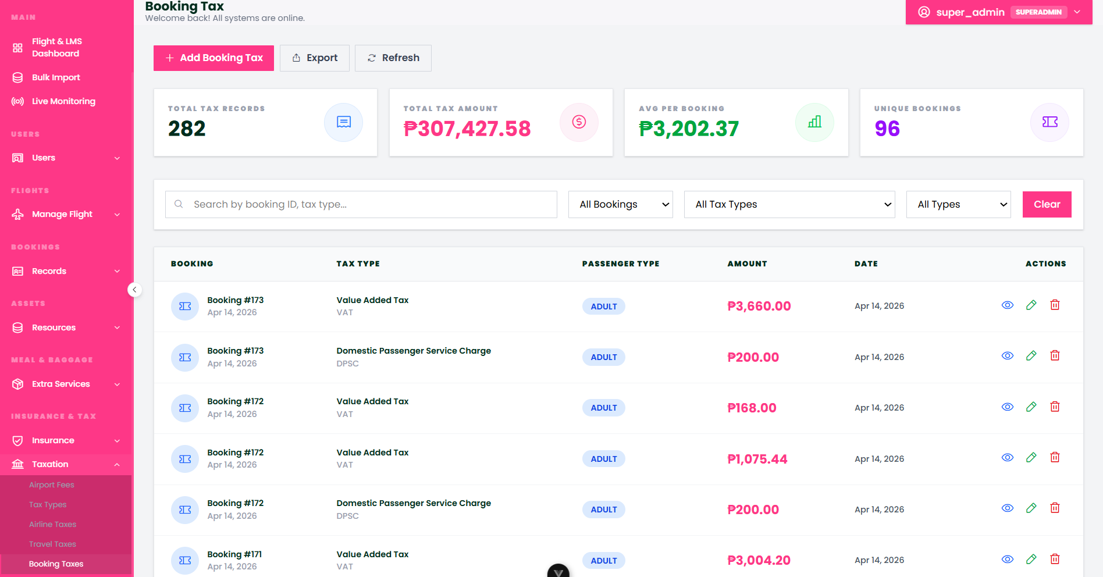
Figure 33. Global Booking and Transactional Taxes
The Booking Taxes module manages the general fiscal levies applied to the total reservation value, such as processing taxes or platform service fees. This final layer of taxation ensures that the comprehensive cost of the booking is captured, providing a high-fidelity representation of the financial checkout process in a commercial aviation environment.

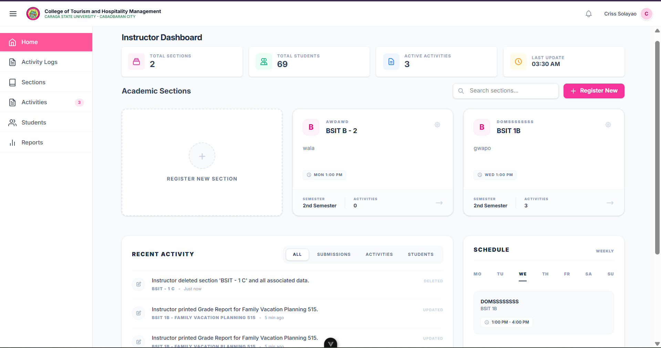

Figure 1. Instructor Dashboard
The Instructor Dashboard serves as a centralized hub that provides an immediate overview of teaching workloads through real-time summary cards tracking sections, students, and active flight simulations. The main interface streamlines administration by displaying detailed class lists alongside a "Register New Section" button for quick updates, while a Recent Activity feed at the bottom logs all system actions for easy auditing. To ensure efficient time management, a dedicated weekly schedule panel on the right highlights the current day's classes, keeping instructors aligned with their teaching timetable.

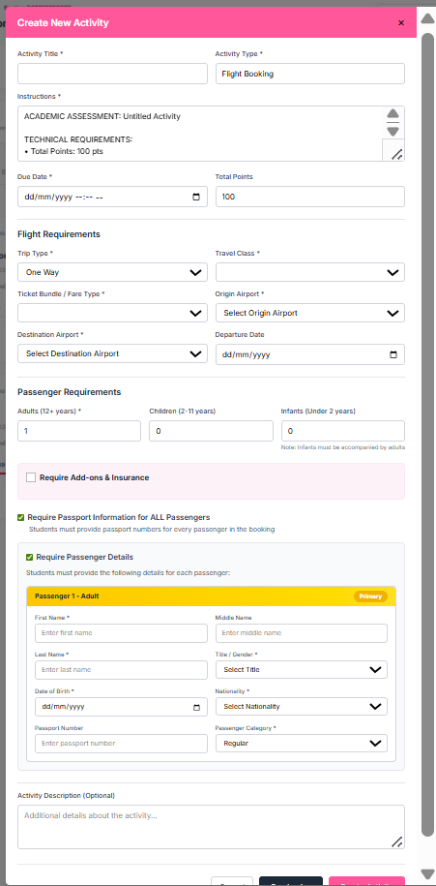
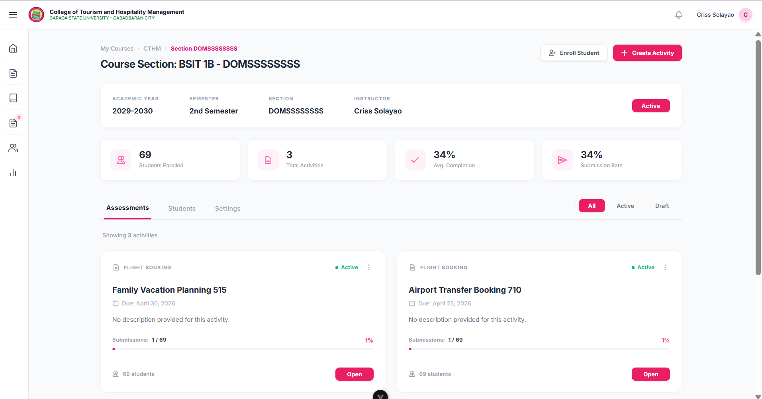

Figure 2. Course Section
The Course Section page offers a comprehensive overview of a specific class, displaying its academic details alongside four real-time summary cards that track student enrollment, activity counts, and overall completion and submission rates. Instructors can perform immediate administrative tasks using the "Enroll Student" and "+ Create Activity" buttons, the latter of which allows for the direct assignment of flight booking simulation tasks. The interface features an Assessments tab with live submission counters for monitoring student progress, while integrated Students and Settings tabs provide a centralized space to manage class rosters and section configurations efficiently.

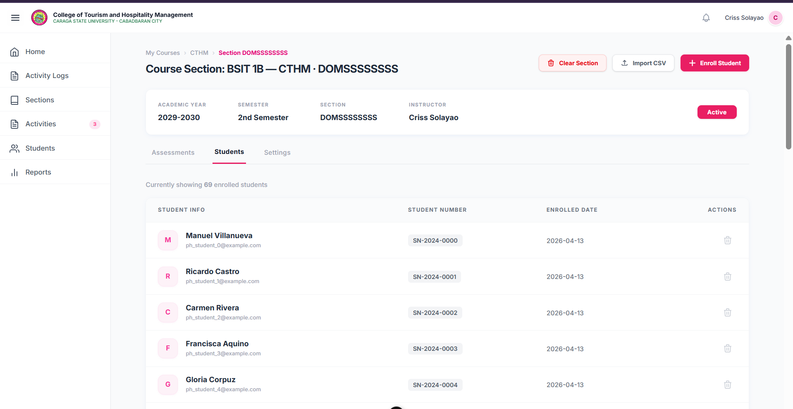

Figure 3. Instructor Student tab
The Students tab provides a centralized management interface for the class roster, displaying essential student details such as names, emails, ID numbers, and enrollment dates. To streamline administration, instructors can add students individually via the "+ Enroll Student" button or perform batch enrollments using the "Import CSV" feature, which is ideal for handling large class sizes. The interface offers precise control through individual delete icons for removing specific students and a "Clear Section" button for a total roster reset. Ultimately, this tab serves as the primary gateway for governing student access to all flight booking simulation activities assigned to the section.

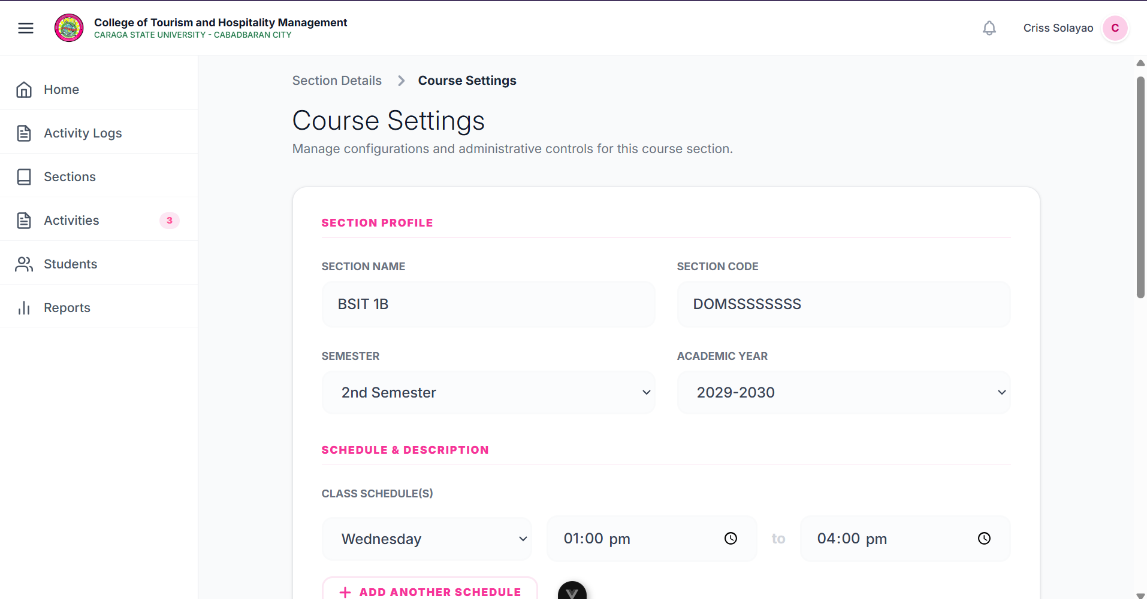

Figure 4. Course Settings
The Course Settings page serves as the administrative control center for a class, allowing instructors to modify core identity details such as the section name, unique code, semester, and academic year. To ensure scheduling accuracy, the Schedule & Description area enables the configuration of specific meeting times, with the "+ Add Another Schedule" button providing the flexibility to accommodate sections that meet multiple times per week. These configurations directly sync with the dashboard's weekly schedule widget and student-facing views, providing a centralized way to maintain organized and accurate class information throughout the academic term.

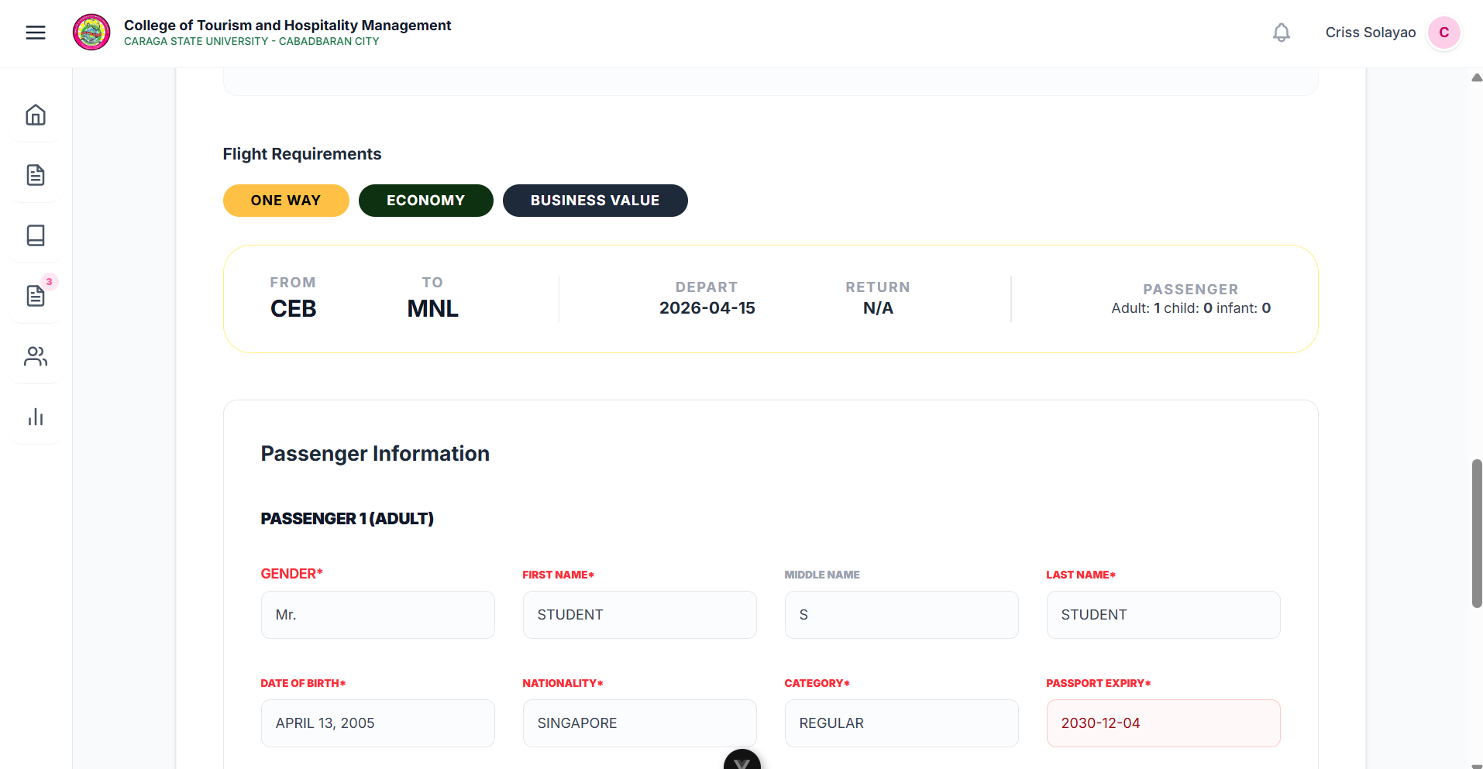
Figure 5. Instructor Activity Instruction/Details
The Passenger Information page simulates the high-stakes task of an airline ticketing agent by requiring students to encode precise traveler records into the reservation system. A persistent Flight Requirements bar at the top serves as a real-time reference, displaying the instructor's specific booking conditions—such as trip type, route, and seat class—to ensure the student remains compliant with the assigned scenario. To progress, students must accurately populate mandatory fields for each passenger, including full name, nationality, date of birth, and passport details, which the system later audits against the activity's requirements to evaluate performance and data entry accuracy.

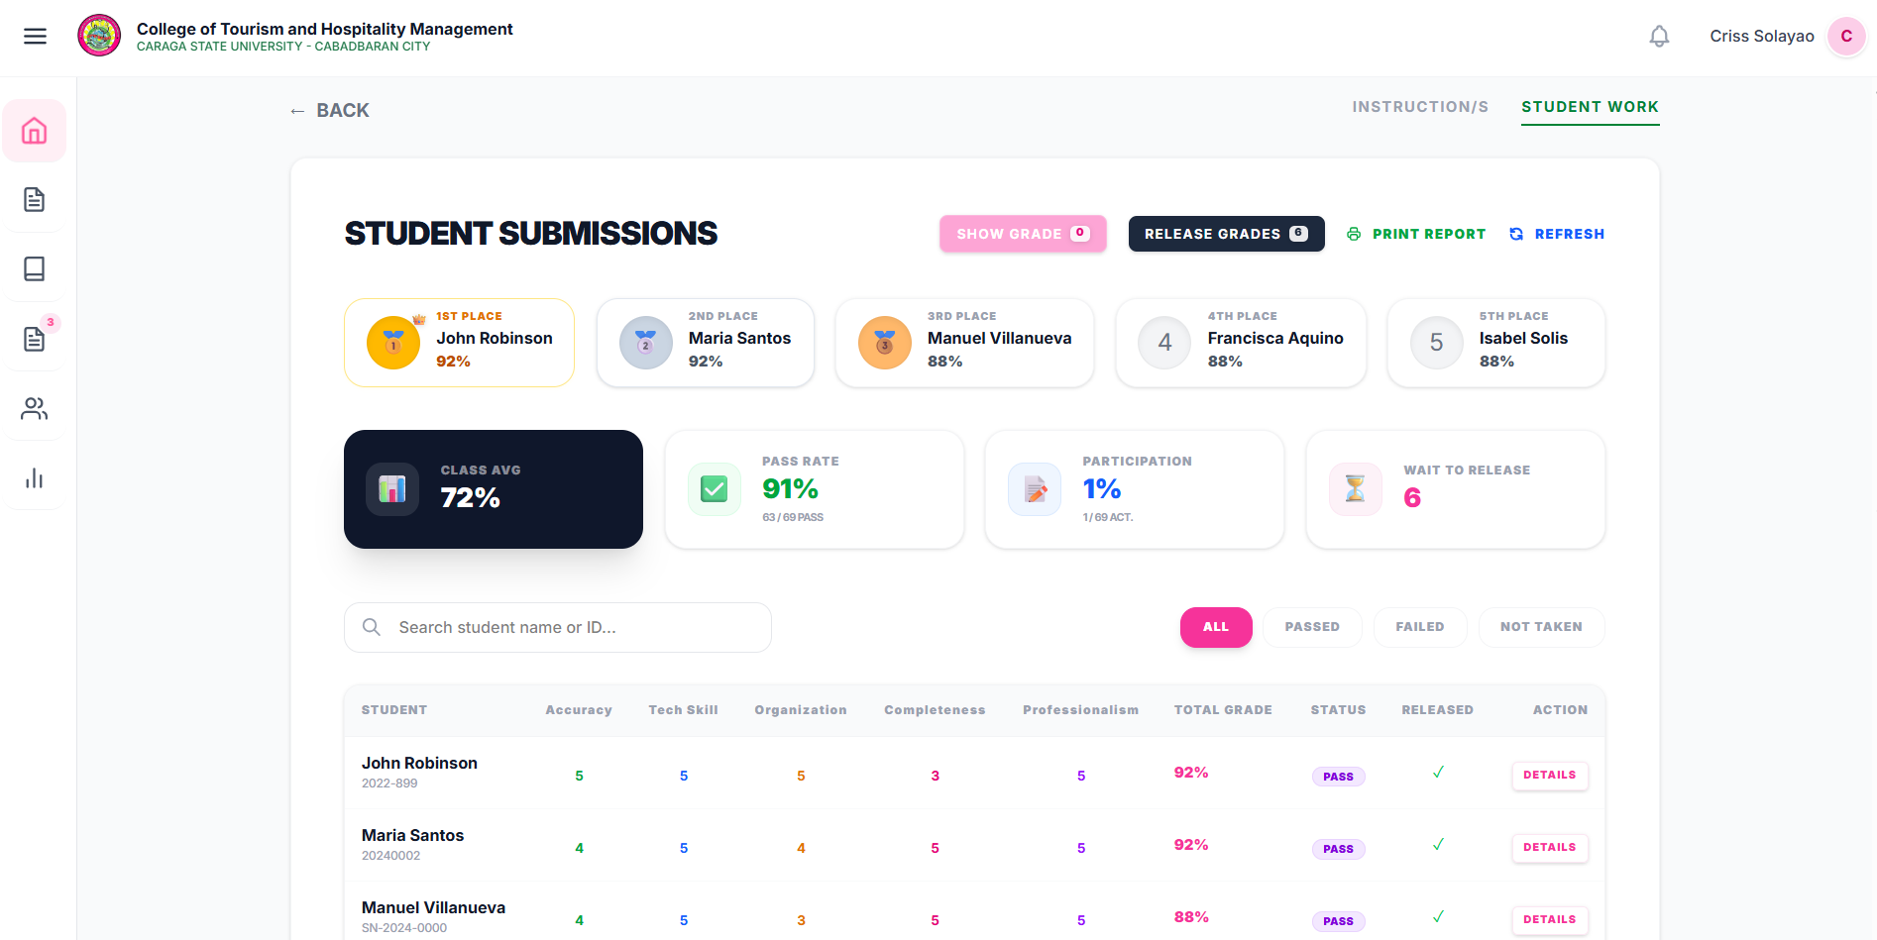
Student Submissions

Figure 6 .Student Submissions
The Student Submissions page functions as a comprehensive grading and analytics center, featuring a leaderboard ranking of the top five students and high-level summary cards for metrics like class average, pass rate, and participation. The core of the page is a detailed grading table that breaks down scores by specific criteria—including Accuracy, Tech Skill, and Professionalism—while providing a "Details" button for deep-dives into individual performances. Instructors can manage results using the "Show Grade" toggle for visibility control, the "Print Report" button for physical record-keeping, and status filters (Passed, Failed, Not Taken) to efficiently track student completion status.

Individual Student Assessment Result

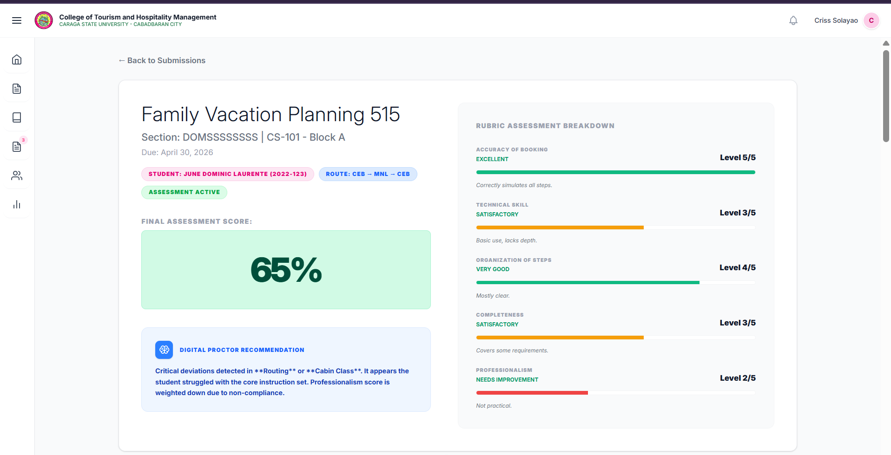
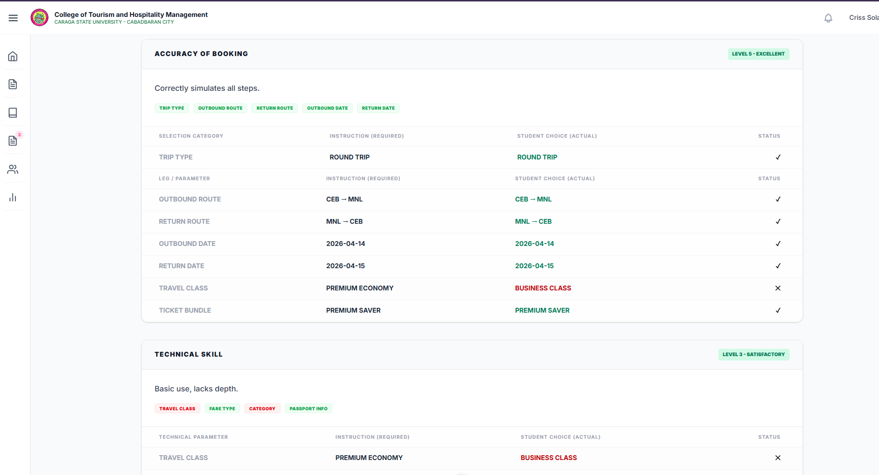
Figure 7. Individual Student Assessment Result

The Individual Student Assessment Result page provides a granular post-simulation analysis, pairing core student data and the Final Assessment Score with automated diagnostic tools. A Digital Proctor Recommendation box identifies specific errors—such as routing deviations or cabin class mismatches—offering instant insight into point deductions without requiring manual review. The evaluation is further detailed through a Rubric Assessment Breakdown that scores students across five categories, including Accuracy of Booking and Technical Skill, utilizing color-coded progress bars (green, orange, red) to visually highlight strengths and deficiencies for a comprehensive, one-stop performance report.

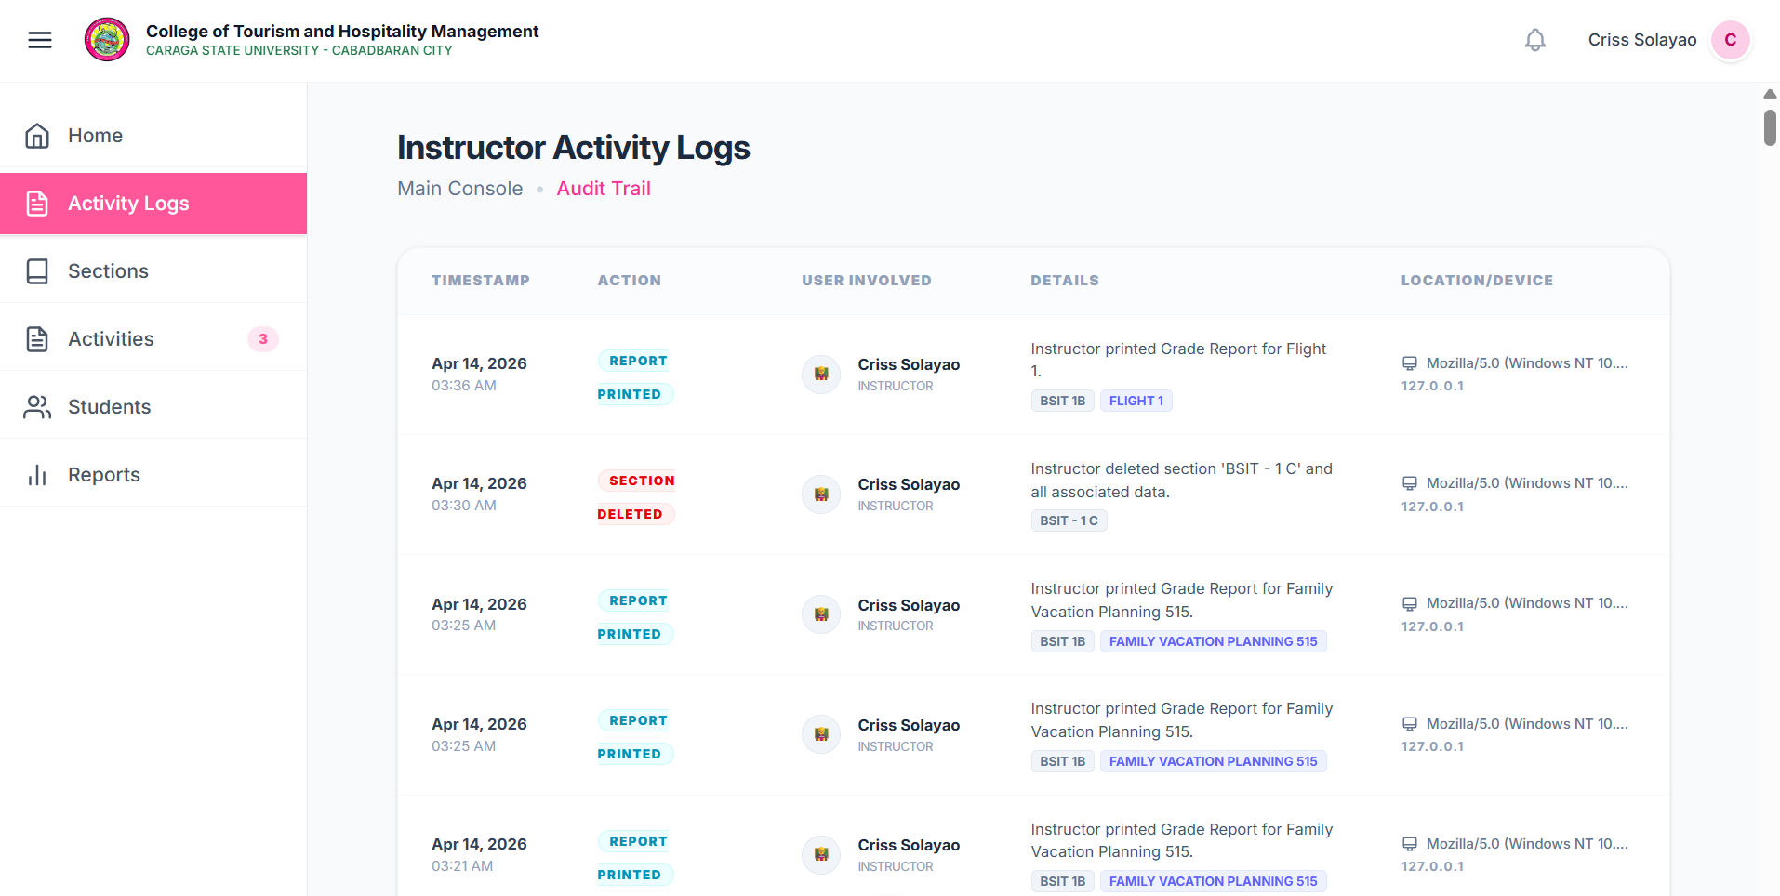

Figure 8. Instructor Activity Logs

The Instructor Activity Logs, or Audit Trail, serves as a comprehensive accountability tool by recording every system action with a precise timestamp, color-coded action badges, and specific descriptions of tasks like report generation or data deletion. To ensure robust security, each entry includes a Location/Device column that logs IP addresses and browser types, verifying the identity of the user involved in each transaction. This transparent, time-stamped history allows instructors to audit past activities and verify significant platform events, ensuring that all administrative actions are fully traceable and documented.

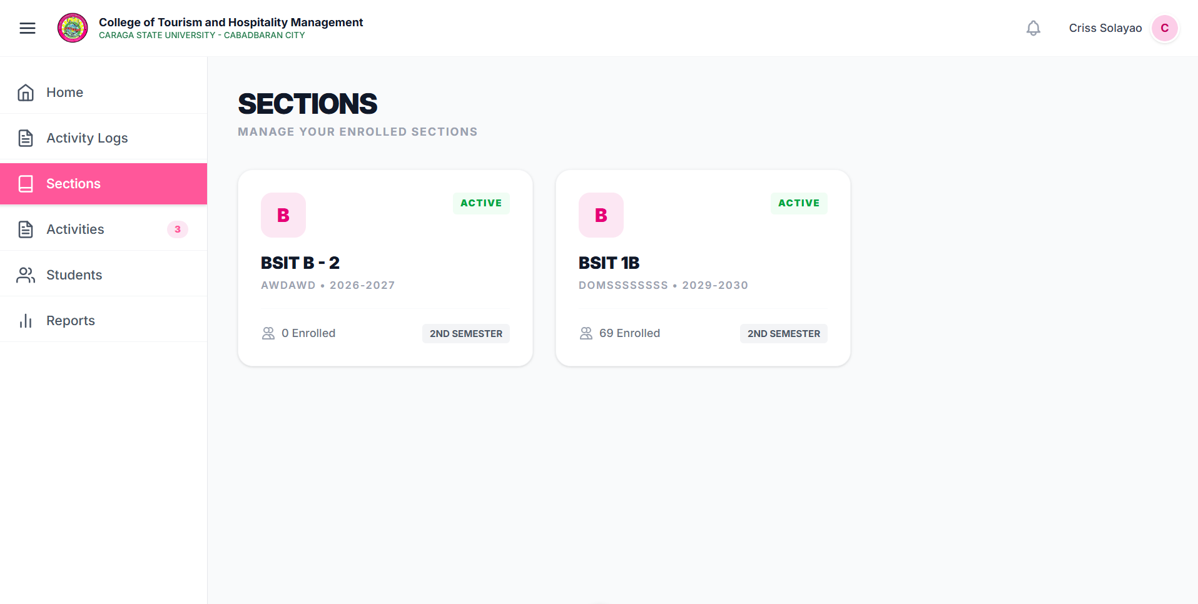
Figure 9. Sections tab/page
The Sections page serves as a central directory where instructors can oversee their entire course load through an organized collection of section cards. Each card displays essential metadata—including the section name, unique code, academic year, and enrollment counts—providing a high-level overview of all classes at a glance. An "Active" status badge identifies sections currently in progress, while the interactive cards allow for seamless navigation into detailed management views for students, assessments, and specific class settings.

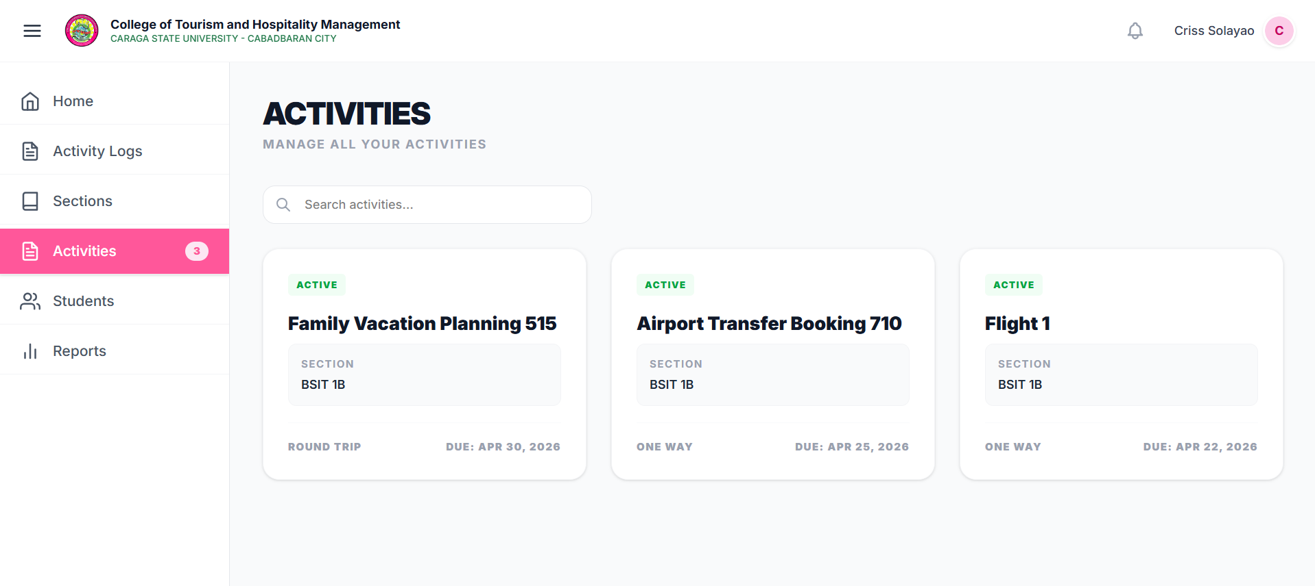

Figure 10. Activities Page
The Activities page serves as a comprehensive directory for all flight booking simulation tasks, presenting each activity as a card that displays essential metadata such as trip type, assigned section, and due dates. A real-time "Active" badge confirms which simulations are currently accessible to students, while a built-in search bar enables instructors to filter and locate specific tasks across multiple sections quickly. By interacting with any card, instructors gain immediate access to the full activity detail page, allowing them to monitor student progress, review grades, and manage simulation settings from a single, organized interface.

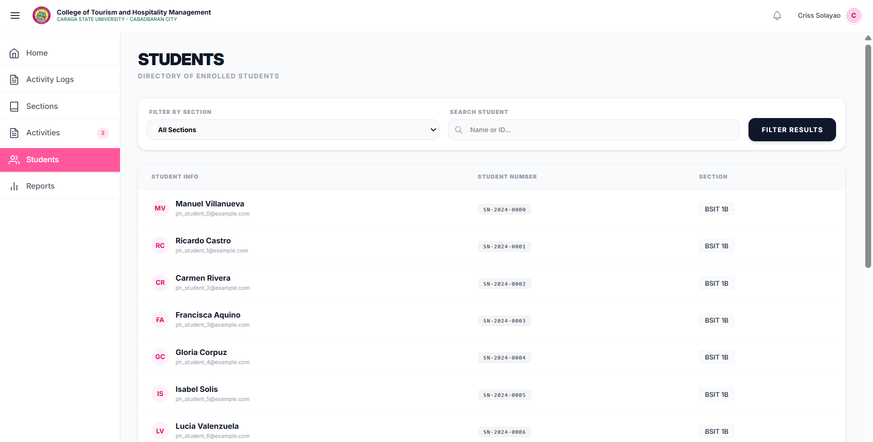

Figure 11. Students Page
The Students page acts as a master directory, consolidating enrollment records from every managed section into a single, searchable list that displays student names, emails, ID numbers, and section assignments. To navigate large rosters efficiently, instructors can utilize a "Filter by Section" dropdown alongside a targeted "Search Student" bar to locate individuals by name or ID instantly. By using the "Filter Results" button to combine these parameters, instructors gain a precise view of their student population, ensuring quick verification of enrollment details across the entire platform.
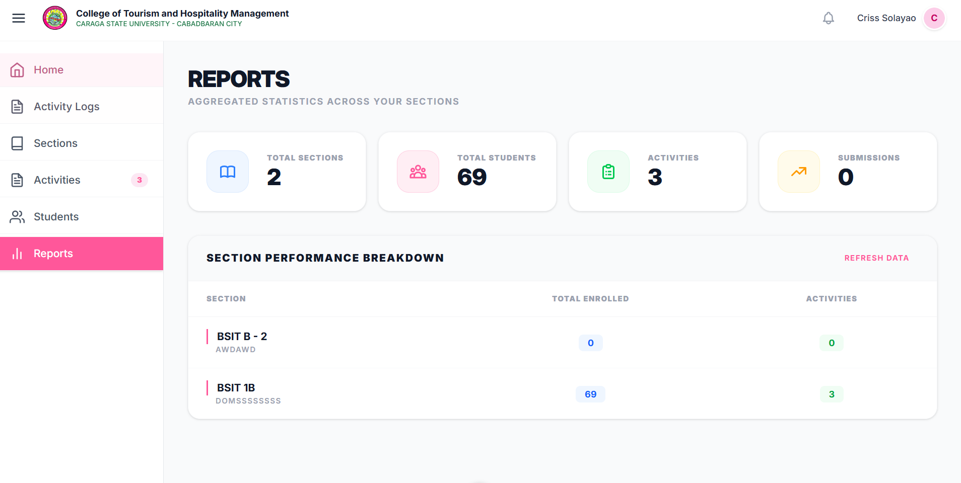
Figure 12. Report Page
The Reports page functions as a centralized analytics hub, offering an aggregated overview of an instructor's entire workload through real-time summary cards that track total sections, students, activities, and submissions. Detailed class comparisons are facilitated by the Section Performance Breakdown table, which displays enrollment and activity counts for each group side-by-side to highlight engagement trends. With a "Refresh Data" button to ensure accuracy, this page empowers instructors to monitor cross-sectional performance and make informed, data-driven decisions regarding their teaching load.

4.4 Testing Results
Following the evaluation approach described in Chapter 3, the system testing used both quantitative and qualitative methods. User Acceptance Testing (UAT) collected data through surveys based on the ISO/IEC 25010 software quality model and feedback from students and instructors.
4.5.1 Technical Verification
Controlled testing validated core functions. Table 4.3 summarises the functionality, performance, and reliability.
Table 4.3: Test Summary
Test Case | Description | Result
Start → Student Login | User enters valid credentials to access system | Passed
Student Dashboard | System displays dashboard after login | Passed
Available Activities | System shows list of activities | Passed
Select Activity | User selects flight booking simulation | Passed
Instructions | System displays activity instructions | Passed
Enter Activity Code | User inputs correct activity code | Passed
Search Flight | User searches for available flights | Passed
Search Result | System displays available flight options | Passed
Select Flight | User selects preferred flight | Passed
Passenger Details | User inputs passenger information | Passed
Add-ons Selection | User selects optional services (e.g., baggage) | Passed
Review Booking | System displays booking summary | Passed
Payment Process | User completes simulated payment | Passed
Booking Success | System confirms successful booking | Passed
Check-in | User proceeds to check-in process | Passed
Select Flight Manifest | System retrieves booking for check-in | Passed
Verify Passenger Details | System validates passenger info | Passed
Baggage & Boarding Info | System processes baggage and seat assignment | Passed
Issue Boarding Pass | System generates boarding pass | Passed
End | Process completes successfully | Passed
Start → Instructor Login | User enters valid credentials to access system | Passed
Instructor Dashboard | System displays instructor dashboard after login | Passed
View Instructor Logs | View system logs and activity history | Passed
Section Selection | Select course section to manage | Passed
Section Overview | View overview of selected section | Passed
Activity Management | Manage activities for the course | Passed
Create New Activity | Create new simulation activity | Passed
Select Existing Activity | Select from existing activities | Passed
Enter Activity Details | Enter activity details and instructions | Passed
View Student List | View list of enrolled students | Passed
Enroll Students | Enroll students into course/activity | Passed
Enter Student ID | Input student ID for enrollment | Passed
Course Settings | Configure course settings | Passed
Create/Update Sections | Create new or update existing sections | Passed
Activate Activity | Activate activity for student access | Passed
Activity Details Page | View detailed activity information | Passed
View Student Work | Review student work and submissions | Passed
Release Student Score | Release grades to students | Passed
View Student Grade | View individual student grades | Passed
Generate Grade Report | Generate comprehensive grade reports | Passed
Confirm and Print | Confirm before printing reports | Passed
Print Grade Report | Print or export grade reports | Passed
End | Complete instructor workflow | Passed
Start → Admin Login | User enters valid credentials to access system | Passed
Admin Dashboard | System displays admin dashboard with system overview | Passed
Flight Management | Manage flight-related configurations | Passed
Manage Flights | Create, update, delete flight records | Passed
Manage Routes | Manage flight routes and destinations | Passed
Manage Schedules | Configure flight schedules and timings | Passed
Manage Seats | Manage seat configurations and availability | Passed
Pricing & Add-ons | Configure pricing and additional services | Passed
Manage Taxes | Set up and manage tax rates | Passed
Pricing Config | Configure pricing rules and structures | Passed
Manage Insurance | Manage insurance options and policies | Passed
Manage Add-ons | Configure additional services | Passed
User Management | Manage all user accounts in the system | Passed
Instructor Directory | View and manage instructor accounts | Passed
Student Overview / LMS | Access student overview and LMS data | Passed
Passenger Info | View passenger information records | Passed
Update User Records | Update user account information | Passed
Track User Logs | Track and monitor user activity logs | Passed
Check User Status | Check user account status and permissions | Passed
Monitoring & Operations | Monitor system operations in real-time | Passed
Live Flight Monitor | Monitor live flight status and operations | Passed
DCS Check-in Counter | Access DCS check-in counter interface | Passed
DCS Manifest | View and manage DCS flight manifests | Passed
System Security | Implement system-wide security protocols | Passed
Error Handling | Display error messages for invalid credentials | Passed
End | Complete admin workflow | Passed

4.5.2 User Acceptance Testing
Evaluation Setup
User Acceptance Testing (UAT) was conducted with selected CTHM students and instructors. Participants were asked to perform booking tasks and evaluate the system.
Table 4.4 presents the UAT protocol used in this study. A total of 15 participants were evaluated, consisting of group admin (n=1), CTHM instructor (n=4), and CTHM students (n=10). Group sessions lasted approximately 2 hours each to allow for in-depth system demonstration and discussion, while admin sessions lasted 30 minutes, focusing on the flight schedules, user accounts management, managing overall data, and operational data oversight. The total field time was approximately 5 hours.
Table 4.4 Table 4.4 presents the UAT protocol used in this study
Aspect | Decision | Rationale
Sample size | 15 participants total: 3 group admin+ 1 CTHM instructor + 4 CTHM students + 10 | Sufficient for initial usability evaluation within limited time and resources
Evaluation type | Single‑session structured demonstration + interview | Longitudinal deployment not possible; expert review provides deep qualitative feedback
Location | 1 site within: CSUCC | Ensures controlled environment and consistent testing conditions
Instrument | ISO/IEC 25010:2011 based questionnaire + semi‑structured interview | Validated instrument; no development time; captures both quantitative and qualitative data
Participants
Group | Role of Representative | Number of Participants | Time per Participant | Time Investment
Admin | CTHM Technician | 1 | 30 minutes | 30 minutes
CTHM Instructor | Instructors | 4 | 30 minutes per instructor | 2 hours
CTHM Student | Tourism Students | 10 | 15 minutes | 2h 30m
Total |  | 15  participants | 1h 15m | Approximately 5 hours field time

Quantitative Evaluation Results
Each evaluator completed an ISO/IEC 25010‑based questionnaire covering eight product quality characteristics and three quality‑in‑use characteristics. Ratings used a 5‑point Likert scale (1 = Poor, 2 = Fair, 3 = Good, 4 = Very Good, 5 = Excellent). Table 4.4 presents the individual ratings and averages. A total of fifteen (15) participants completed the evaluation.
Scoring Formula
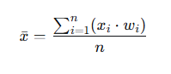
The overall average rating for each quality characteristic was computed using the weighted mean formula:

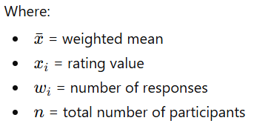
Table 4.5: Analysis and Interpretation of ISO/IEC 25010 Evaluation Results
Quality Characteristic | Admin  (n=1) | Instructor  (n=4) | Student  (n=10) | Average | Interpretation
Product Quality
1. Functional Suitability | 5.00 | 4.5 | 4.9 | 4.80 | excellent
2.Performance Efficiency | 4.00 | 4.75 | 4.8 | 4.52 | excellent
3. Compatibility | 5.00 | 4.5 | 4.8 | 4.77 | excellent
4. Usability | 4.00 | 5 | 4.6 | 4.53 | excellent
5. Reliability | 4.00 | 4.75 | 4.7 | 4.48 | excellent
6. Security | 3.00 | 4.25 | 4.6 | 3.95 | Very Good
7.Maintainability | 3.00 | 4.5 | 4.7 | 4.07 | Very Good
8. Portability | 4.00 | .4.5 | 4.7 | 4.40 | excellent
Product Quality Average Total : |  |  |  | 4.44 | excellent
Quality in Use
Effectiveness | 4.00 | 4.75 | 4.9 | 4.55 | excellent
Efficiency | 4.00 | 4.75 | 4.9 | 4.55 | excellent
Satisfaction | 4.00 | 4.5 | 4.7 | 4.40 | excellent
Freedom from Risk | 4.00 | 4.00 | 4.9 | 4.30 | excellent
Quality in Use Average |  |  |  | 4.45 | excellent

The Results presented in Table 4.5 indicate that the Smart Flight Booking Simulation Platform achieved a high level of overall system quality , as reflected by the consistently high ratings across all ISO/IEC 25010 characteristics.
The system received an overall product quality assessment of 4.44 which represents the Excellent rating. Among the characteristics, Functional Suitability(4.80) received the highest rating, indicating that the system effectively performs all required functions and meets user needs. The platform demonstrates success in implementing the core components which establish a standard procedure for actual fight reservation and check-in operations.
The system received excellent ratings for Compatibility (4.77) and Usability (4.53) which demonstrated its capacity to function well in various settings while delivering an intuitive experience to users. The results show that users could navigate the system without major problems while completing their tasks.
The system demonstrates fast response times and dependable operation through its Performance Efficiency (4.52) and Reliability (4.48) ratings. The technical tests confirmed these results because the system responded according to requirements and maintained operational uptime.
Security (3.95) and Maintainability (4.07) received slightly lower ratings which both still fall within the Very Good range. The system maintains sufficient security standards together with reasonable maintainability efforts yet needs improvement particularly for enhancing access security and data protection and system growth capabilities.
The system received an excellent rating for Portability (4.40) which shows that it can operate without significant problems on multiple platforms and different environmental settings.
The system achieved an overall score for quality in use which established its performance level.

Qualitative Findings
During the demonstrations, stakeholders provided rich feedback that contextualises the quantitative ratings.
Table 4.6 summarises the key comments and suggestions.
Participants | Positive Feedback | Constructive Suggestions
CTHM Student | “User friendly and efficient system” | “ Font should be minimal and readable “
CTHM Instructor | “ real like airline booking site with complete details such as seat selection , pricing / add ons and modes of payments “ | “ Add international routes , payment center as an option for 24 hours hold of booking . Add other airlines like CEB PAC , QATAR AIRWAYS , EMIRATES , and etc.”
Admin | “ User friendly “ | “2 admins (LMS & Manage) security”

Key Findings
The Smart Flight Booking Simulation Platform was tested and User Acceptance (UAT) was done, and the results showed a number of important things based on both quantitative and qualitative data.

The system got a high overall score in both product quality (4.44) and quality used (4.45), which are both very good. This means that the platform met the necessary standards for functionality, usability and effectiveness.

Second, all of the functional requirements in Table 4.1 were fully met, and all the test cases in Table 4.3 passed. This shows that the system works correctly and reliably in all of the student, instructor, and admin modules.

Third, performance testing showed that the system met all of its non-functional requirements, such as quick response times, efficient database queries, and stable system uptime. This shows that the platform works well from a technical point of view and can handle many users at once.

Fourth, users thought the system was realistic and easy to use. Students said it was easy to use and worked well, while teachers pointed out how similar it was to real airline booking systems, especially when it came to choosing seats, prices, and extras.

But some things could be better: security and maintainability got slightly lower scores but still “Very Good”, which suggests that the system controls needs to be better and that the systems need to be able to grow in the future.
Finally, qualitative feedback emphasized the need for additional features, such as international flight support and enhanced booking functionalities, which can further improve the realism and educational value of the platform.

4.5 Discussion
Problem Resolution
Table 4.7 identified the problem in chapter 1, system implemented, evidence from results and confidence level.
Identified Problem | System Implementation | Evidence from Results | Confidence Level
Lack of practical training tools for CTHM students | Developed a Smart Flight Booking Simulation Platform with real-world booking. | Functional Suitability = 4.80 (Excellent); All test cases Passed | High for prototype; Moderate for full institutional deployment
Limited exposure to real airline booking systems | Simulation includes flight search, seat selection, add-ons, payment, and check-in process | Positive feedback: “real like airline booking site” (Instructor) | High for capability; Moderate for real-world operational alignment
Difficulty understanding booking workflow | Step-by-step system flow (search → booking → payment → check-in) | Usability = 4.53 (Excellent) | High for usability effectiveness; Moderate for complex real-world scenarios
Lack of interactive and engaging learning tools | Interactive simulation with activities and user participation | Satisfaction = 4.40 (Excellent) | High for engagement; Moderate for long-term learning retention
Absence of risk-free training environment | Fully simulated system (no real payment or airline integration) | Freedom from Risk = 4.30 (Excellent) | High for simulation safety; Low for real-world risk exposure
Inefficient traditional teaching methods | Integration of simulation-based learning approach | Effectiveness = 4.55 (Excellent) | High for instructional support; Moderate for curriculum-wide adoption
Limited system performance in similar tools | Optimized system with fast response and stable performance | Performance Efficiency = 4.52; All NFR targets met | High for system performance; Moderate for scalability under larger user load
Security and scalability concerns | authentication and system controls implemented | Security = 3.95 (Very Good) | Moderate for current security; Requires enhancement for enterprise-level deployment
Lack of advanced airline features | Core booking features implemented but limited advanced functions | Suggestions: international flights, rebooking, more airlines | Moderate for current functionality; Low for advanced industry-level features

The study confirmed that CTHM students need hands-on training tools for airline booking systems, as traditional theoretical instruction limits real-world experience. The Smart Flight Booking Simulation Platform effectively addressed this gap by providing a realistic, interactive environment where students perform complete booking and check-in procedures.
The system achieved high ratings in functional suitability (4.80) and usability (4.53), demonstrating that it operates properly while remaining user-friendly. Students successfully applied theoretical knowledge to practical scenarios, mastering reservation handling and post-booking procedures.
Developed using Agile methodology, the system incorporated user feedback throughout the process, ensuring timely delivery of essential features. However, limitations remain: the platform supports only domestic flights without real-time data integration and lacks advanced features like rebooking, cancellations, and international travel options. These gaps affected the evaluation of security and maintainability.
Overall, the system successfully met its educational objectives, proving that simulation-based learning effectively enhances tourism and hospitality training at CTHM.

CHAPTER 5
CONCLUSIONS, AND RECOMMENDATIONS

5.1 Conclusion
The Smart Flight Booking Simulation Platform definitively addresses the problem identified in Chapter 1. The study confirmed that CTHM students lacked hands-on training tools for airline booking systems, and the developed platform successfully filled this gap by providing a realistic, interactive, and structured simulation environment.
This conclusion is supported by the results presented in Chapter 4. All functional and non-functional requirements were successfully met, and all system test cases passed, confirming that the platform operates correctly and reliably. Furthermore, the User Acceptance Testing results showed an overall Excellent rating, with product quality scoring 4.44 and quality in use scoring 4.45. High scores in functional suitability (4.80), usability (4.53), and effectiveness (4.55) demonstrate that the system is not only technically sound but also user-friendly and effective as a learning tool.
Therefore, it can be conclusively stated that the system successfully solves the identified problem by bridging the gap between theoretical learning and practical application. The platform enables students to gain real-world experience in airline booking and check-in processes, while also supporting instructors and administrators in managing and evaluating learning activities. While there are areas for future improvement, these do not diminish the system’s overall effectiveness in achieving its intended purpose.
5.2 Recommendation
Future development should prioritize integrating *predictive student analytics* for instructors to identify learning gaps and *AI-powered personalization* for tailored passenger recommendations. The *dynamic pricing model* should be refined by incorporating real-time weather data and global fuel indices to improve fare accuracy. Additionally, implementing *WebSocket-based flight tracking* and automated SMS notifications would significantly enhance real-time responsiveness for passengers. These targeted upgrades will ensure the system remains technologically competitive and highly responsive to both academic and operational needs.
1. Promo code/discount
The promotional code system enables customers to enter discount codes during checkout to receive either price reductions or percentage discounts. The system checks code validity by testing expiration dates and usage limits and eligibility criteria. Airlines use it for their marketing campaigns together with their seasonal promotions and loyalty rewards and partnership discounts which help them increase their booking rate.
2. Rebook or cancel a confirmed booking and change a flight
Passengers who want to change their flight reservations or cancel their bookings can use the self-service feature which allows them to access their reservations through "My Trips" by entering their confirmation number and last name. The system calculates fare differences, applies change fees by ticket type, and issues travel credits. Non-refundable tickets become eCredit; refundable tickets get monetary refunds. Customers who make bookings at least 7 days before their departure date can use the 24-hour free cancellation policy.

3. Implement a waitlist and inventory management how airlines manage overbooked and upgrade passenger
Intelligent inventory system optimizes seat availability across fare classes and manages overbooking by creating waitlists for voluntary bumping based on fare class, check-in time, and loyalty status. It provides compensation options for volunteers and adheres to regulations for involuntary bumping, while also managing upgrade requests and automatically confirming passengers when seats become available due to cancellations.

4. Integrate an international flight
International booking module handling cross-border requirements: passport verification, visa checks, customs documentation, and entry regulations. The system enables users to handle multiple currencies together with currency conversion and time zone management and international baggage regulations. The system connects with government databases to enable API and PNR data submission for immigration processes. The system verifies visa requirements while checking health documents and ensuring compliance with international aviation standards.

5. Children traveling with adults require UMNR service
UMNR (Unaccompanied Minor) Service requires all Unaccompanied Minors between 5 to 14 years old to travel under complete supervised protection. The system protects passengers throughout their journey because airline personnel monitor them from their check-in procedure until their arrival at their final destination. The system includes several features which allow guardians to provide their contact details and verify their pickup person while using identification wristbands to access priority boarding and crew supervision. The system prevents users from making tight connections and last-flight bookings while it charges them service fees.

6. Bassin for infant seat
The system allows parents to request airline bassinets (skycots) for children under 2 during long-distance flights. It identifies bulkhead seat availability by displaying eligible seats and monitoring aircraft inventory, factoring in age and weight restrictions for infants. Parents receive confirmation of seat assignments and notifications 24 to 48 hours before departure, requiring confirmation and providing turbulence alerts. If bassinets are fully booked, passengers are automatically placed on waiting lists.

7. Weight and balance (trim ) Calculation
The Critical Safety System calculates aircraft weight distribution to ensure a proper center of gravity (CG) for safe operations. It totals the weight of passengers, baggage, cargo, fuel, and catering services, producing pilot trim sheets that keep CG within certified limits. The system protects against overloads, reduces fuel usage, and connects with check-in systems for real-time data using IATA average weight measurements. It issues alerts to halt departures in case of violations.

8. Travel Bank, Flight Credit, or Electronic Wallet
The digital wallet facilitates the management of refunds, cancellation credits, compensation vouchers, and future travel promotional funds. It tracks cancellation deposits and their expiration, allows partial payments with various payment methods, and enables fund transfers between family accounts. Users can monitor their account balance and transaction history, with the system automatically applying expiring credits and ensuring fraud protection through authentication. Access to funds is granted by logging into user accounts.

REFERENCES:
[1] R. Law, R. Leung, and D. Buhalis, “Information technology applications in hospitality and tourism: A review of publications from 2005 to 2007,” J. Travel Tour. Mark., vol. 26, no. 5–6, pp. 599–623, 2009, doi: 10.1080/10548400903163160.
[2] T. M. Tung, “Developing Quality Hospitality Students Through Simulation and Experiential Learning asa Guide for Hospitality Education,” GATR Glob. J. Bus. Soc. Sci. Rev., vol. 9, no. 4, pp. 283–292, 2021, doi: 10.35609/gjbssr.2021.9.4(5).
[3] C. S. Deale, S. Bae, and S.-H. Lee, “Educators’ Use and Views of Simulations as Teaching Tools within a Discipline: The Example of Hospitality and Tourism,” Int. J. Scholarsh. Teach. Learn., vol. 15, no. 2, pp. 1–10, 2021, doi: 10.20429/ijsotl.2021.150210.
[4] Oberstone, J. (2010). Spreadsheet Simulation of Airline Reservation Policy Using Multimedia Software. International Journal of Advanced Corporate Learning (iJAC), 3(1), 26-31.

[5] M. Sigala, “The Evolution of Internet Pedagogy: Benefits for Tourism and Hospitality Education,” vol. 1, no. 2, [Online]. Available: www.hlst.ltsn.ac.uk/johlste
[6] O. Chernikova, N. Heitzmann, M. Stadler, D. Holzberger, T. Seidel, and F. Fischer, “Simulation-Based Learning in Higher Education: A Meta-Analysis,” Rev. Educ. Res., vol. 90, no. 4, pp. 499–541, 2020, doi: 10.3102/0034654320933544.
[7] D. Buhalis and R. Law, “This is the Pre-Published Version of the article published in the journal : This is the Pre-Published Version of the article published in the journal :,” Tour. Manag., vol. 29, no. 4, pp. 609–623, 2008.
[8] T. Lainema and O. P. Hilmola, “Learn more, better and faster: computer-based simulation gaming of production and operations,” Int. J. Bus. Perform. Manag., vol. 7, no. 1, pp. 34–59, 2005, doi: 10.1504/IJBPM.2005.006242.
[9] L. Ochoa Siguencia, G. Marzano, and D. Herman, “Information Technology and Consumer Behaviour in Tourism: Student Travel Planning By Using the Internet,” Soc. Integr. Educ. Proc. Int. Sci. Conf., vol. 6, no. May, pp. 402–411, 2018, doi: 10.17770/sie2018vol1.3084.
[10] M. Beheshti, S. Rahimizhian, and M. Ilkan, “The Role of Information and Communication Technology ( ICT ) in Tourism Education : A Case Study of Higher Education Students The Role of Information and Communication Technology ( ICT ) in Tourism Education : A Case Study of Higher Education Students,” no. September, 2020.
[11] A. Huang, E. de la Mora Velasco, and A. Haney, “Examining Instructional Technologies in Hospitality and Tourism Education: A Systematic Review of Literature,” J. Hosp. Tour. Educ., vol. 36, no. 2, pp. 113–131, 2024, doi: 10.1080/10963758.2022.2109480.
[12] L. K. Price-Howard and H. Lewis, “Perceived usefulness of simulation learning in hospitality education,” Int. Hosp. Rev., vol. 37, no. 2, pp. 384–393, 2023, doi: 10.1108/ihr-05-2022-0028.
[13] M. A. Pratt and S. Hahn, “Enhancing hospitality student learning through the use of a business simulation,” J. Hosp. Leis. Sport Tour. Educ., vol. 19, pp. 10–18, 2016, doi: 10.1016/j.jhlste.2016.05.001.
[14] H. Zheng, J. Yuan, and L. Chen, “Short-Term Load Forecasting Using EMD-LSTM neural networks with a xgboost algorithm for feature importance evaluation,” Energies, vol. 10, no. 8, 2017, doi: 10.3390/en10081168.
[15] W. K. O. Ho, B. S. Tang, and S. W. Wong, “Predicting property prices with machine learning algorithms,” J. Prop. Res., vol. 38, no. 1, pp. 48–70, 2021, doi: 10.1080/09599916.2020.1832558.
[16] K. Tziridis, T. Kalampokas, G. A. Papakostas, and K. I. Diamantaras, “Airfare prices prediction using machine learning techniques,” 25th Eur. Signal Process. Conf. EUSIPCO 2017, vol. 2017-Janua, pp. 1036–1039, 2017, doi: 10.23919/EUSIPCO.2017.8081365.
[17] M. Shaikh and R. Borate, “Airline Booking System,” Technoarete Trans. Adv. Comput. Appl. (TTACA, vol. 2, no. 1, pp. 12–18, 2023.
[18] J. Kavander, “Developing Kanban board backend by using Django web framework,” 2022.
[19] J. Boyar, S. Krarup, and M. N. Nielsen, “Seat Reservation allowing seat changes,” Electron. Notes Theor. Comput. Sci., vol. 50, no. 1, pp. 24–38, 2001, doi: 10.1016/S1571-0661(04)00163-X.
[20] D. K. Rigby, J. Sutherland, and H. Takeuchi, “Embracing agile,” Harv. Bus. Rev., vol. 2016, no. May, 2016.
[21] S. V. Salunke and A. Ouda, “A Performance Benchmark for the PostgreSQL and MySQL Databases,” Futur. Internet, vol. 16, no. 10, 2024, doi: 10.3390/fi16100382.

APPENDICES

A. Relevant Source Code
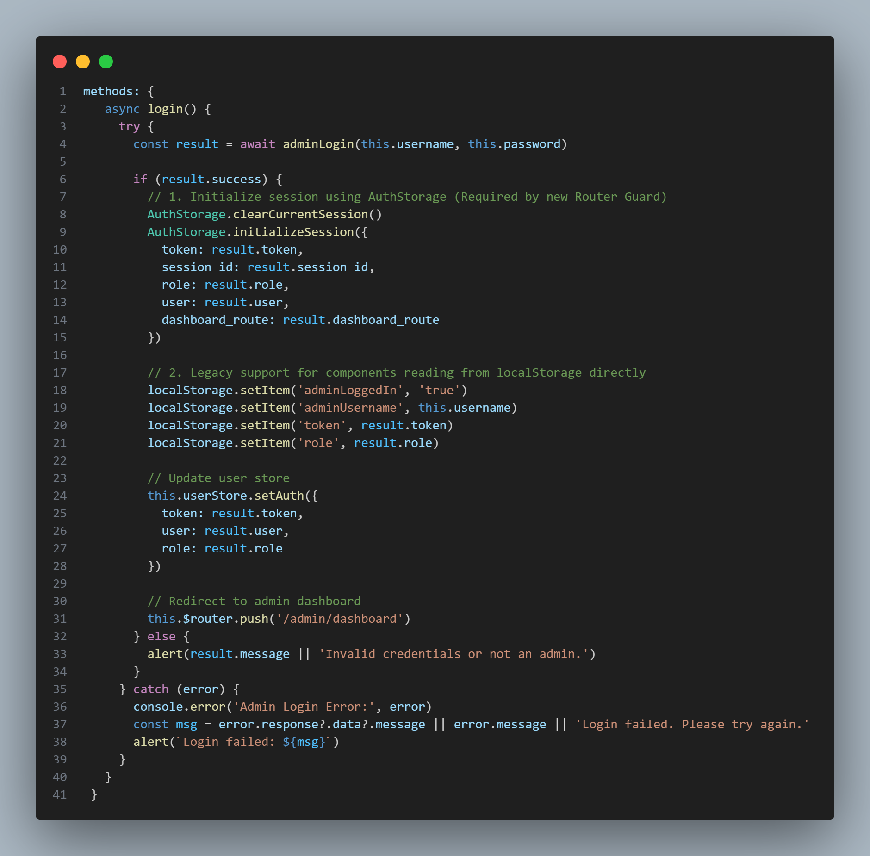
Source: Admin/login.vue
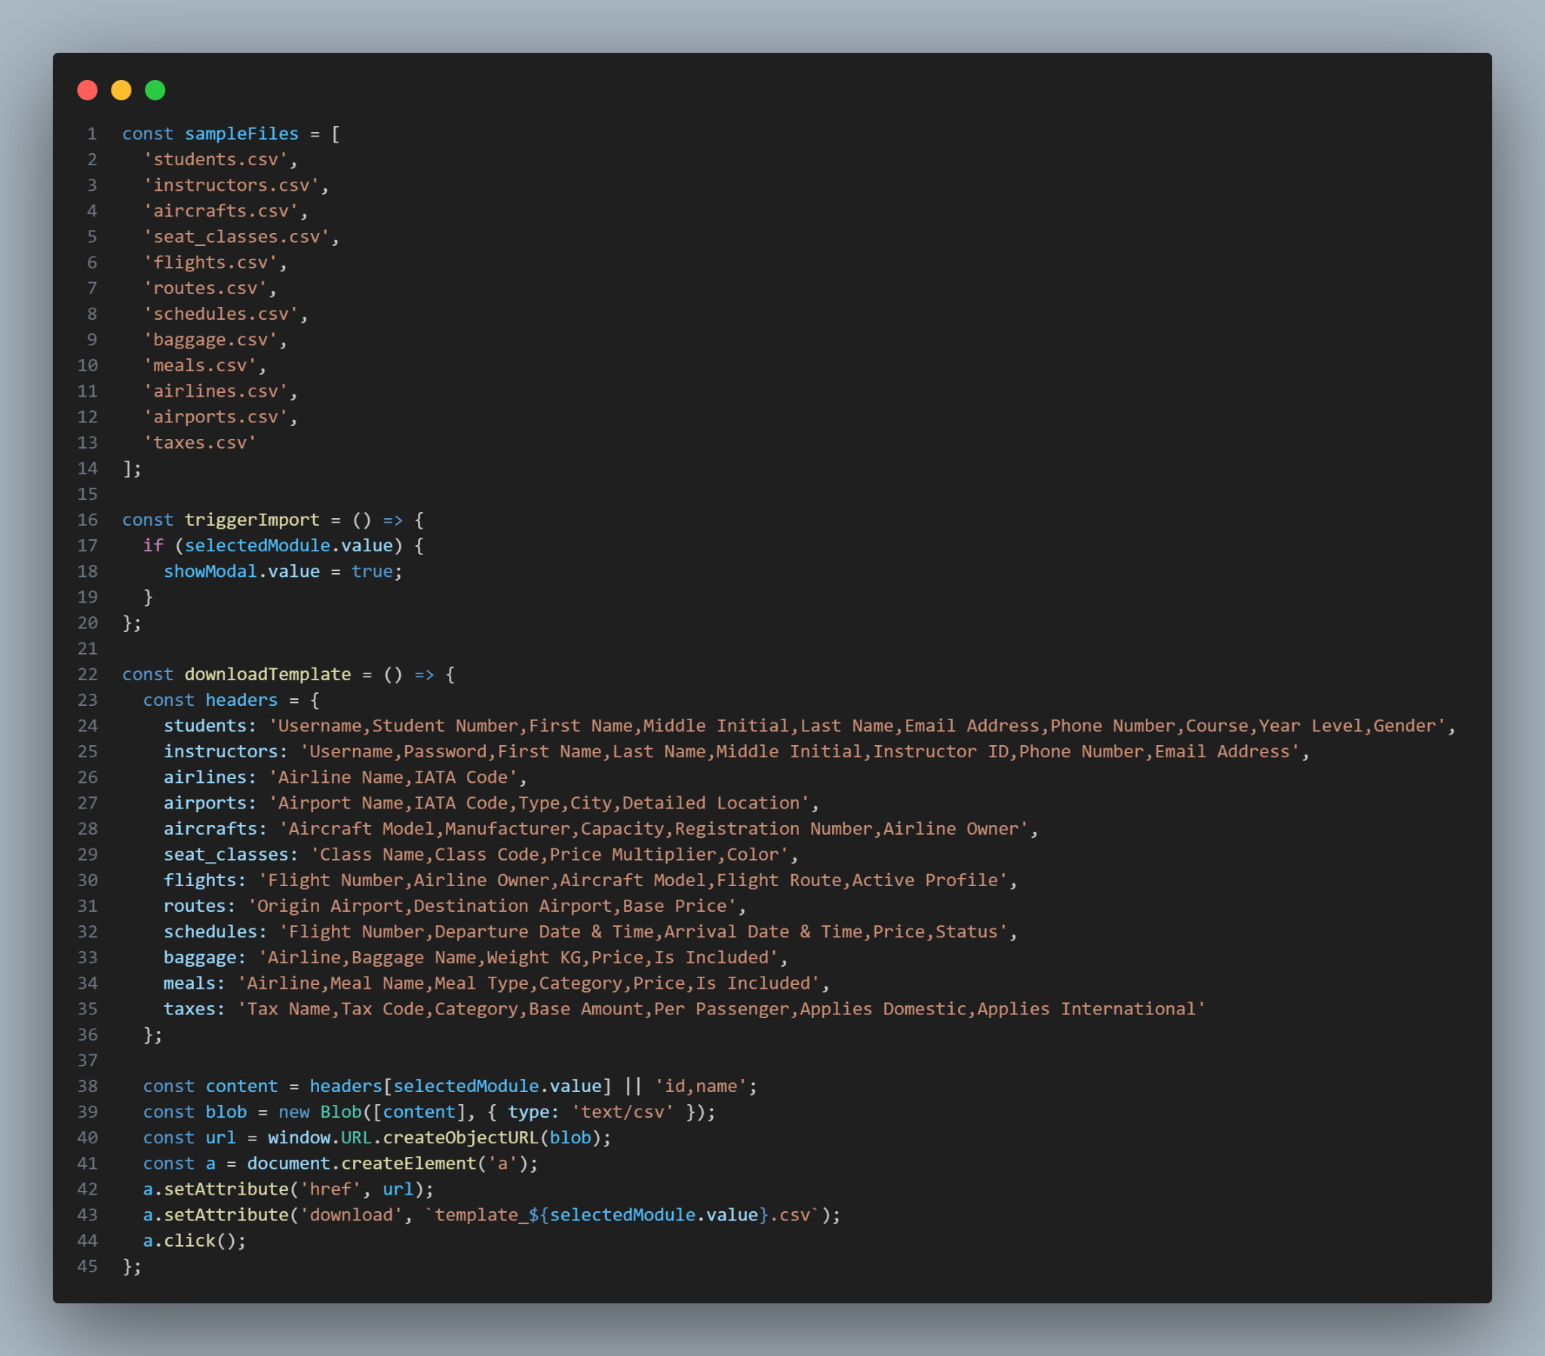
Source: Admin/bulk_import.vue

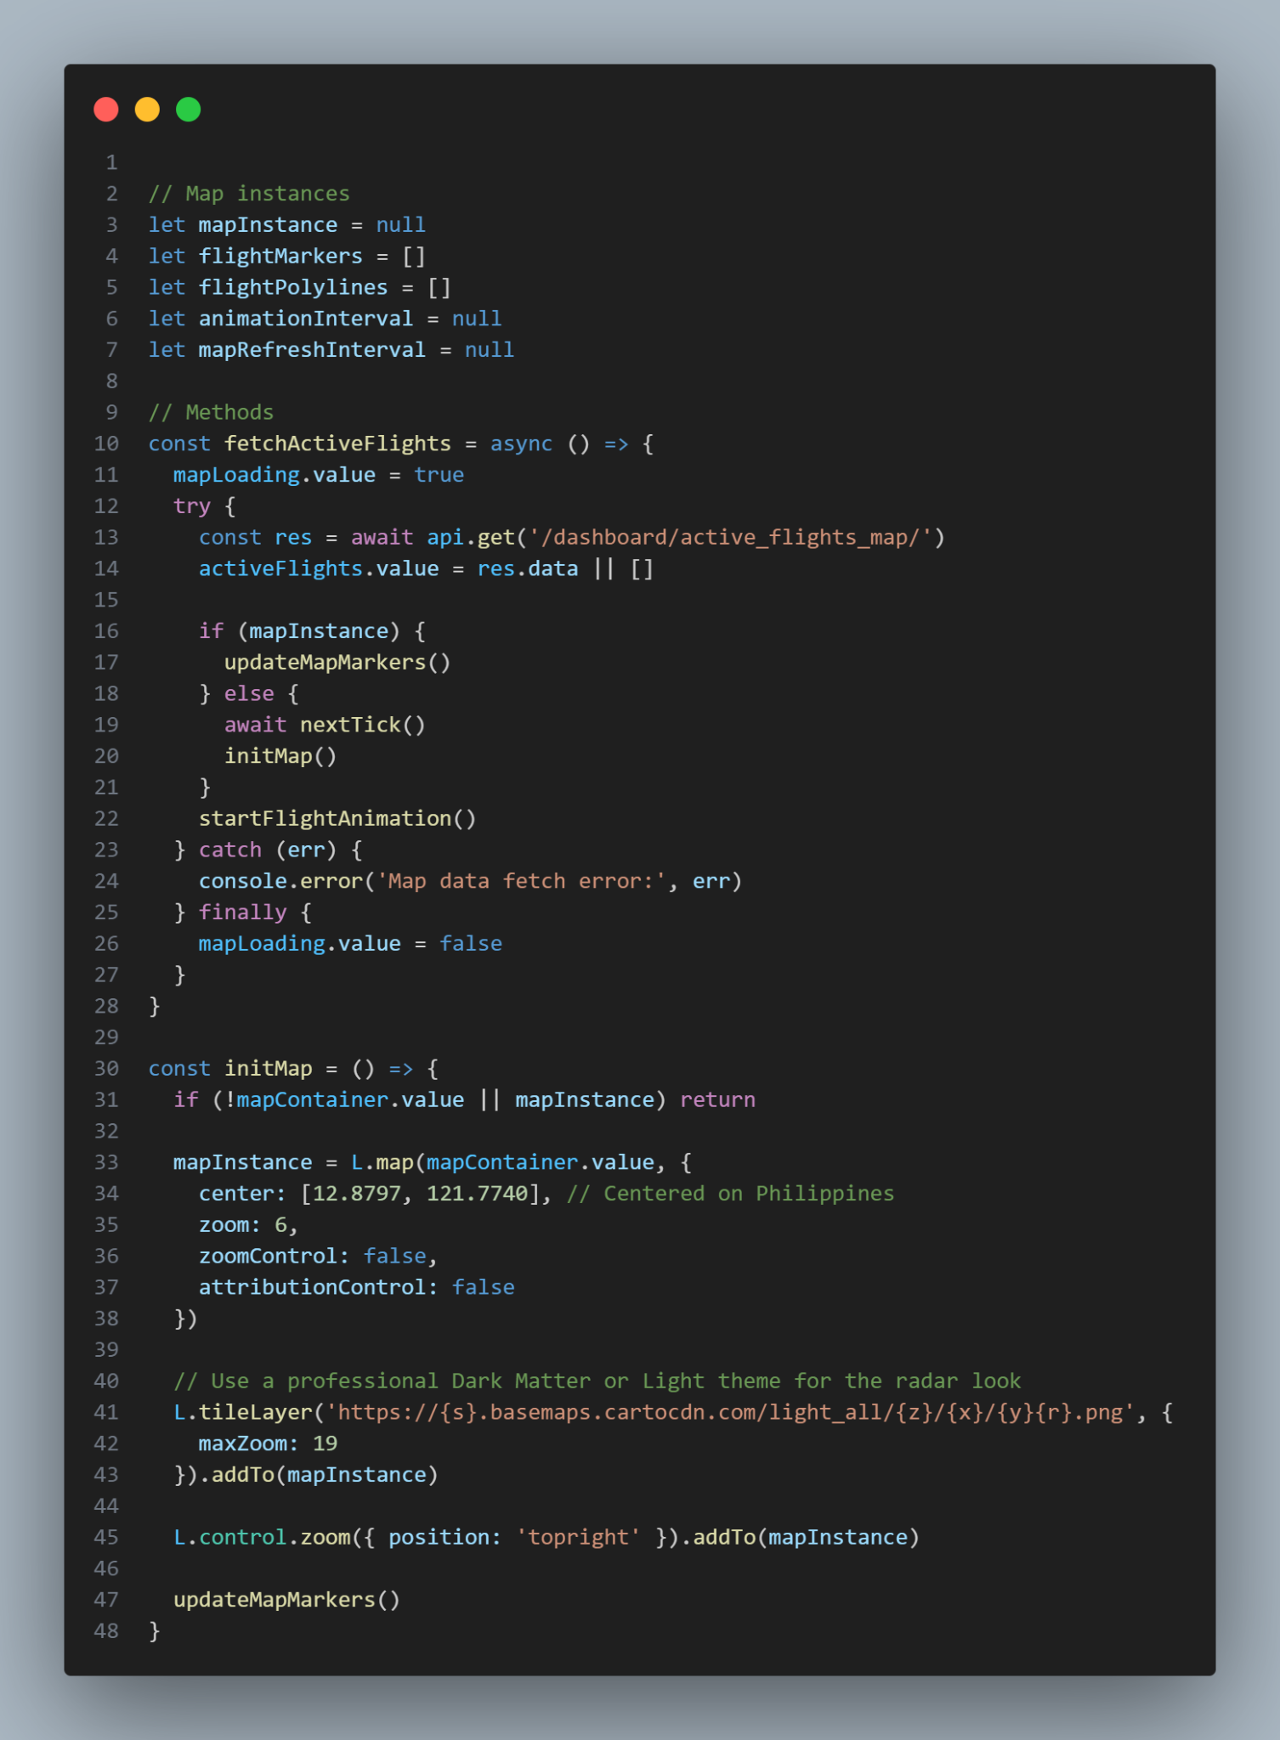
Source: Admin/live_monitor.vue

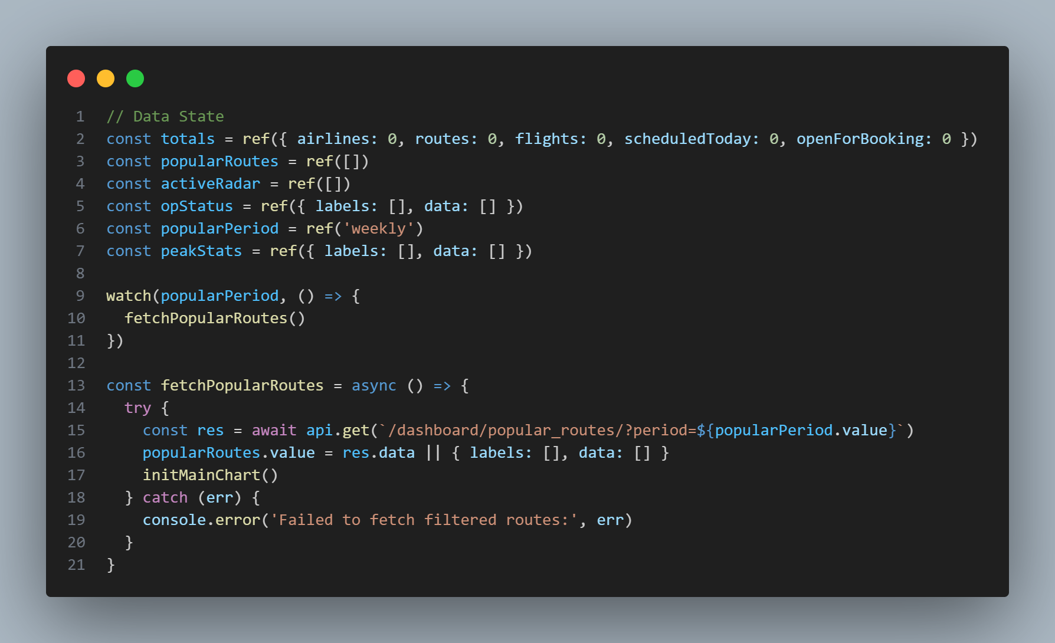
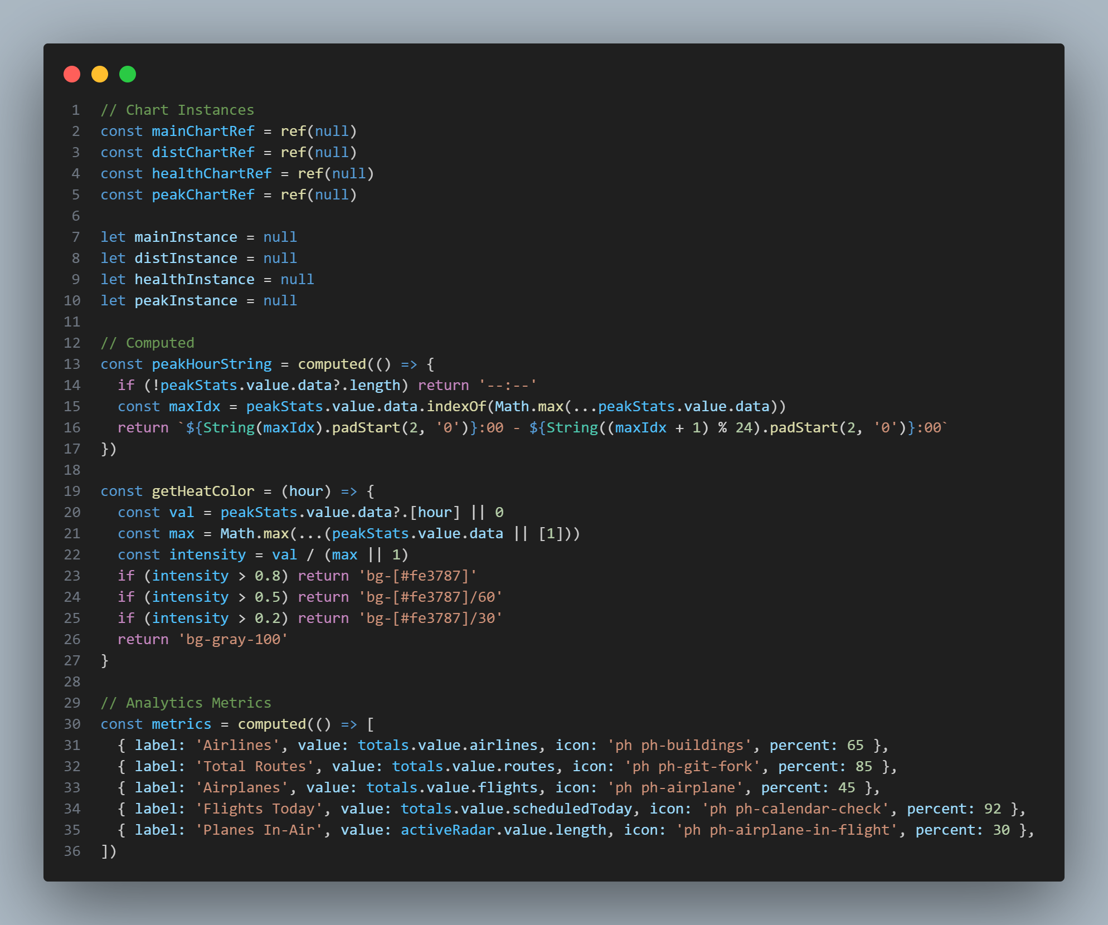
Source: Admin/FlightModule.vue
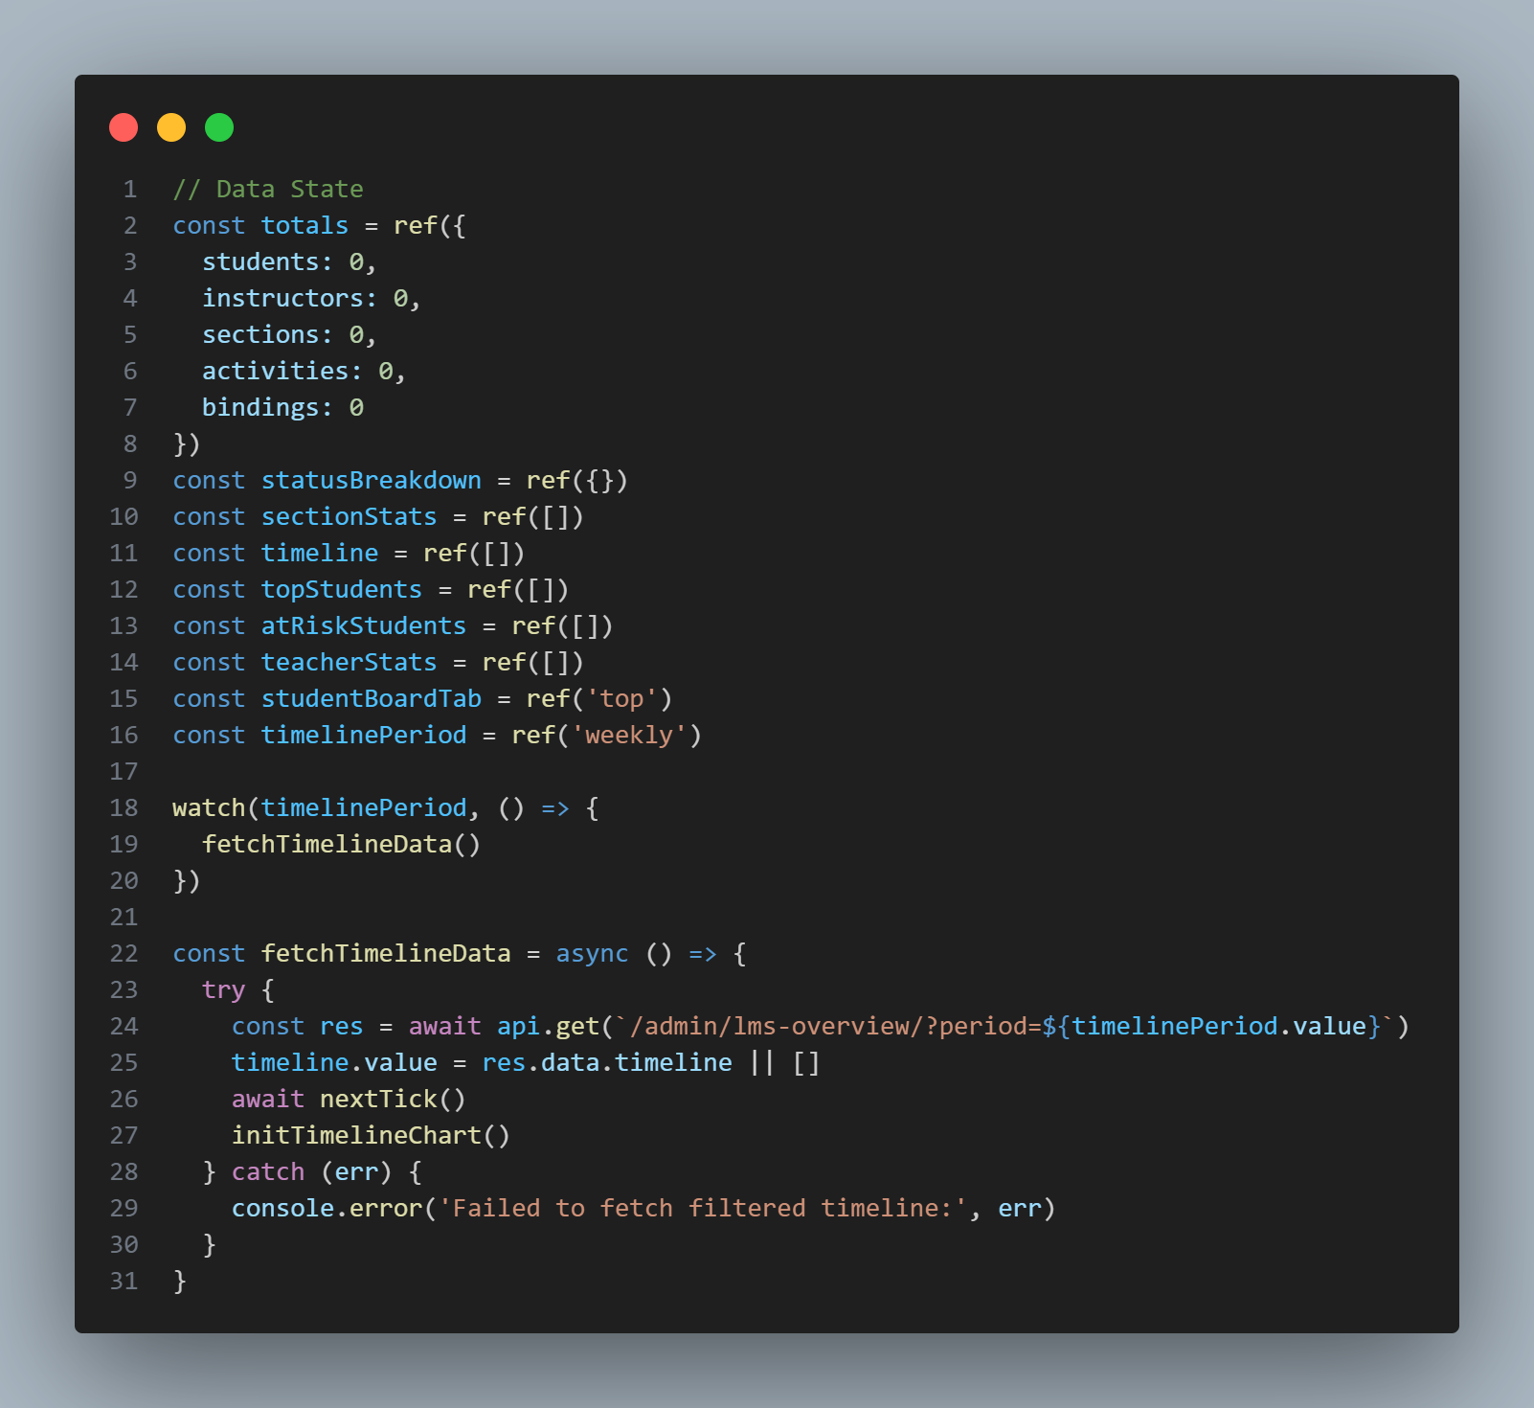
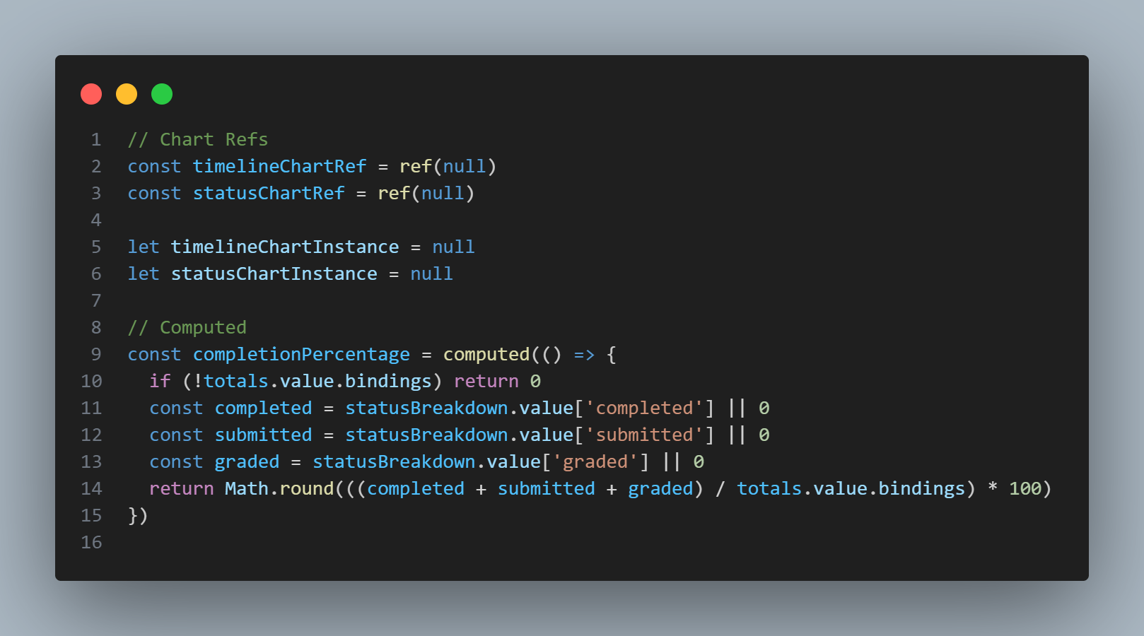
Source: Admin/LmsModule.vue

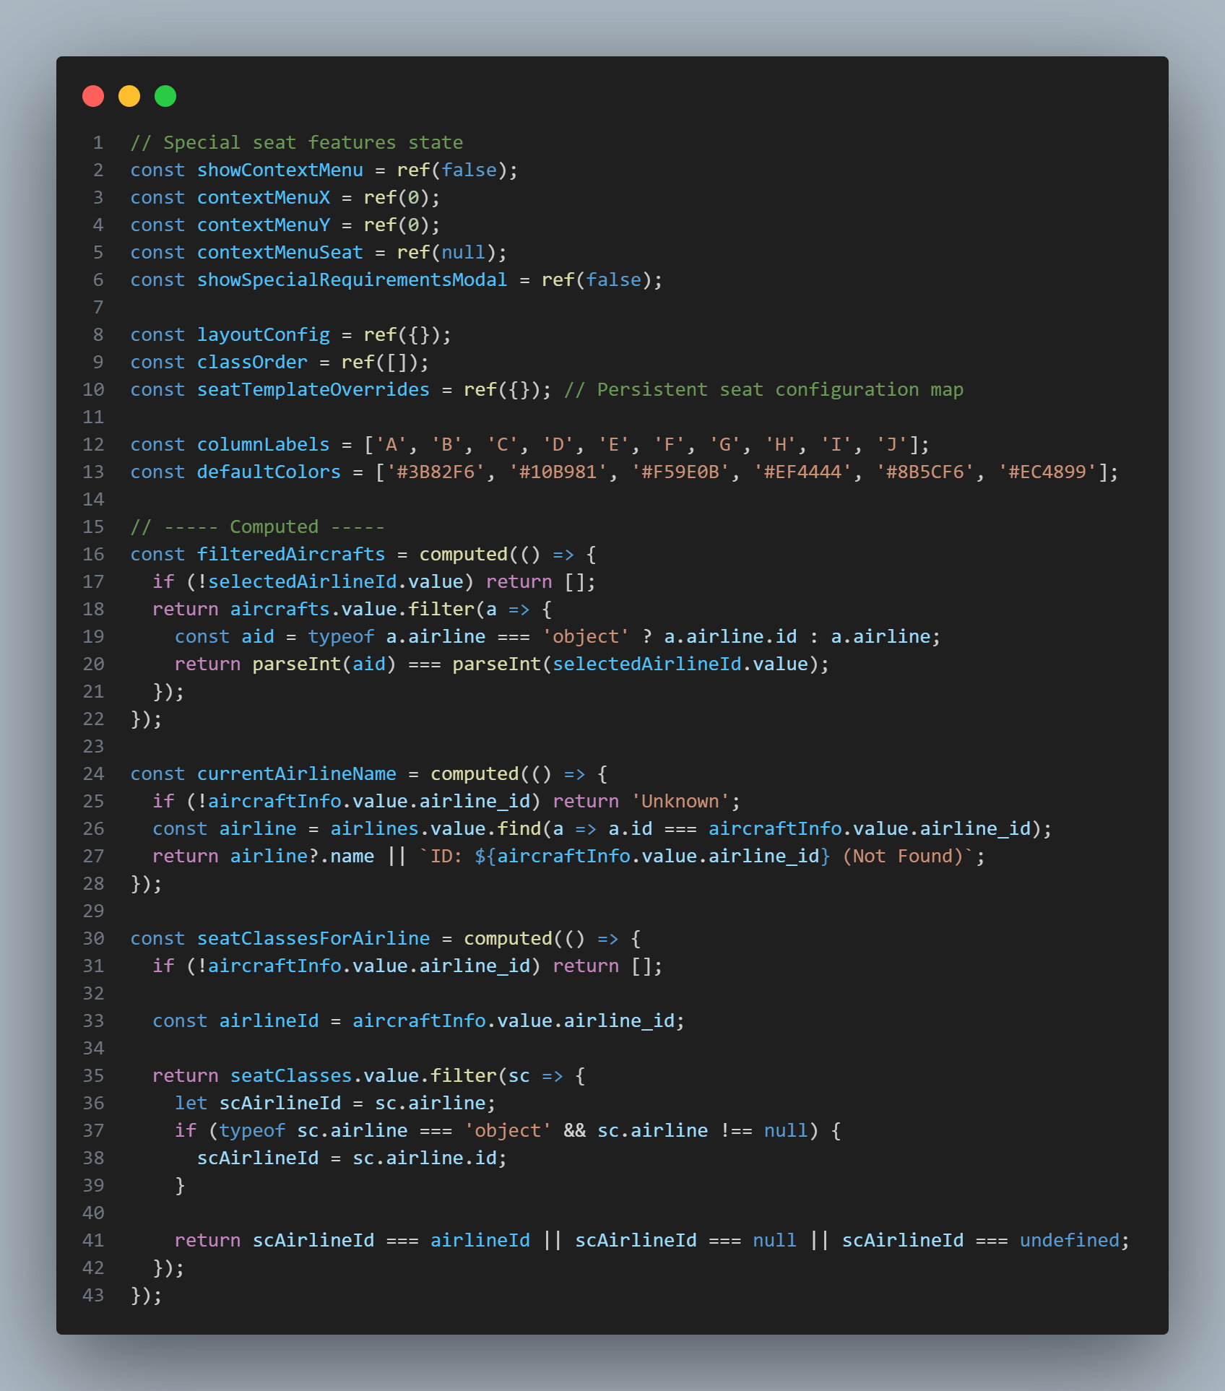
Source: Admin/seat.vue
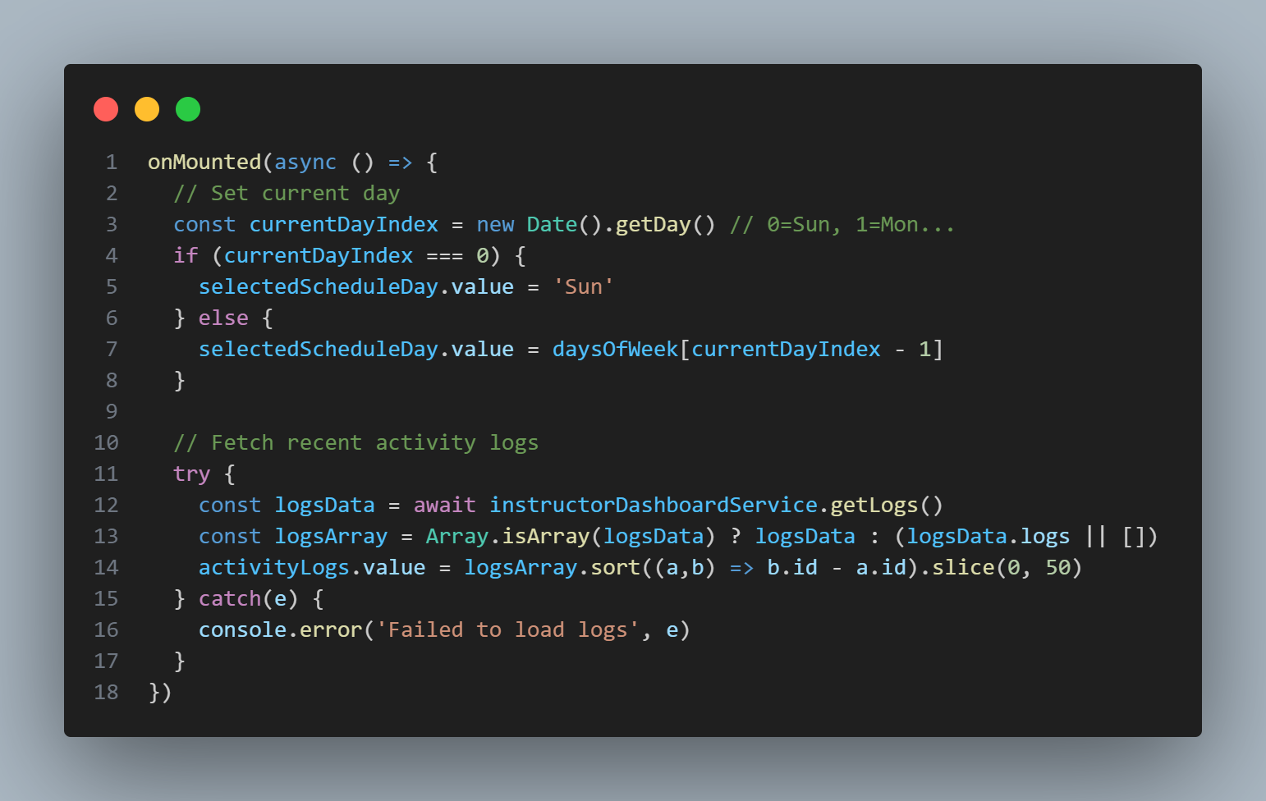
Source:Instructor/Instructor_dashboard.vue
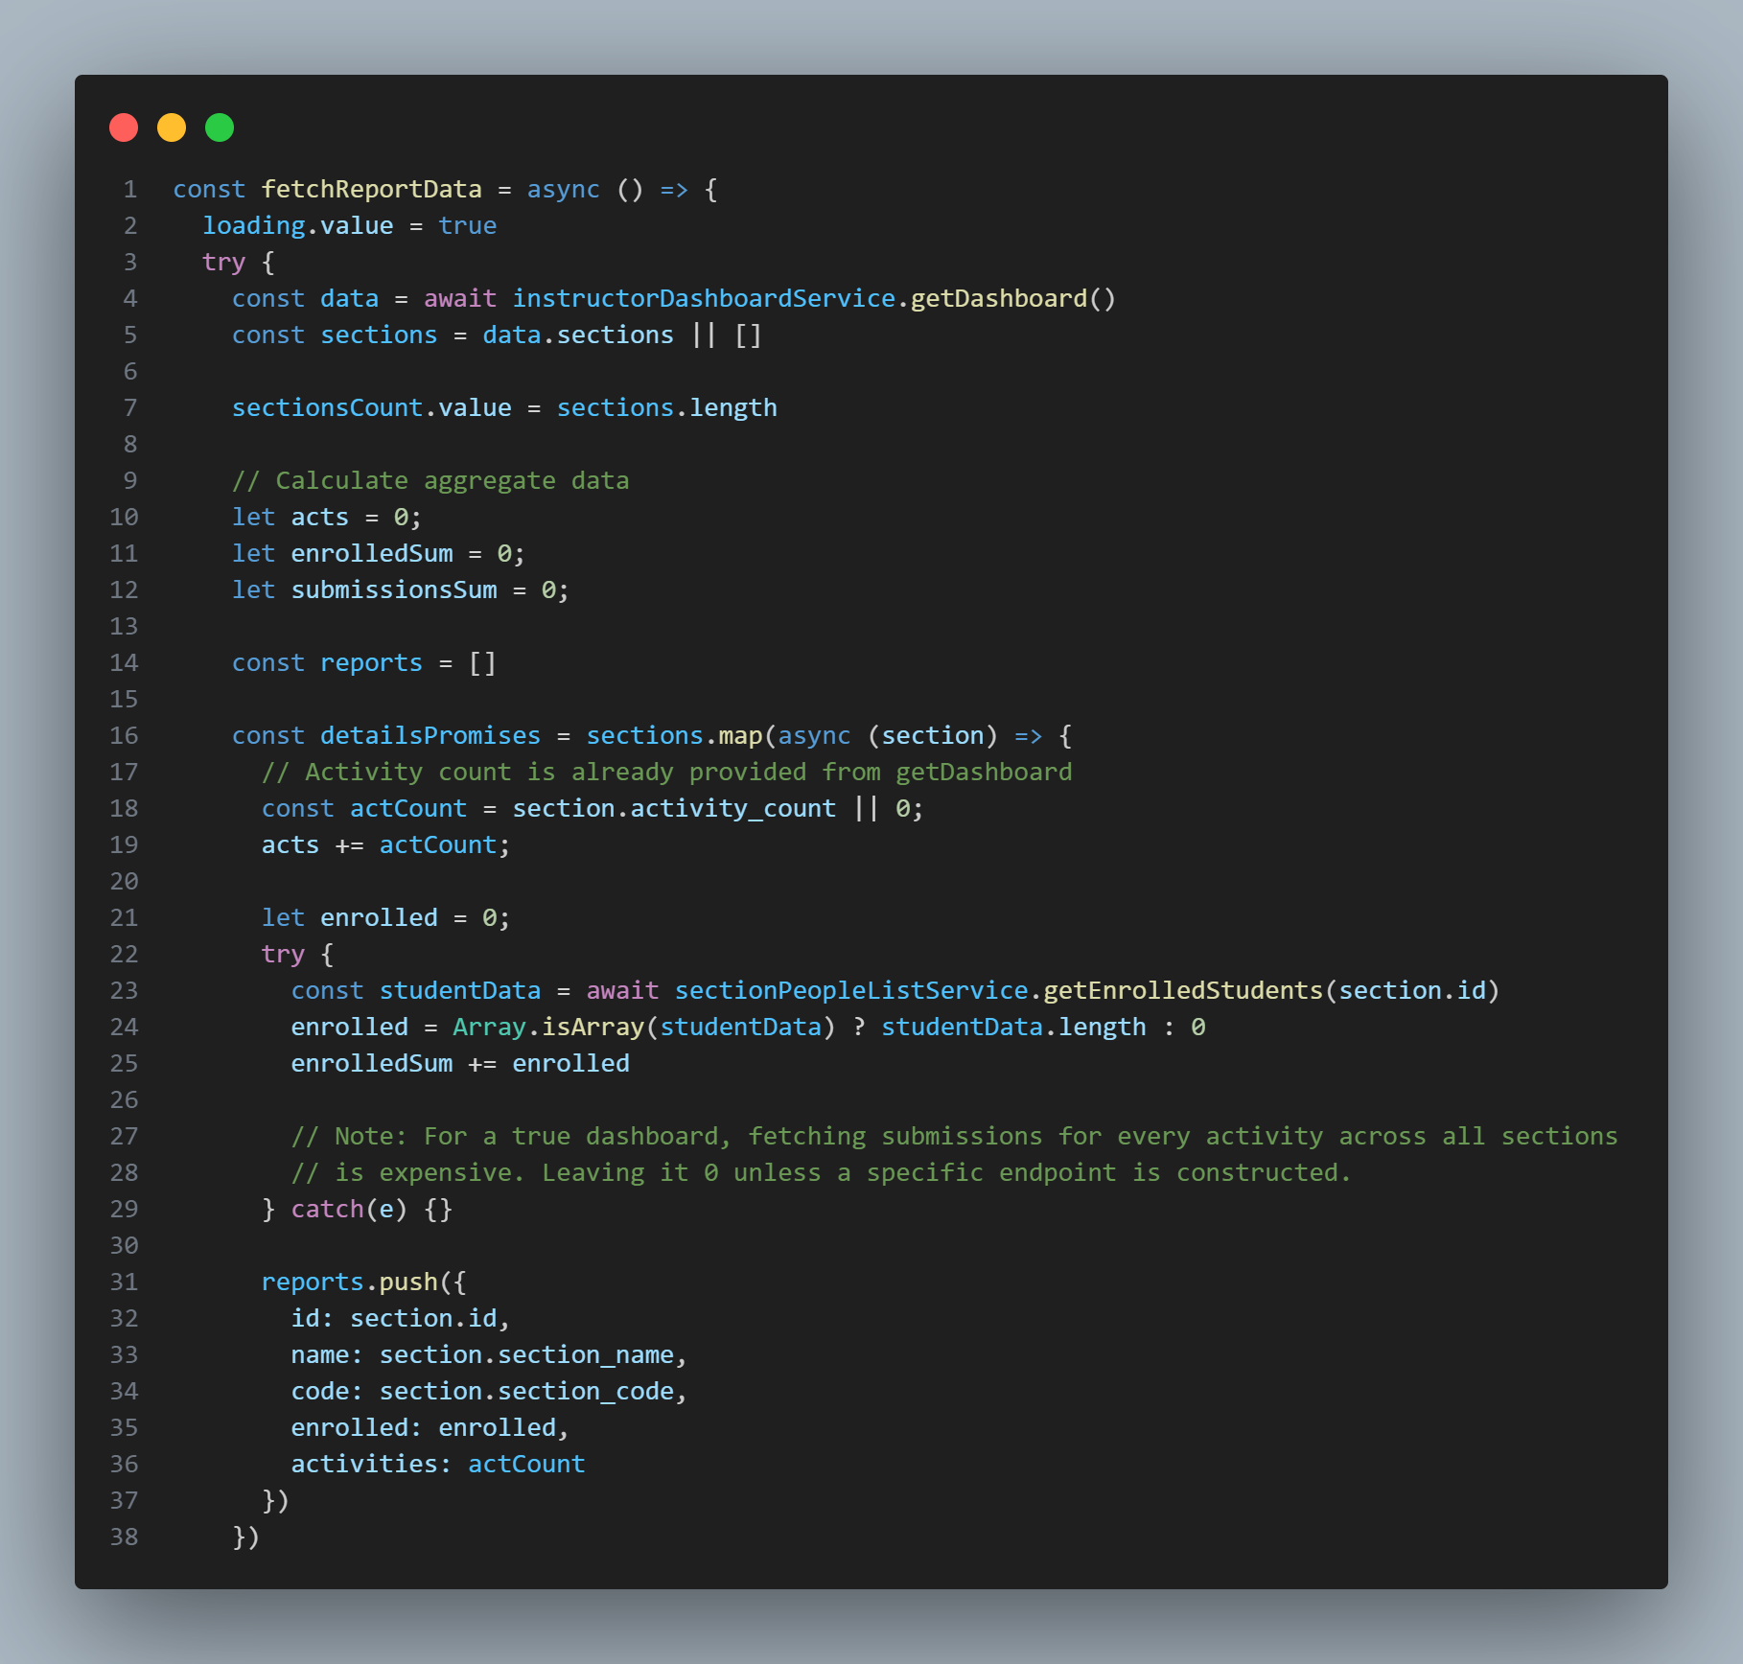
Source:Instructor/Instructor_report.vue
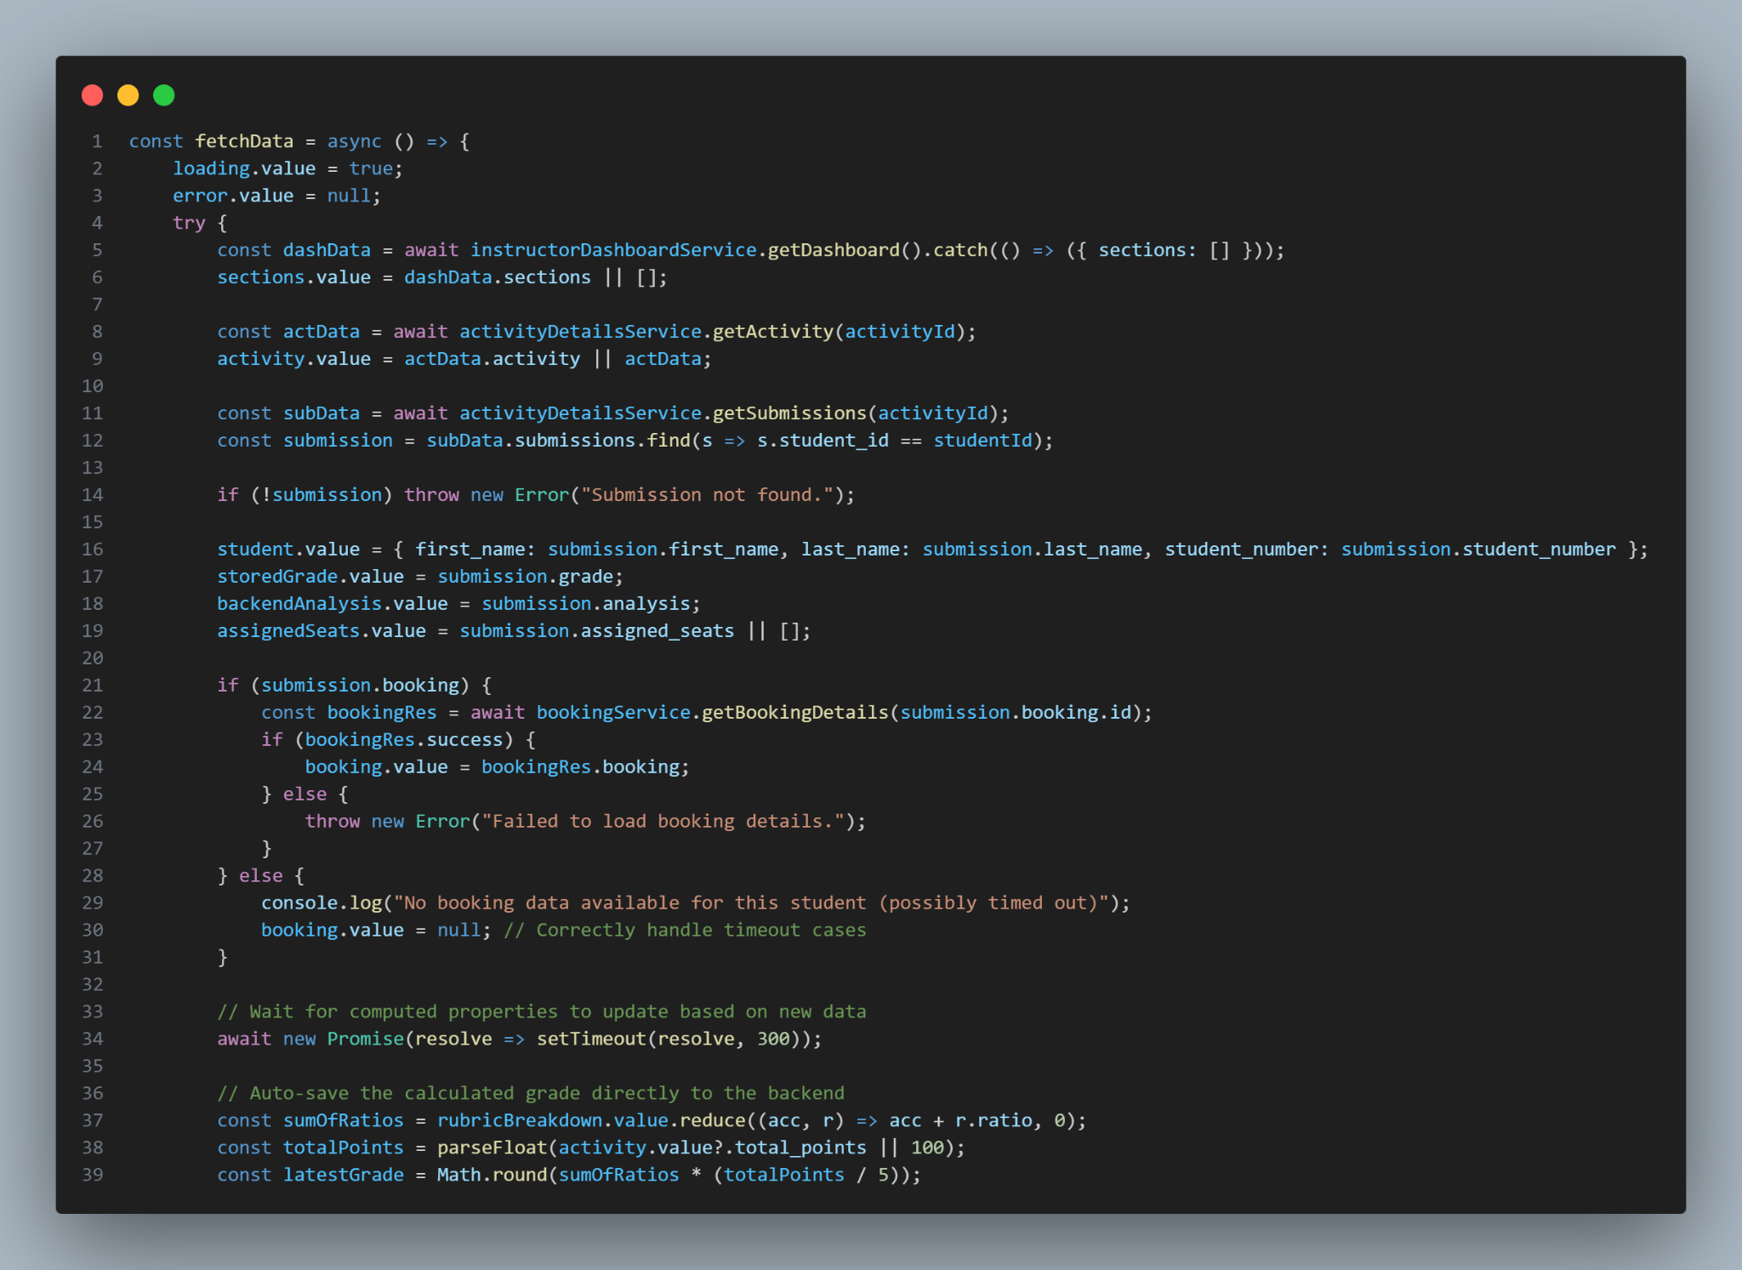
Source:Instructor/Instructor_student_score.vue
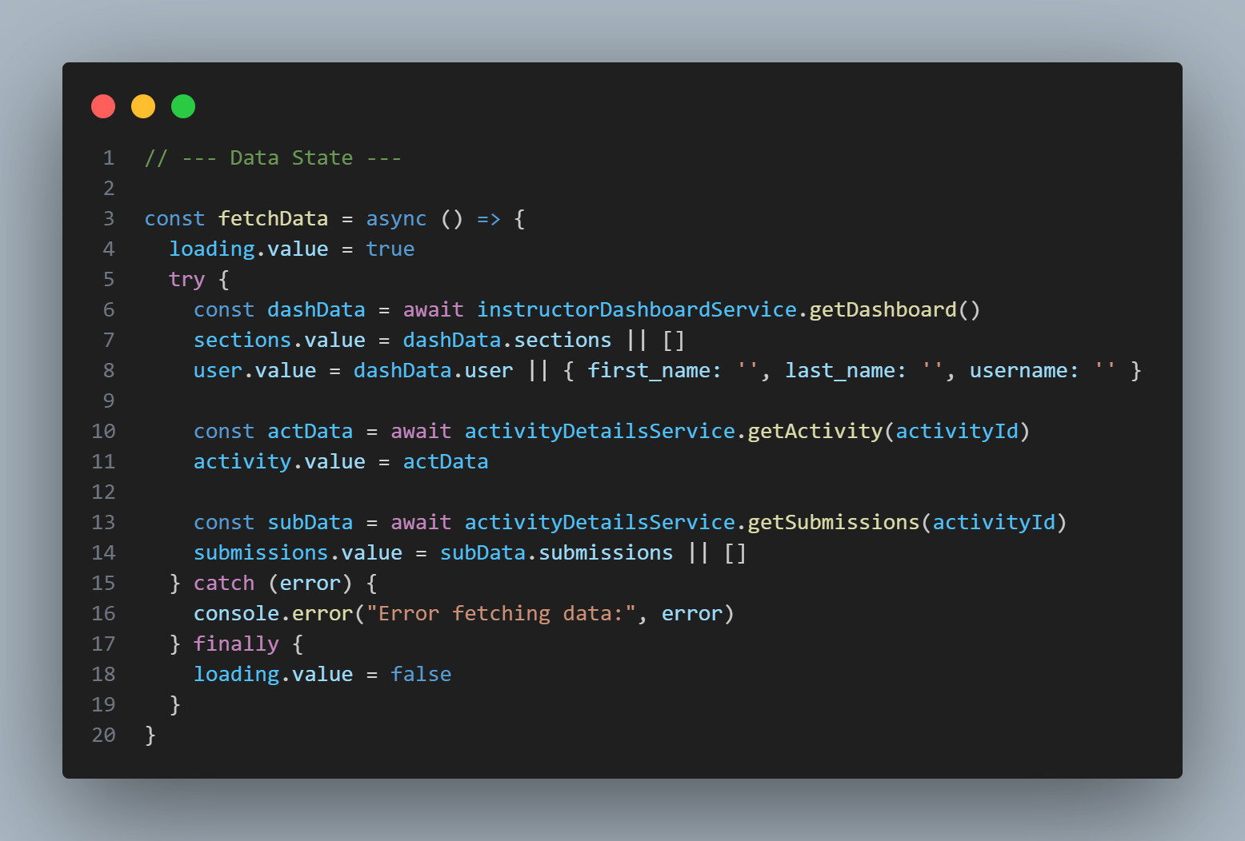
Source:Instructor/Activity_toplist.vue
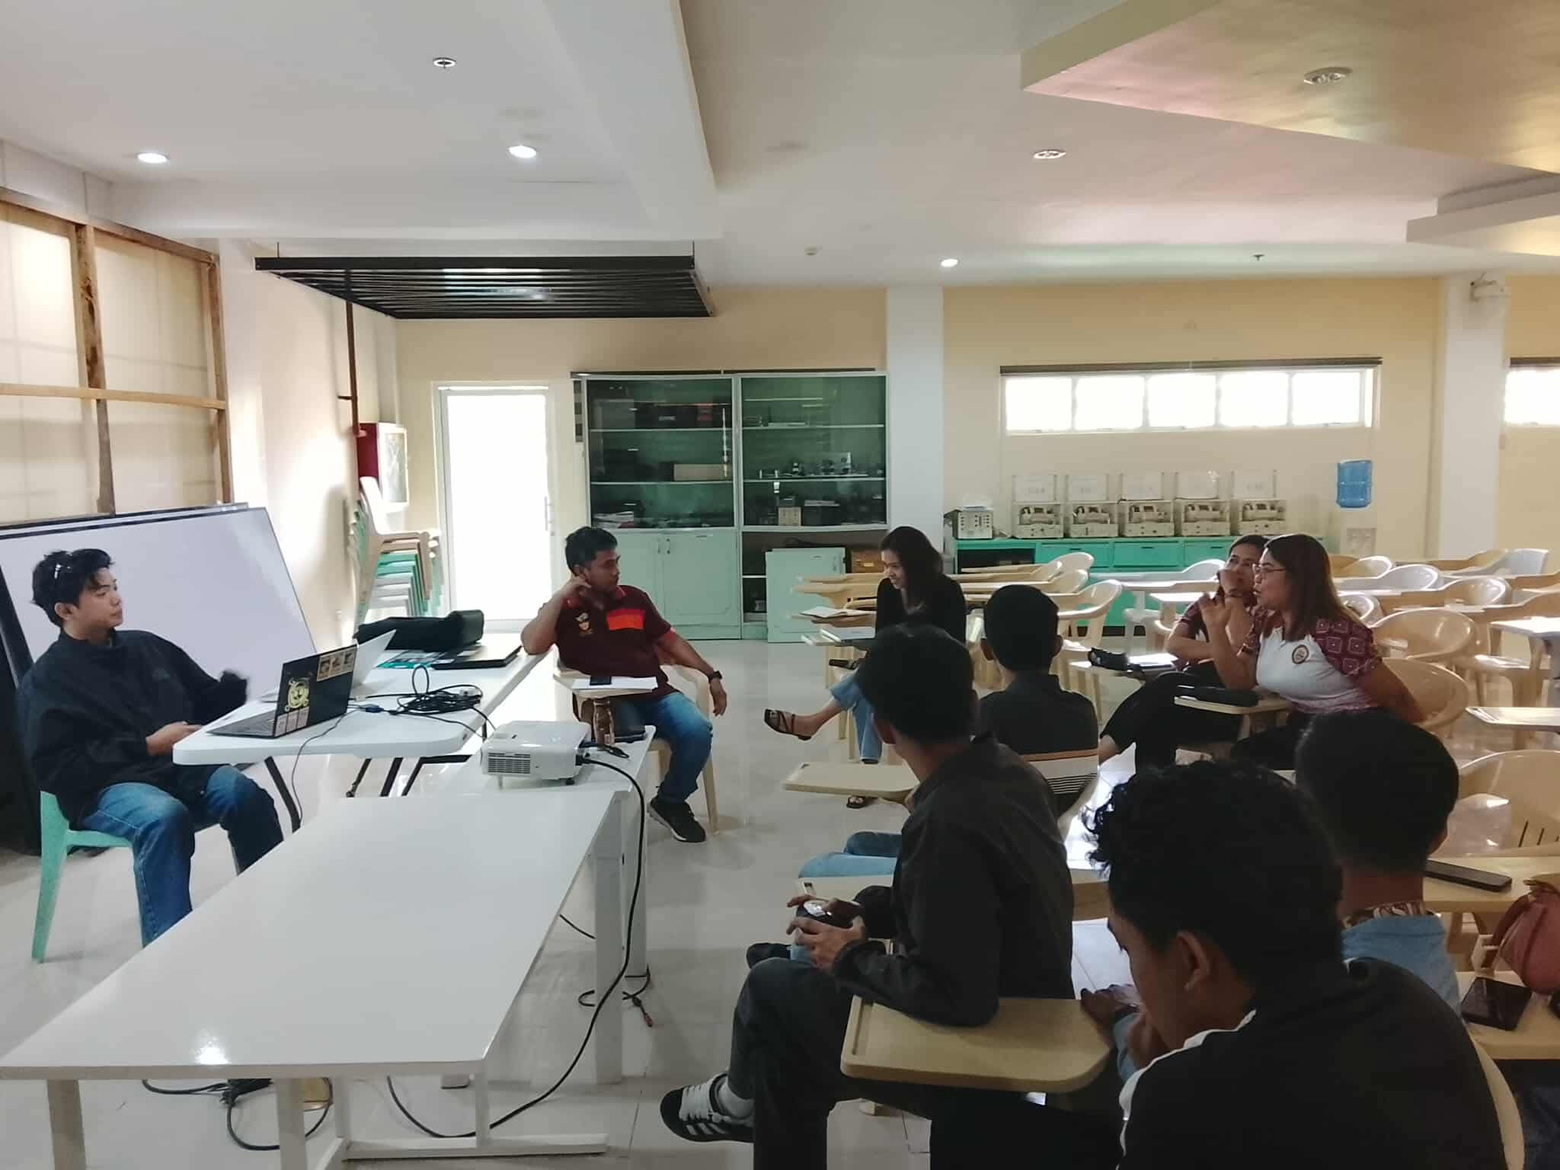
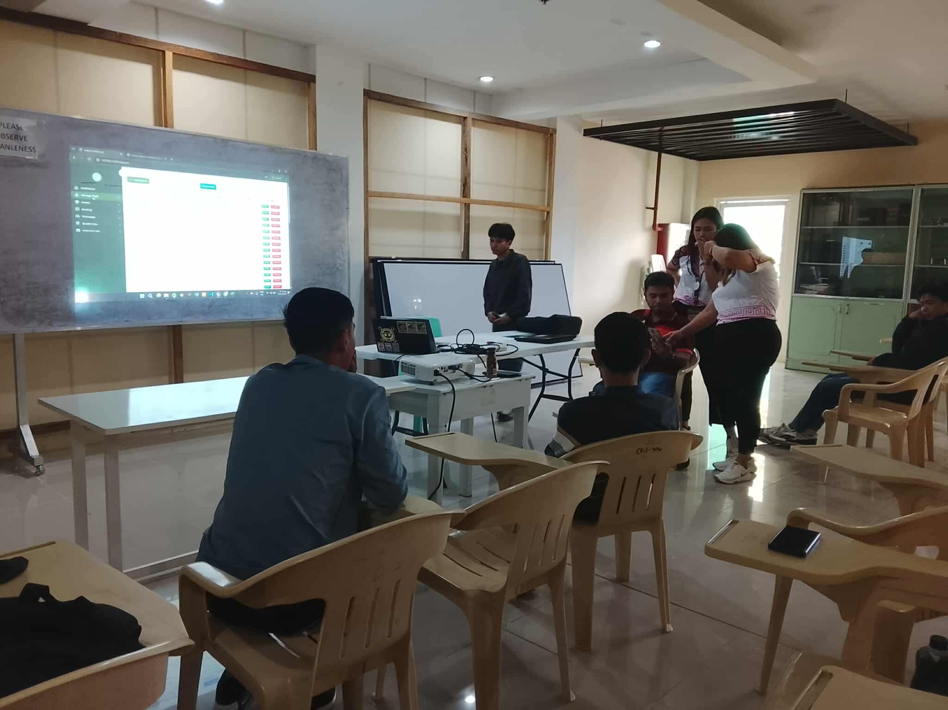
B. Letter to Conduct Interview with Pictorial

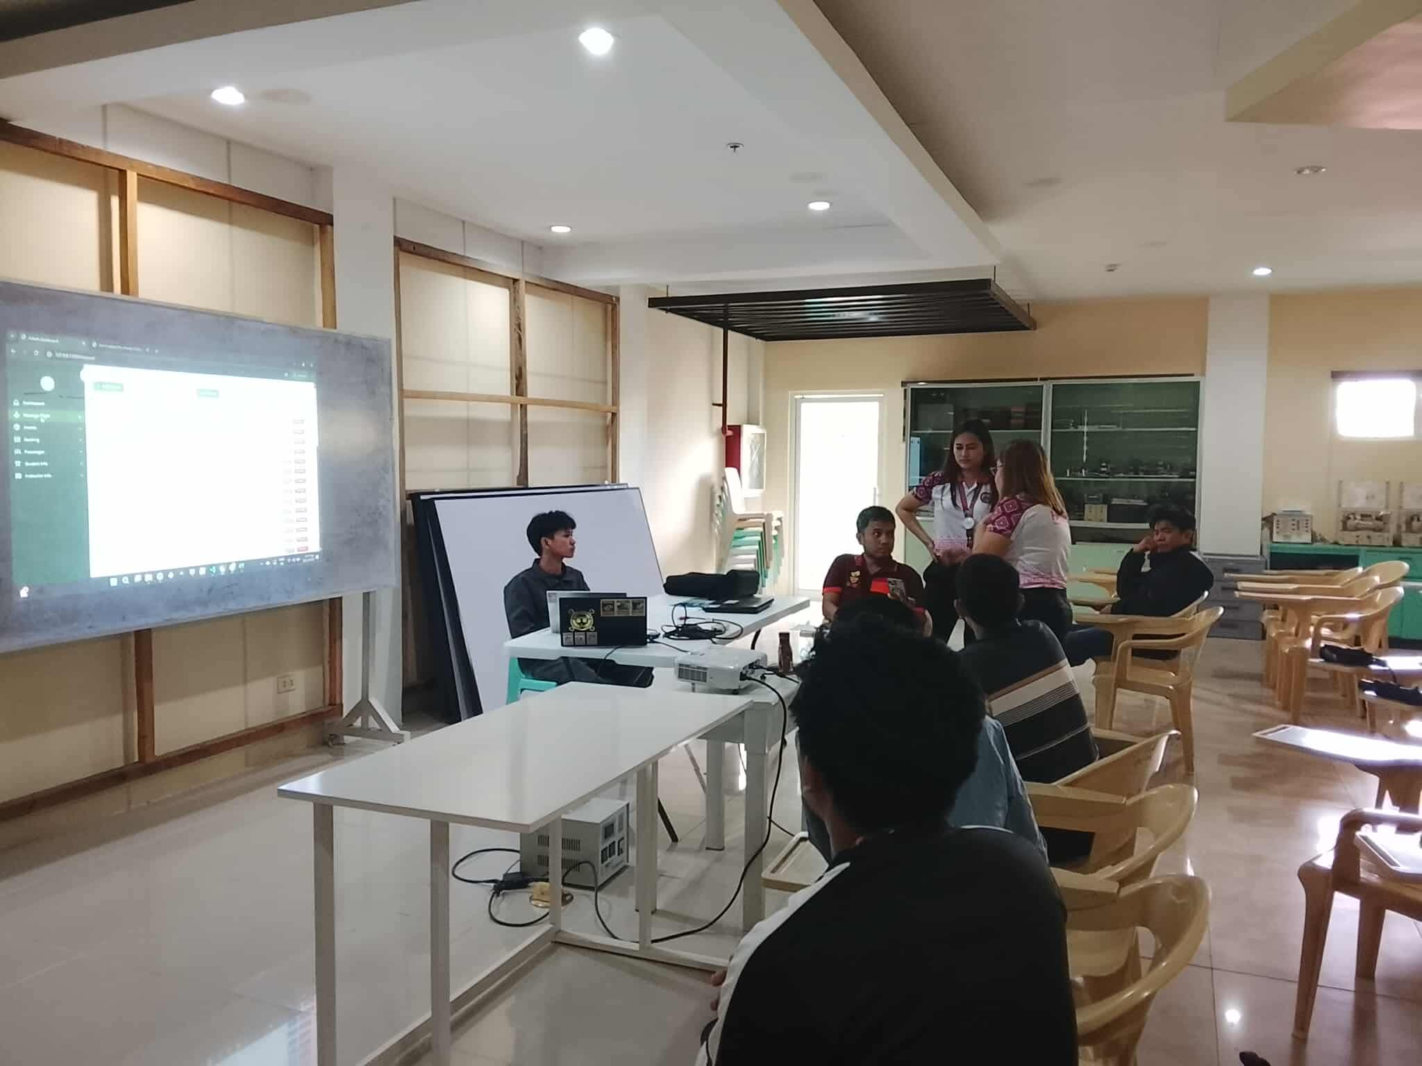

C. Sample Survey Questionnaire
SYSTEM QUALITY EVALUATION FORM
Framework: ISO/IEC 25010:2011
Target Product: A “SMART FLIGHT BOOKING SIMULATION PLATFORM FOR CTHM-CSUCC: AN INTERACTIVE AND DATA-DRIVEN TRAINING TOOL FOR TOURISM EDUCATION”
Evaluator: __________________________ Date: _________________ Rating Scale: 5 – Excellent | 4 – Very Good | 3 – Good | 2 – Fair | 1 – Poor PART 1: PRODUCT QUALITY
Quality Characteristic | Sub-Characteristic/ Criteria | Rating (1-5)
1. Functional Suitability | The system provides a complete and accurate simulation of the air travel reservation process, including seat selection, service add-ons, and secure transaction simulation.
2. Performance  Efficiency | The platform maintains high responsiveness and low latency during peak usage, ensuring smooth transitions between search results and booking confirmations.
3. Compatibility | The web application demonstrates consistent formatting and full functional parity across all modern web browsers and desktop resolutions.
4. Usability | The user interface is designed with a clear navigational hierarchy, making it easy for students to complete complex reservation tasks with minimal guidance.
5. Reliability | The system ensures data persistence and prevents operational conflicts, such as duplicate seat assignments or lost booking records.
6. Security | Robust access control mechanisms safeguard user data and maintain strict privacy between student simulations and administrative records.
7. Maintainability | The system architecture supports modular updates and systematic debugging, ensuring long-term operational stability.
8. Portability | The application is optimized for deployment in diverse web environments, ensuring consistent behavior across different institutional hosting infrastructures.

PART II: QUALITY IN USE (USER EXPERIENCE)
Characteristic | Definition | Rating (1-5)
Effectiveness | Users can achieve complete and accurate results for all intended tasks, such as generating valid flight itineraries and administrative reports.
Efficiency | The platform minimizes the time and effort required to perform standard operations, such as class enrollment or multi-passenger flight bookings.
Satisfaction | The overall user experience is professional and engaging, meeting the high standards expected for academic and vocational training simulations.
Freedom from Risk | Potential user errors are mitigated through real-time validation and clear system feedback, ensuring a safe and accurate simulation environment.

PART III: MY FINAL THOUGHTS (Additional Comments)
What did I like most about the system?
______________________________________________________________________ ______________________________________________________________________ What could be improved or added?
______________________________________________________________________ ______________________________________________________________________ Any other observations?
______________________________________________________________________ ______________________________________________________________________
Evaluator's Signature: ________________________
Thank you for your participation!

D. Evaluation Process
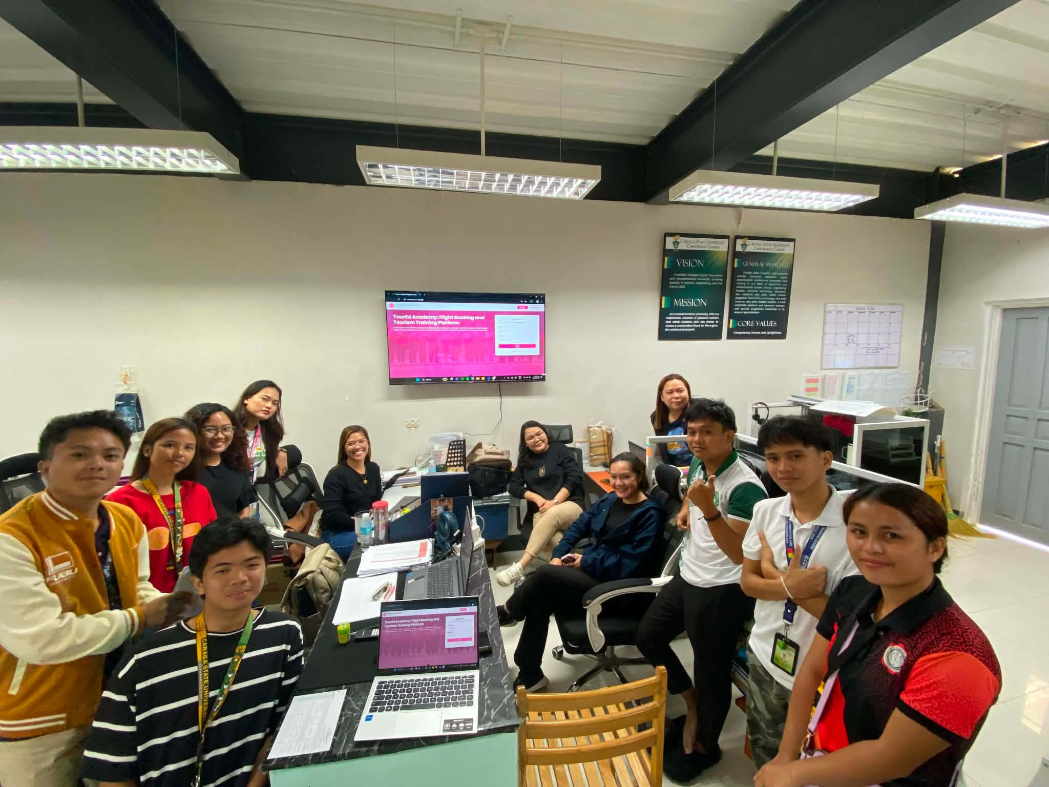


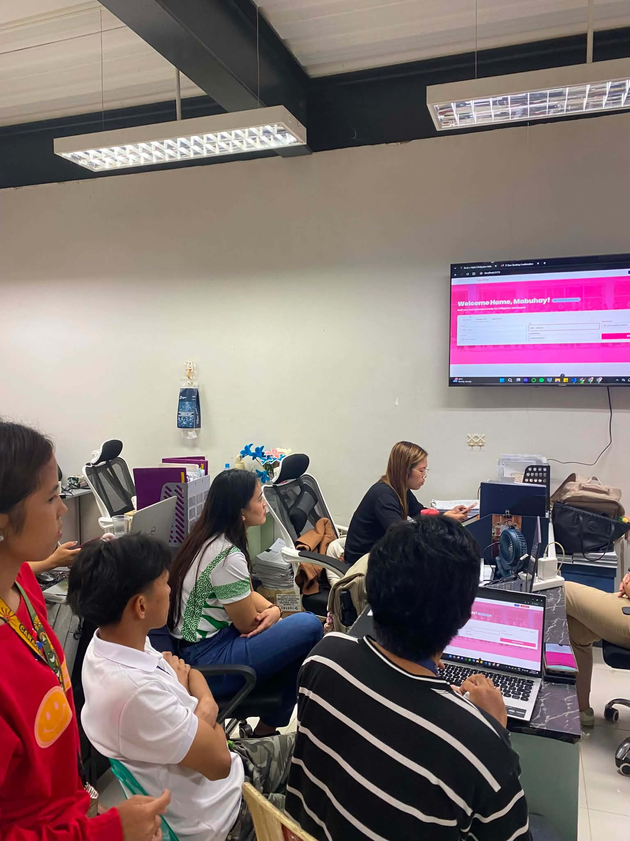


We conducted an evaluation at Caraga State University – Cabadbaran City, specifically within the College of Tourism and Hospitality Management (CTHM), as part of the system assessment phase for the study titled “A Smart Flight Booking Simulation Platform for CTHM-CSUCC: An Interactive and Data-Driven Training Tool for Tourism Education.” The purpose of this evaluation was to gather feedback from students and instructors regarding the system’s functionality, usability, and overall performance.

The data collected helped identify the strengths of the system, as well as areas that need improvement. These insights ensured that the platform is efficient, accurate, and user-friendly, while also supporting better learning experiences and data-driven decision-making within the college.

